Kira Graham
Hertfordshire Business School
The Business of Ethnic Travel: Responsible Tourists and Responsible Operators

Abstract
The purpose of this paper is to identify how tour operators educate their clients, what actions tour operators and tourists take to reduce negative social and cultural impacts of host destinations and to determine which tourists go on certain types of holidays. This research is important as sustainable tourism is a colossal concern and examining what tourists and tour operators are doing to close the attitude-behaviour gap is paramount to acknowledge in order to understand how to progress with the increasing pressure of ethical tourism in the future. From gathering research, it is apparent mass tourism, The Organised Mass Tourist typology and teenager/young adult groups do not take responsibility for their own actions, limit their interaction with locals and finally, cause irritation in host communities. Tour operators are taking more responsibility for their actions and are starting to educate tourists regarding destinations but not all tourists welcome the education.

Key Words
- Social and Cultural Impacts
- Sustainable Tourism
- Business Care
- Tourist Types

1.0 Introduction
Over the last two decades, ethical touring has become a concern for stakeholders involved, including tourism related firms, tourists and host destinations however, it is only recently that the topic has proven significant enough for firms to take a more responsible approach to touring and changing their operations to fit a more ethical mannerism (Khan, 2014). Lewis (1985:381) defines business ethics as "rules, standards, codes or principles, which provide guidelines for morally right behaviour". Whether tourism related businesses, more specifically tour operators, are doing enough to reduce their negative social and cultural impacts is becoming an increasingly hot topic and is having knock-on effects for host communities with fragile culture infrastructures (Chafe, 2005) as local communities are not benefiting and norms are not being conserved due to tourism.
On-the-other-hand, tourists are perceived for lacking respect and appreciation for cultures, according to Crick (1989) however, is this due to tourists acting irresponsibly or due to tour operators not giving them the information and guidelines they need to know how to act? Further discussions include tourist and tour operator typologies, why tour operators practice ethical touring and the role tour operator provide/should provide to customers.

2.0 Business Care for Ethical Touring
Goodwin (2011) states that tourists are demanding more from tour operators and more importantly, want "the broader experience of the destination and its sustainability" meaning tourists want to experience more of the places they are visiting but also want to see sustainability within them. These two key elements tend not to go hand in hand due to negative social and cultural impacts.
An anonymised responsible tour operator, hereby referred to as 'Alpha', promotes sustainability within tourists and develops a strong host/guest relationship. According to Ziffer's (1996) theory, it would be classed as a Pro-active tour operator (see Section 3.2), ensuring their holidays benefit everyone involved.
On-the-other-hand, a second and much larger anonymised tour operator, hereby referred to as 'Bravo', are still limiting guest interacting with the local community despite taking some responsibility in other forms. Bravo could be identified as an Opportunistic/Sensitive tour operator according to Ziffer (1996) - (see Section 3.2). Their clients tend not to experience a destination for its true form, stay within a hotel and contribute very little to the local economy; further causing resentment between hosts and guests (Sandbrook, 2010). Figure 1 displays locals get frustrated when a mass number of tourists enter their community because tourists are not acting culturally appropriately and do not contribute towards the economy. Figure 2 represents an example of what occurs when hosts reach the Antagonism Stage in Figure 1. Furthermore, locals tend not to benefit vastly from tourism (Butler and Hinch, 2007) meaning Bravo's guests may be more inclined to stay within a hotel to avoid conflict, further enforcing the host's annoyance.
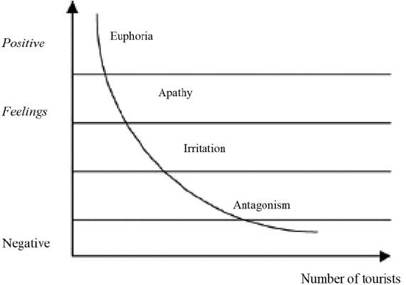
Figure 1: Doxey's Index of Irritation (Doxey, 1975)

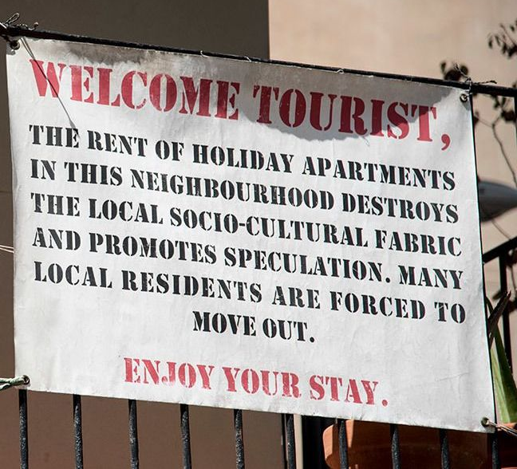
Figure 2: McLaughlin (2017) - hosts publicly displaying their annoyance in Spain

2.1 Pre-trip education
Tepelus (2005) believes tour operators are educating tourists about destinations in addition to educating the locals on the tourists in hope these parties would respect each other and the tourism industry would not destroy a host community. However, this does not limit The Demonstration Effect (Fisher, 2004), which occurs when a weaker culture copies the language, views and dress of a dominant culture further leading to The Cross-Culture Adaptation Theory (Kim, 1988) when a culture loses their own norms but adopts norms from another culture.
Cultural brokering, as defined by Liamputtong (2010), means to educate individuals regarding cultural behaviours to avoid social error and sustain good relationships. Alpha acts as a culture broker by educating their clients on aspects of the destination and community and by providing guidelines. Although tour operators cannot enforce guidelines, Alpha is a niche tour operator where clients pay a premium to travel responsibility and therefore, are likely to respect the advice provided.

3.0 Characteristics
3.1 Tourist Types and Activities
According to Becken (2004), there is an attitude-behaviour gap surrounding sustainable tourism which occurs when a consumer is concerned by sustainability however, their buying behaviours do not differ. Moreover, negative social impacts entail the gap as tourists do not recognise their responsibilities as visitors (Juvan and Dolnicar, 2014) because:
- No alternative behaviours being established (Becken, 2007)
- Tourists want escapism and to relax as oppose to concern themselves with sustainability (Wearing et al., 2002)
- Specific types of tourists may be denying responsibility, most likely younger tourists who engage in illegal/frowned upon activities (Gössling et al., 2009)
Children are the age group most likely to involve themselves with sustainability, given guidance (Ryan, 1992) and teenagers are most likely to engage with illegal/condemned activities whilst abroad (Josiam et al., 1998 and Gossling et al., 2009). Further creating responsibilities for hosts to control drug use, aggression and unorderly behaviour. Pearce, (1990) however, claims this group can typically be between the ages of 18-35. In addition, it is thought that individuals travelling act more responsibility than those in groups (Gossling et al., 2009).
Figure 3 establishes that tourists have basic responsibilities but sustainable tourists have additional responsibilities suggesting tourists should be concerned by their actions however, most tourists need direction to act responsibly (Pearce, 2005); especially those falling into a younger demographic age range. Tour operators could consider educating their clients in different ways depending on their age range. Figure 4 identifies why tourists leave their residents for a temporary one through tourism. Similarly, tour operators could educate their clients to impose positive social and cultural impacts by depicting their motivations.

Figure 3: Role Responsibilities of Tourists, Swarbrooke (1999)

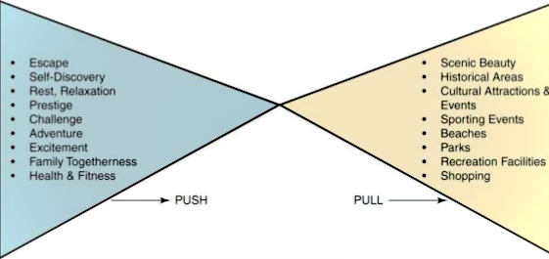
Figure 4: Push and Pull Model, Crompton (1979)

3.2 Tour Operators
Ziffer (1996) identified four basic tour operator groupings:
- Opportunistic
  - aware of the negative cultural impacts caused but are not concerned by them.
- Sensitive
  - develops low-impact trips, are aware of host destination's concerns but profit is the main motivation.
- Constructive
  - donates a percentage of profit to good causes.
- Pro-active
  - plays an active role in conserving and improving an area and work alongside charities.
These basic tour operator types could be linked with tourist types depending on how active they are in the host community. Cohen (1972:167-168) gives an overview of four tourist typologies:
- The Organised Mass Tourist
  - least adventurous, buys a planned package holiday and makes almost no decisions during their trip.
- The Individual Mass Tourist
  - similar to the previous but trip is not entirely pre-planned, needs familiarity and rarely ventures from comfort zone.
- The Explorer
  - limited involvement with the local community and returns to their comfort bubble when things get too "rough".
- The Drifter
  - no relationship with tourists, completely immersed in host community and has no planned itinerary.

Relating Ziffer's (1996) and Cohen's (1972) theories together, The Opportunistic may correlate to The Organised Mass Tourist because they do not make themselves aware with the host community, nor the social and culture impacts they are inflicting. The Sensitive and The Individual Mass Tourist both involve themselves somewhat in the host community. The Constructive and The Explorer groupings relate as they more actively involve themselves in the host community and finally, The Pro-active and The Drifter interconnect as they fully immerse themselves within the host community and actively contribute towards the destination. Although, it is important to identify that The Drifter will not associate themselves with The Pro-active tour operator so these typologies do not completely correlate with each other.
Based further on Cohen's (1972) tourist typologies, Smith (1978) devised a framework stating undeveloped destinations would receive Drifters, slightly more developed areas would receive Explorers and so on until a destination becomes so popular, The Organised Mass Tourist occurs.

3.3 Host Community
In order for a host community to preserve and protect their social and cultural norms, standard social frameworks need to be established first (Enemuo and Oduntan, 2012). However, tour operators including Bravo still operate holidays to destinations with fragile infrastructures (Suleic et al., 2014).
Replacing a host community's profitably industry with tourism often leads to staged authenticity of cultures (Ramos et al., 2016). Moreover, tourists are more likely to visit a destination developed for tourists rather than to see the export the country produces (Baldacchino, 2006) which reinforces the concept of mass tourism as opposed to sustainable tourism. Additionally, Luke (2002) states tourism is economically appealing and host communities have been seen to abandon their main industries for tourism to later have their communities destroyed due to recklessness of tourists, lack of education from tour operators and finally, oblivious behaviours of the locals.
Holloway and Taylor (2006) defines a tourism destination as an area in which markets itself as a place tourists can visit however, it is disputed. As shown in Figure 1 (Doxey, 1975), residents of the local community get so frustrated with tourists, they publicly show antagonism however, tourists still enter the destination. In other cases, locals have been pushed from their own land to develop more hotels for tourists (Wood, 2017). Furthermore, Holloway and Taylor's (2006) statement may prove incorrect as a destination may not market itself but rather, tour operators market a destination.

4.0 Strategies to Mitigate Negative Social and Cultural Impacts
Alpha has an inspiring policy to reducing negative social and cultural impacts:
- Developing long term host community relationships
- Encouraging clients, staff and leaders to act in a socially responsible way
- When looking at new destination, ensuring staged authenticity is not taking place and checking to see whether the existing community is strong enough to withhold tourism (preventing The Cross-Culture Adaptation Theory - see Section 2.1)
Sigala (2008) suggests Bravo is responsible and do reduce negative social and cultural impacts:
- Selecting and working with contractors that abide by Bravo's "environmental schemes and achieve annual sustainable targets"
- Developed certificated excursions to certain attractions
- Co-ordinating with local government and authorities regarding future developments
In contrary, Bravo is not as active as Alpha as they are still limiting host and guest relationships (see Section 2.0). Suleic et al., (2014) claims Bravo is extremely irresponsibly as they do not change holiday destinations. Not only does this overwhelm communities with mass tourism and result in a "loss of cultural identity" but could result in hosts relying on tourism.
In addition, tour operators could use local services separately to support the community rather than horizontal integration (Tepelus, 2005). For example, using a local tour excursionist, local produce and restaurants rather constantly using the leading tour operator's facilities which creates leakage and a misleading sense of experience in a destination (Bruner, 1991 and Wang, 1999).

5.0 Advantages for practicing ethical tourism
ABTA (2016) establishes sustainable tourism is a substantial trend for the current market and for the future. Furthermore, Goodwin (2011) claims that there are benefits to a tourism related firm adopting a responsible approach which includes ethical commitment and social responsibility in having an active role ensuring host communities are treated fairly. Suleic et al., (2014) argues that the main reason businesses practice social responsibility is to "achieve public good" but another reason could also be for the "interest of society". Non-the-less, Suleic et al., (2009) proposes firms are egotistical and practice ethical tourism for status and prestige, similar to those motivations suggested in Figure 4 as to why tourists travel.
Responsibility is not only in the interest of tour operators but also in the interest of related stakeholders, such as tourists and local host communities too, declares Khan (2014). This is to ensure destinations are maintaining themselves for future generations of residents and tourists; it is the tour operator's responsibility to provide tourists and communities with the education and tools to acknowledge this and take action upon it.

6.0 Conclusion
To analysis the initial task, Alpha actively immerses themselves within host communities and could be identified as a Pro-active tour operator whilst Bravo could be identified as either Opportunistic/Sensitive tour operators (see Section 3.2). More importantly, suggesting the clientele the firms receive, which typology they could be identified as and established activities they engage in.
Ethical tour operating is not only seen as a trend, a motivation to achieve profit but also a prestigious matter to support (see Section 5.0). Tour operators are taking it upon themselves to increase their positive social and culture impacts on host communities using a level of involvement that suits their typology and are increasingly acting as culture brokers by educating both tourists and locals on each other to mitigate social error and ensure cultures interconnect but do not adopt or replicate another.
Having looked in depth regarding tourist motivations (see Section 3.1), it appears the teenagers/young adults are most likely to have negative social and cultural impacts on a destination by engaging in illegal/condomed activities and act with little responsibility whilst children are more likely to get involved with ethical travelling if given guidance. Under the impression tour operators are being more pro-active regarding their actions, it could be recommended that tour operators should give tourists the opportunity to be more pro-active whilst not forcing the concept upon them. Moreover, providing clients with guidelines regarding an in-bound destination to reduce negative social and cultural impacts, so guests can experience more of a destination.

7.0 References
ABTA (2016) Travel Trends Reports 2017. London: ABTA.
Baldacchino, G. (2006) Warm Verus Cold Water Island Tourism: a Review of Policy Implications. Charlottetown: Island Studies Journal.
Becken, S. (2004) How Tourists and Tourism Experts Perceive Climate Change and Carbon-Offsetting Schemes. Abingdon: Routledge.
Becken, S. (2007) Tourists' Perception of International Air Travel's Impacts on the Global Climate and Potential Climate Change Policies. Abingdon: Journal of Sustainable Tourism.
Butler, R. & Hinch, T. (2007) Tourism and Indigenous Peoples: Issues and Implications. Burlington: Elsevier.
Chafe, Z. (2005) Interest in Responsible Travel Grows: Vital Signs 2005. Washington: Worldwatch Institute.
Cohen, E. (1972) Toward a Sociology of International Tourism. Camden: Social Research. Pp. 167-168.
Crick, M. (1989) Representations of International Tourism in the Social Sciences: Sun, Sex, Sights, Savings, and Servility. London: Annual Review of Anthropology. Pp.307-344.
Crompton, J. (1979) Motivation for Pleasured Travel. Oxford: Annuals of Tourism Research.
Doxey, G.V. (1975) A Causation Theory of Visitor-Resident Irritants: Methodology and Research Inferences. San Diego: Travel and Tourism Research Associations.
Enemuo, O.B. and Oduntan, O.C. (2012) Social Impacts of Tourism Development on Host Communities of Osun Oshogbo Sacred Grove. Umudike: Journal of Humanities and Social Science.
Fisher, D. (2004) The Demonstration Effect Revisited. Canterbury: Annuals of Tourism Research.
Goodwin, H. (2011) Taking Responsibility for Tourism. Oxford: Goodfellow Publishers Limited.
Gössling, S., Haglund, L., Kallgren, H., Revahl, M. and Hultmand, J. (2009) Swedish Air Travellers and Voluntary Carbon Offsets: Towards the Co-creation of Environmental Value. Abingdon: Taylor & Francis.
Holloway, J.C. and Tayor, N. (2006) The Business of Tourism, 7th edn. Harlow: Financial Times Prentice Hall.
Josiam, B.M., Hobson, J.S.P., Dietrich, V.C. and Smeaton, G. (1998) An Analysis of the Sexual, Alcohol and Drug-Related Behavioural Patterns of Students on Spring Break. Amsterdam: Tourism Management.
Juvan, E. and Dolnicar, S. (2014) The Attitude-Behaviour Gap in Sustainable Tourism. Abingdon: Annals of Tourism Research.
Khan, S. (2014) Tourism Business: An Ethical Dimension. New Delhi: International Journal of Hospitality and Tourism Systems.
Kim, Y.Y. (1988) Communication and Cross-Culture Adaptation: An Integrative Theory. Clevedon: Multilingual Matters.
Lewis, P. V. (1985) Defining "Business Ethics": Like Nailing Jello on the Wall. California: Journal of Business Ethics.
Liamputtong, P. (2010) Performing Qualitative Cross-Cultural Research. Cambridge: Cambridge University Press.
Luke, T.W. (2002) On the Political Economy of Clayoquot Sound: The Uneasy Transition from Extractive to Attractive Models of Development. Montreal: McGill-Queen's University Press.
McLaughlin, K. (2017) Who is Behind Anti-Tourism Attacks in Spain and What Do They Want? [Online] Available at: https://scroll.in/article/846685/who-is-behind-anti-tourism-attacks-in-spain-and-what-do-they-want [Accessed 25th November, 2017].
Pearce, P.L. (1990) The Backpacker Phenomenon: Preliminary Answers to Basic Questions. Townsville: James Cook University.
Pearce, P.L. (2005) Tourist Behaviour: Themes and Conceptual Schemes. Clevedon: Channel View. P.28.
Ramos, H., Stoddart, M.C.J. and Chafe, D. (2016) Assessing the Tangible and Intangible Benefits of Tourism: Perceptions of Economic, Social and Cultural Impacts in Labrador's Battle Harbour Historic District. Charlottetown: Island Studies Journal.
Ryan, C. (1992) The Child as the Visitor. London: World Travel and Tourism Review.
Sandbrook, C.G. (2010) Local Economic Impact of Different Forms of Natured Based Tourism. Cambridge: Wiley.
Sigala, M. (2008) A Supply Chain Management Approach for Investigating the Role of Tour Operators on Sustainable Tourism: The Case of TUI. Aagean: Journal of Cleaner Production.
Smith, V.L. (1978) Hosts and Guests. Oxford: Blackwell.
Suleic, M., Dragin, A. and Dragicevic, V. (2014) Business Ethnics of Tour Operators – The Case Study of TUI. Turizam: University of Novi Sad Facilities of Science.
Swarbrooke, J. (1999) Sustainable Tourism. Wallingford: CABI.
Tepelus, C.M. (2005) Aiming for Sustainability in the Tour Operating Business. Amsterdam: Elservier.
Wang, N. (1999) Rethinking Authenticity in Tourism Experience. Amsterdam: Elsevier – Annuals of Tourism Research.
Wearing, S., Cynn, S., Ponting, J. and McDonald, M, (2002). Converting Environmental Concern Into Ecotourism Purchasing: A Qualitative Evolution of International Backpackers in Australia. Didcot: Journal of Ecotourism.
Wood, M.E. (2017) Sustainable Tourism on a Finite Planet: Environmental, Business and Policy Solution. Abingdon: Routledge.
Ziffer, K.A. (1996) Tourism, Ecotourism and Protected Areas: The State of Nature Based Tourism Around the World and Guidelines for its Development. Cambridge: IUCN Gland.

