how to Help “XXX” preserve honey bees

Business Ethics and Sustainability Module

By: Monica Oregna
Student ID: @XXXXXX
Tutor’s Name: XXXXXX
Word Count: 2,750
Submission Date: 09/01/2018

Contents

Abstract……………………………………………………………………………………...1

- Introduction
  - Aims………………………………………………………………………………...…..2
  - Overview of “XXX” Company…………………………………………….………..2-3

- Evaluation of Company’s Industry & Campaign
  - Business Ethics Justification……………………………………………………….4
  - Assessment of “XXX’s” Industry…………………………………………………...4
    - Ethical Business Circles – Mahoney 2003……………………………..4-5
    - “Customer Relations and Marketing” Layer…………………………….5-6
    - “The Company and Community” Layer ……………………………...…7-8
  - Evaluation of “XXX’s” Campaign……….………………………………………9-10
    - Environmental Aspect………………………………………………….10-11
    - Social Aspect……………………………………………………………11-12
    - Economic Aspect…………………………………………………………..12

- Sustainable Development Goals & Recommendations
  - Responsible Consumption and Production………………………………….13-14
    - Recommendations……………………….………………………………...14
  - Climate Action…………………………………………………………………..15-16
    - Recommendations………………………………………….……………...16

- Conclusions
  - Conclusion………………………………………………………………………17-18

- References
  - References list………………………………………………………………….19-23

- Appendices
  - Appendix 1 – Honey Industry’s Assessment ……………………………….24-25
  - Appendix 2 – Ethical Business Circles - Mahoney (2003)……………………..26
  - Appendix 3 – FARM-Africa Case Study…………………………………………27
  - Appendix 4 – Evaluation of XXX’s Campaign….……………………………28-30
  - Appendix 5 – Circular Economy Model …………………………………………31
  - Appendix 6 – Sustainability at XXX ……………………………………………..32
  - Appendix 7 – Studies on Climate Change……………………………………....33
  - Appendix 8 – Cradle to Cradle Design Framework…………………………….34
  - Appendix 9 – Leighton Buzzard & Sainsbury’s Case Studies…………..…….35
List of Figures & Tables

Figure 1. XXX Hive Classic…………....……………………………………………….…..3

Figure 2. The Russian Doll Model of Sustainability…………………………………….10

Table 1. Challenges & Opportunities of Honey Market….……………………………...6

Table 2. Challenges & Opportunities of Domestic Production……………….…...……8

List of Appendix Figures

Figure 1. European Honey Importers……………………………………………………24

Figure 2. Honey Suppliers to Europe…………………………………………………….25

Figure 3. Ethical Business Circles – Mahoney (2003)………………………………...26

Figure 4. Top-Bar Hive…………………………………………………………………….27

Figure 5. XXX’s Video……….…………………………………………………………….28

Figure 6. How XXX Hive Works………………………………………………………28-29

Figure 7. Facebook Page………………………………………………………………....30

Figure 8. Twitter Page……………………………………………………………………..30

Figure 9. The Circular Economy Model………………………………………………….31

Figure 10. XXX Pollinator House………………………………………………………...32

Figure 11. Western Red Cedar & Araucaria Hoop Pine Products……………………32

Figure 12. Organic Cotton Suits………………………………………………………….32

Figure 13. Cradle to Cradle Design Framework………………………………………..34

Abstract
This report critically analysed the Indiegogo crowdfunding campaign of XXX, a honey harvesting system company, launched in 2015. The report intended to assess XXX’s industry under a Business Ethics perspective, in doing so the Ethical Business Circles of Mahoney (2003) was applied to identify major opportunities and challenges in the honey industry taking under consideration, consumer’s purchasing behaviour and local production of honey. Furthermore, the concept of Sustainability was introduced on the basis of a deep analysis of social, economic and environmental aspects in respect to the company’s campaign.

Two Sustainable Development Goals were examined, Responsible Consumption and Production and Climate Action to provide recommendations how XXX could improve their existing product in response to climate change, which is correlated to bees’ disappearance and how they could use additional sustainable techniques to become more natural and responsible beekeepers.

- Introduction
  - Aims
This report aims at evaluating XXX and its innovative beehive invention, XXX initiated with a crowdfunding campaign on Indiegogo (XXX, no date). Looking from a critical angle, the Ethical Business Circles Model of Mahoney (2003) is applied to judgementally analyse XXX’s industry, the honey industry. A brief overview on the industry’s growth potential is presented, in terms of total number of sales, imports, exports and production gained in 2015. The report also investigates XXX’s Indiegogo campaign to determine if the company operates in a sustainable manner, by incorporating environmental, social and economic elements. On the foundation of the United Nations Sustainable Development Goals, Responsible Consumption and Production and Climate Action are studied to draw recommendations on how XXX could improve their existing products in the near future.

  - Overview of “XXX” Company
In essence, the company’s invention is founded on a honey harvesting system, started up by a father and son from Australia in 2015. This innovative creation was thought to facilitate the beekeepers’ job, when they harvest honey from the beehive. The fascinating idea of XXX Hive stands behind the XXX Frames that create minimal disturbance to the bees. These frames contain honeycomb cells, which are filled in with honey. When the frames are full of honey, it can be harvested. To extract the honey from the frames, a turn of a key makes the cells open and the honey flow down into an empty jar (XXX, no date). A picture of XXX Hive is illustrated in figure 1.
Figure 1. XXX Hive Classic
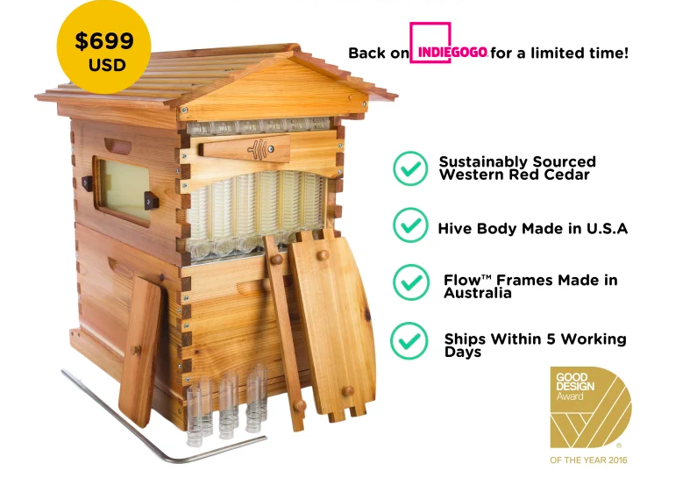
(Indiegogo, no date)

XXX’s campaign on Indiegogo gained an enormous success for being one of the most crowdfunded campaigns, funds equal to $13,288,350 were raised in 2015. Since their remarkable achievement on Indiegogo, the company has begun to operate at a large scale, providing their products to North America, Australia and Europe (Indiegogo, no date).

Since XXX’s launch, the company has started conducting business in an ethical and sustainable manner, which is emphasised in the next paragraphs of the report through the use of the Russian Doll Model of Sustainability. In this way, XXX has inspired many beekeepers, arising their interest in pollinators and their vital role in the natural world. In order to understand the ethical principles of the honey industry, the Ethical Business Circles Model outlines challenges and opportunities below.

- Evaluation of Company’s Industry & Campaign
  - Business Ethics Justification
Contextualising XXX into the concept of Business Ethics, implies the study the business situations, activities and decisions where issues of right or wrong are addressed (Matten & Crane, 2010). XXX’s ethical behaviour stands on its primary responsibilities of supporting beekeeping and raising awareness of how important bees are for humans, thanks to pollinating services that sustain flowering and agricultural plant species.

  - Assessment of “XXX’s” Industry
XXX operates within the honey industry, which is one of the most lucrative world industries. In 2016, $2.2 billion worth of export sales was generated, which has seen an increase of 27% from all exporting countries since 2012 (Workman, 2017).
A further industry’s assessment is presented in the appendices section (please see appendix 1, pp. 24-25).

    - Ethical Business Circles – Mahoney (2003)
A useful model that helps identify the non-ethical areas and wrongdoings of a business, is the Ethical Business Circles of Mahoney (2003). Additional explanation of the model is found in the appendices section (please see appendix 2, p. 26).
This model is more commonly used to assess businesses’ activities, nevertheless it has taken into account to evaluate the honey industry. In view of two of the circles of Mahoney’s model, analysis is provided to investigate how the honey industry deals with customer relations and marketing and how it affects local communities and environment.

    - “Customer Relations and Marketing” Layer
The customer relations and marketing layer looks at trends of European consumers when purchasing honey. Consumers are nowadays more driven towards low-calorie products and healthy alternatives for being more mentally concerned about their health, because of obesity levels on rise. Along with low-calories products, consumers are very interested in products with health benefits, such as raw sugar and honey, 25% of which is being consumed in food and beverages (Ministry of Foreign Affairs, 2016).

In recent years, media played an essential role for making consumers more conscious on the negative effects and nature of GMOs (genetically modified organisms). Pesticides and herbicides used to grow crops contain GMOs that are killing the honey bees’ population and are negatively impacting the supply of domestic honey. Thus, importers require GMO-free certification when they purchase honey (Ministry of Foreign Affairs, 2016). Other challenges and opportunities of the honey market are presented in table 1.

Table 1. Challenges & Opportunities of Honey Market
Challenges | Opportunities
- Disappearance of honeybees because of a colony collapse disorder associated with chemicals poisoning (Peta, no date).  - Decline in honeybees and honey production due to contaminated pollen collected from the European fields by honeybees. 17 toxic pesticides can currently be detected in pollen, which are produced by agrochemical industries, like Bayer based in Germany (Greenpeace, 2014) | - European customers prefer to purchase local, fair-trade or organic certified products, which have widely spread in Germany, France and UK (Ministry of Foreign Affairs, 2016).
- Honey laundering, which consists in relabelling honey from one origin country to another to make the perceived quality more appealing to the buyer. In 2011, Chinese honey was shipped to Europe and U.S and re-labelled before entering both nations (Ministry of Foreign Affairs, 2016) | - European buyers constantly test imported honey to verify whether it has been laundered (Ministry of Foreign Affairs, 2016).

    - “The Company and the Community” Layer
The company and the community layer looks at how beekeeping practices and local production of honey sustain local and rural communities. Local honey production supports independent local farmers with the improvement of skills and knowledge, generation of income, creation of more work opportunities and social benefits. Starting from the enhancement of local skills and knowledge, introduction of beekeeping and honey production as a business, have hugely enhanced pre-existing skills of local people, as well as their abilities of small-scale farmers. Building small enterprises assure the creation of more job opportunities for local people, including the advancement of techniques and equipment in the locality (Bradbear, 2009). A good example is FARM-Africa, an innovative charity that helps local farmers start up new sustainable ventures by introducing new technologies. A further discussion is highlighted in the appendices section (please see appendix 3, p. 27).

Honey production and beekeeping practices in local communities guarantee the generation of income from trading honey, which requires few inputs, has a good cash value associated with weight and bulk and is a non-perishable resource, if appropriately extracted and processed (Bradbear, 2009). Furthermore, beekeeping reinforces social benefits when farmers form associations during harvest times, encouraging tight working relationships within local communities and benefits of social harmony (Hilmi, Bradbear & Mejia, 2011). Challenges and opportunities of the honey domestic production are presented in table 2.

Table 2. Challenges & Opportunities of Domestic Production
Challenges | Opportunities
- Shortage of honey domestic production attracts international and cheaper imports, that lead to a market share loss for local producers and upward pricing. In addition, local producers can be victim to high degree of competition and a lack of research capacity because of high costs (Ministry of Foreign Affairs, 2015). | - To assist small local businesses in this sector, there are legislative measures in place such as Honey Standards in terms of Regulation 2000, Agricultural Standards Act 1990, other Regulations concerning honey’s packing, grading and marking (Agriculture News, 2017).  - The European market has opened up more opportunities for new entrants. In this way, suppliers from developing countries have the opportunity to enter the European market (Ministry of Foreign Affairs, 2015).

  - Evaluation of “XXX’s” Campaign
XXX’s mission, “Harvesting honey is so much easier for the beekeeper, and so much easier on the bees” reflects on the innovative beekeeping practices being less intrusive and damaging (Indiegogo, no date). Their campaign on Indiegogo, named as: “XXX: Honey on Tap Directly From Your Beehive”, demonstrated to be the most successful campaign with $16 million raised and 20,000 products ordered from more than 140 countries at the end of the campaign in 2015 (Indiegogo, no date). Pictures, links to video and other material of the Indiegogo campaign can be found in the appendices section (please see appendix 4, pp. 28-30). Their extraordinary success led to the establishment of three factories in Brisbane, Portland and Oregon with over 35 employees and additional six/seven warehouses around the globe (Hassall, 2016).

XXX established a business for a positive purpose which points towards a sustainable and responsible approach. But what is sustainability really about? The idea of sustainability was defined by the World Commission on Environment and Development as a concept of sustainable development, stating that sustainable development is: “Development that meets the needs of the present without compromising the ability of future generations to meet their own needs” (Brundtland Commission, 1987, para. 3).

A theory, how sustainability should be achieved, is explained by Levett’s sustainability model “Russian Doll Model of Sustainability”, shown in figure 2. The model is formed by three core elements embedded into each other, economy, society and environment. Environment is the most important element, but if it gets damaged, sustainability may not be attained because of life’s endangerment or extinction. Economy and society come after, as they are not seen as essential states for survival. The model is also associated with environmental preservation to build a strong foundation on the nature of sustainability (Levett, 1998).

Figure 2. The Russian Doll Model of Sustainability

(Adapted from Levett, 1998)

    - Environmental Aspect
Using the “Russian Doll Model of Sustainability” for XXX, the environmental element is strongly highlighted in the website and Indiegogo campaign. XXX uses raw materials for its products and limits waste by reusing timber panels and offcuts that have not been used in manufacturing. The XXX Pollinator House is the result of these unutilised resources, in order to reduce the carbon footprint and waste (XXX, no date). This is a good example of circular economy, which is explained in more details in the appendices section (please see appendix 5, p. 31).

In terms of materials used for the production of hives, Western Red Cedar is a sustainable type of wood sourced in North America. They also use Araucaria hoop pine to produce the Araucarian timber, as well as some of the hives and brood boxes (XXX, no date).

They use certified organic cotton in line with the standards of Global Organic Textile for beekeeping suits for adults and children, mesh veils and caps. (XXX, no date). Pictures of Pollinator House, products made from Western Red Cedar and Araucaria hoop pine, as well as organic cotton suits can be found in the appendices section (please see appendix 6, p. 32).

Although they strongly promote their products as made from sustainable sources, plastic is used to manufacture the XXX frames, which is not the healthiest solution for bees for the plastic’s property to off-gas and its derived problems to the environment.

    - Social Aspect
In its campaign, XXX promotes the creation of a beekeepers’ community and education in the fundamental role of bees as pollinators of crops and plants. However, the company does not refer to its involvement in multiple projects that helped raise funds for needed communities. In the case of Nepal Earthquake and Vanuatu Cyclone, XXX partnered with Oxfam Australia to raise funds for communities affected by both natural disasters. Funds equal to $133,855 and $97,360 were raised respectively. Moreover, the company constantly works with charities for the Hunger Project, for which $30,850 have been donated for tools and infrastructures to those living in hunger. XXX has also established a Beekeeping Club Support Program that sustains local beekeeping clubs, associations and societies through donations and material, to make sure right practices and knowledge is transferred to new and existing beekeepers (XXX, no date).

    - Economic Aspect
From the Indiegogo campaign, XXX does not make any reference to the economic element. However, it is obvious that they have impacted the local economy in a positive way, by creating more than 30 local jobs in the Australian manufacturing industry. By creating new jobs, the Australian local economy has seen an enhancement in terms of economic revenue and employment opportunities for the local society. The company’s success could also attract major investors to the locality, in this way economic and social elements will see an overall improvement. This is a clear example of shared value where practices enhance the competitiveness of the company, meanwhile economic and social conditions advance simultaneously (Porter & Kramer, 2011).

- Sustainable Development Goals & Recommendations

  - Responsible Consumption and Production

In September 2015, United Nations elaborated a new sustainable development agenda with the scope of ending poverty, promoting the protection of the planet and ensuring wealth and set 17 Sustainable Development Goals that countries will have to achieve by 2030 (United Nations, no date).

Responsible Consumption and Production is one of the 17 Sustainable Development Goals (SDGs). This goal promotes a good efficiency of resources and energy by reducing pollution, degradation and use of resources, guaranteeing access to basic services, sustainable infrastructure, decent jobs, an improved quality of life and welfare profits from economic activities. It is in the businesses’ interest to understand environmental, social and economic impacts of their products or services. They should also suggest viable solutions that guide to a more sustainable world by improving individuals’ lifestyles and well-being (United Nations, no date).

XXX makes every effort to do business in a sustainable, ethical and reforming way by impacting positively their programs dedicated to the environmental conservation and community by manufacturing their products (XXX Hives, XXX Super, Brood Boxes and XXX Frames) using sustainable sources, like Western Red Cedar, Araucaria hoop pine and certified organic cotton. In spite of this, plastic is the component of the XXX frames and foundation, appreciated for its light weight, lower cost and its capability of not getting rotten. XXX claims to use a BPA-free plastic meaning that is not produced with bisphenol-S, but it is still plastic that off-gases in case of humidity, heating up and cooling down events (XXX, no date). Controversially to timber offcuts, that are reutilised for the production of pollinator houses, plastic cannot be reutilised, so it is more likely to become a source of landfill waste. Plastic in landfill is very polluting and is eaten by marine and land animals. Therefore, XXX should consider a more sustainable material or technique to replace their BPA-free plastic.

    - Recommendations
To move towards a more “natural beekeeping”, there a couple of options that XXX should consider in the future, such as replacing plastic in the beehives with wax foundation or use frames without foundation. The first option provides a better guidance for bees to build the right cell sizes desired by beekeepers, they are not very expensive and are made from recycled beeswax, however wax foundation contains a high quantity of pesticides which are not good for the bees. The second option involves the use of frames without foundation, these allow bees to build the right size of wax cells they need and combat mites, who make them grow healthier. Using frames without foundation, bees are not exposed to chemicals from plastics and beekeepers can save money and energy from their production. The only downside of this technique is that bees may not build straight wax cells, because of a lack of foundation, so beekeepers need to check more regularly (PerfectBee, 2016).
All elements considered, frames without foundation seem to be the most sustainable and natural practice for XXX. This would help the company lower the cost of XXX Hives and eliminate the plastic in their hives. In this way they would limit the use of resources, energy and reduce pollution, all elements promoted by the Responsible Consumption and Production Goal.
  - Climate Action
Climate Action, is also one of the 17 Sustainable Development Goals, requires immediate action to fight against climate change and its negative effects on national economies and lives. All forms of life are affected by climate change that causes rising sea levels, changing weather conditions and extreme weather events. Gas emissions are also considered to be the main driver of climate change. Renewable energy is a form of energy that could reduce gas emissions. To tackle climate change, the 2015 Paris Agreement was instituted, where all countries agreed to limit rising global warming to below 2 degrees. (United Nations, no date)

Businesses can address climate change by improving energy efficiency, lowering carbon footprint, investing in low-carbon or climate-smart products and setting reasonable emission targets. XXX, as a business, is particularly affected by climate change that is associated with the disappearance of honeybees, in fact it impacts pollination by unsettling the time flowers bloom with the time bees pollinate. Due to rising temperatures, flowers bloom earlier than expected, so when bees start pollinating do not find enough nectar. Therefore, there is a high danger that pollination declines together with a lack of resources and food for bees. However, by reducing carbon emissions, flowers and plants may slow down these rapid shifts (Memmott, Craze, Waser & Price, 2007). Further studies on the negative impacts of climate change are outlined in the appendices section (please see appendix 7, p. 33).

XXX Hive Classic is not fully ideal for rapid changes of temperature, which are most likely to happen with climate change. When temperatures drop below zero, hives can become very cold, so a possible risk is the crystallisation of honey, this would make the honey extraction impossible. Other concerns are related to starvation of bee colony, with cold temperatures bees do not forage, so it is imperative for them to have the hive full of honey for their food and to stay warm, otherwise they could risk to die.

    - Recommendations
A possible solution to keep the beehive always warm, is the installation of a solar ventilation, which is powered by a solar panel or a rechargeable battery with solar light. In the interior of the beehive there is an air fan which is controlled by a thermostat when the air temperature reaches its maximum limit. This ventilation also maintains good levels of temperature, humidity and carbon dioxide (Kviesis & Zacepins, 2015). This method uses clean and renewable energy that is a core principle of the Cradle To Cradle Design Framework highlighted in the appendices section (please see appendix 8, p. 34).

XXX, like many other beekeepers, should consider some initiatives to save the bees’ world from disappearing. The first element of consideration is the supply of a bee habitat by securing colony bees a place to live, including blocks of woods of various size containing some loose earth. Secondly, eliminating pesticides from beehives using organic and natural methods. Thirdly, seeding more plants as a constant source of food for bees. Leighton Buzzard is an excellent example of bee-friendly community. Another good example is how Sainsbury’s created a programme “Bee Happy”, based on the realisation of a sustainable habitat for bees (The Wildlife Trusts, no date). Further analysis for both cases can be found in in the appendices section (please see appendix 9, p. 35).

- Conclusions
  - Conclusion
Overall, this study showed that XXX’s ethical behaviour is focused on its primary responsibilities of supporting beekeeping, educating people in the importance of bees for the natural world and increasing beekeepers’ interest in the XXX Hive that facilitates the extraction of honey without hurting the bees.

Among the main findings of two of the layers of The Ethical Business Circles Model of Mahoney (2003), it was discovered that customers relations and marketing have particularly influenced decisions of consumers in purchasing honey, due to honey bees and honey production in decline, customers are more driven to buy organic and fair-trade honey. By investigating how local communities are affected by beekeeping and honey production, it was found that there is a shortage of honey domestic production that is attracting international and cheaper imports, in response to this, the European market has opened up more opportunities for new entrants from developing countries.

The study considered environmental, social and economic elements of the Russian Doll Model of Sustainability of Levett (1998) from which emerged that the company uses natural and environmentally-friendly resources, invests in charity projects for helping needed communities and fosters local economy by providing jobs to the Australian community. Although, XXX strongly promotes their products as made from sustainable sources, plastic is used to manufacture the XXX frames, which is not an environmentally-friendly source.
In order to understand which techniques XXX should use to improve its products and practices, two United Nations Sustainable Development Goals were examined. Based on Responsible Consumption and Product, XXX would have to replace plastic in the XXX Hives with a more natural technique, such as building their XXX frames without foundation to reduce the price of their product and become more environmentally-friendly. Concentrating on Climate Action, XXX would have to make their hives more adaptable to rapid changes of temperature due to climate change, by installing a solar ventilation, in order to keep the beehive at an adequate temperature.

- References
  - References list
Agriculture News. (2017). The decrease in honey production and its impact on local producers and consumers. Retrieved 10th December, 2017, from http://www.bizcommunity.com/Article/196/358/166052.html
Benton, D., Hazell, J. & Hill, J. (2015). The Guide to the Circular Economy: Capturing Value and Managing Material Risk. London: DoSustainability.
Bradbear, N. (2009). Bees and their role in forest livelihoods. Rome: Food and Agriculture Organization of the United Nations.
Brundtland Commission. (1987). Report of the World Commission on Environment and Development: Our Common Future. Retrieved from http://www.un-documents.net/our-common-future.pdf
Crane, A. & Matten, D. (2010). Business ethics: managing corporate citizenship and sustainability in the age of globalization (3rd ed.). Oxford: Oxford University Press.
FarmAfrica. (no date). Sweetening the Pot. Retrieved from: https://www.farmafrica.org/us/downloads/resources/Beekeeping-Case-Study.pdf
XXX. (no date). XXX Frame, So how does it work?. Retrieved 18th December, 2017, from https://XXXXXXXXXXXXXXXXXXXXXXXXXXXXXXXXXXXXX
XXX. (no date). XXX Story. Retrieved 17th December, 2017, from https://XXXXXXXXXXXXXXXXXXXXXXXXXXXXXXXXXXXXXXXXX
XXX. (no date). Sustainability at XXX. Retrieved 5th December, 2017, from https://XXXXXXXXXXXXXXXXXXXXXXXXXXXXXXXXXXXX
XXX. (no date). The XXX on Effect. Retrieved 20th December, 2017, from https://XXXXXXXXXXXXXXXXXXXXXXXXXXXXXXXXXXXX
Greenpeace. (2014). The Bees´ Burden New Greenpeace report reveals pollen collected by bees contaminated with a cocktail of toxic pesticides. Retrieved from 9th December, 2017, from https://www.greenpeace.org.uk/press-releases/bees-burden-new-greenpeace-report-reveals-pollen-collected-bees-contaminated-cocktail-toxic-pesticides-2014/
Hassall, G. (2016). XXX Hive: Cedar and Stuart Anderson talk about life one year after crowdfunding success. Retrieved from 20th December, 2017, from http://www.abc.net.au/news/2016-09-12/XXXXXXXXXXXXXXXXXXXXXXXXXXXXXXXXXXXXXXXXXXXX
Hilmi, M., Bradbear, N. & Mejia, D. (2011). Beekeeping and Sustainable Livelihoods (2nd ed.). Rome: Food and Agriculture Organization of the United Nations.
Indiegogo. (no date). XXX: Honey on Tap Directly From Your Beehive. Retrieved 20th December, 2017, from https://XXXXXXXXXXXXXXXXXXXXXXXXXXXXXXXXXXXXXXXXXXXX
Kviesis, A. & Zacepins, A. (2015). System Architectures for Real-time Bee Colony Temperature Monitoring. Procedia Computer Science, 43, 86-94. doi: https://doi.org/10.1016/j.procs.2014.12.012
Le Conte, Y. & Navayas, M. (2008). Climate change: Impact on honey bee populations and diseases. Revue scientifique et technique (International Office of Epizootics), 27(2), 499-510.
Levett, R. (1998). Sustainability Indicators – Integrating Quality of Life and Environmental Protection. Journal of the Royal Statistic Society, 161(3), 291-302.
Mahoney, J. (2003). Ethical Business Circles Model [Figure]. In Management and Organisational Behaviour (6th ed.). London: Financial Times.
McDonough, W. & Braungart, M. (2002). Cradle to Cradle: Remaking the Way We Make Things (1st ed.). New York: North Point Press.
Memmott, J., Craze, P. G., Waser, N. M. & Price, M. V. (2007). Global warming and the disruption of plant-pollinator interactions. Ecology Letters, 10(8), 710-717. doi: 10.1111/j.1461-0248.2007.01061
Ministry of Foreign Affairs. (2015). What competition do you face on the European honey market? Retrieved 8th December, 2017, from https://www.cbi.eu/market-information/honey-sweeteners/competition/
Ministry of Foreign Affairs. (2016). What is the demand for honey in Europe? Retrieved 16th December, 2017, from https://www.cbi.eu/market-information/honey-sweeteners/trade-statistics/#
Ministry of Foreign Affairs. (2016). Which trends offer opportunities on the European honey market? Retrieved 20th December, 2017, from https://www.cbi.eu/market-information/honey-sweeteners/trends/
PerfectBee. (2016). Foundation or Foundationless Beekeeping? Retrieved 28th December, 2017, from https://www.perfectbee.com/your-beehive/beehives-and-accessories/foundation-or-foundationless/
Peta. (no date). The Honey Industry. Retrieved 12th December, 2017, from https://www.peta.org/issues/animals-used-for-food/animals-used-food-factsheets/honey-factory-farmed-bees/
Porter, M. E. & Kramer, M. R. (2011). Creating Shared Value. Harvard Business Review, 89(1-2), 62-67.
The Wildlife Trusts. (no date). Case Study: Leighton Buzzard. Retrieved from: http://www.wildlifetrusts.org/sites/default/files/leighton_buzzard_case_study.pdf
The Wildlife Trusts. (no date). Case Study: Sainsbury’s. Retrieved from: http://www.wildlifetrusts.org/sites/default/files/sainsburys_case_study.pdf
United Nations. (no date). Goal 12: Ensure sustainable consumption and production patterns. Retrieved 15th December, 2017, from http://www.un.org/sustainabledevelopment/sustainable-consumption-production/
United Nations. (no date). Goal 13: Take urgent action to combat climate change and its impacts. Retrieved 15th December, 2017, from http://www.un.org/sustainabledevelopment/climate-change-2/
United Nations. (no date). Sustainable Development Goals. Retrieved 14th December, 2017, from http://www.un.org/sustainabledevelopment/sustainable-development-goals/
Workman, D. (2017). Natural Honey Exports by Country. Retrieved 11th December, 2017, from http://www.worldstopexports.com/natural-honey-exporters/

- Appendices
  - Appendix 1 – Honey Industry’s Assessment
After New Zealand, Europe is the second largest world producer of honey. European imports have seen a steady increase over the last few years, 339,000 tonnes of honey were imported in 2015. As illustrated in figure 1, Germany was the leading importer with 88,000 tonnes in 2015, followed by UK, France, Belgium and Spain (Ministry of Foreign Affairs, 2016).

Figure 1. European Honey Importers
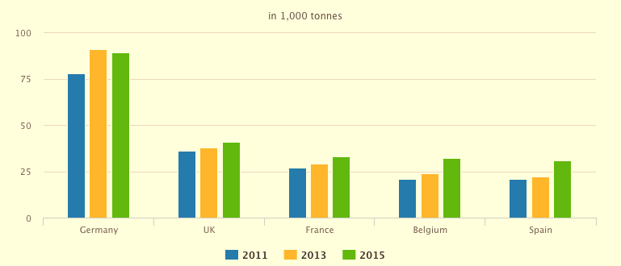

(Adapted from Ministry of Foreign Affairs, 2016)

As shown in figure 2, in 2015, China was the major supplier to the European market with over 98,000 tonnes of honey supplied, due to low labour costs. Other main suppliers were Mexico, Belgium, Ukraine and Germany (Ministry of Foreign Affairs, 2016).
Figure 2. Honey Suppliers to Europe
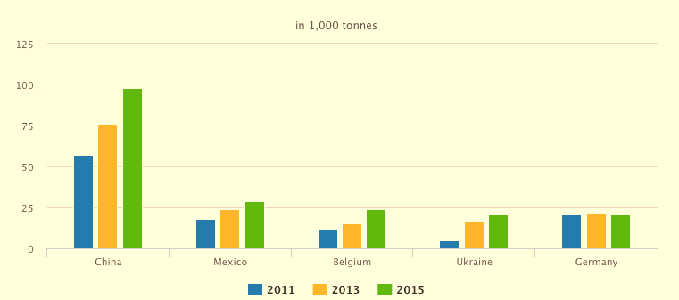

(Adapted from Ministry of Foreign Affairs, 2016)

  - Appendix 2 – Ethical Business Circles - Mahoney (2003)
The Ethical Business Circles of Mahoney (2003) focuses on the occurring businesses activities within various circles that move out from the centre, these are: inside the company, customer relations and marketing, relations with other companies, the company and the community. As illustrated in figure 3, the inmost circle represents inside the company, which regards the way employees and colleagues are treated with respect to the notions of discrimination, loyalty and confidentiality. Moving out from the core of the model, the second circle considers the ethical principles affecting customer relations and marketing and is concerned with advertisement of goods, services and pricing strategies. The third circle regards the relationships of the business with other companies, dealing with the ethical elements of acquisitions, payments with suppliers and potential mistreatments of suppliers’ labour force. The most external circle focuses on how the company operates in relation to the location is based at, looking at factors like environment protection, promotion of cultural diversity, avoidance of bribery, development and help to the community (Mahoney, 2003).

Figure 3. Ethical Business Circles - Mahoney (2003)
(Adapted from Mahoney, 2003)
  - Appendix 3 – FARM-Africa Case Study
FARM-Africa is working to boost forest-based livelihoods and preserve natural forests. As part of Bale Eco-Region Sustainable Management Programme, FARM-Africa supports local beekeepers by providing means of livelihood’s diversification and managing forest resources sustainably. They train local people in the construction of innovative beehives that are easier to manage, less expensive and require less skills than European beehives. An example of beehive is shown in figure 4.

FARM-Africa commits very hard to the empowerment of African women supporting them in building credit groups that permit to earn money to maintain their families.

Figure 4. Top-Bar Hive
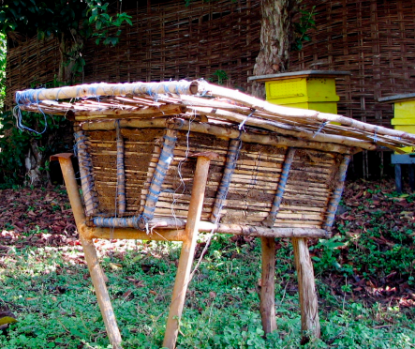
FarmAfrica (no date)

  - Appendix 4 – Evaluation of XXX’s Campaign
Figure 5. XXX’s Video
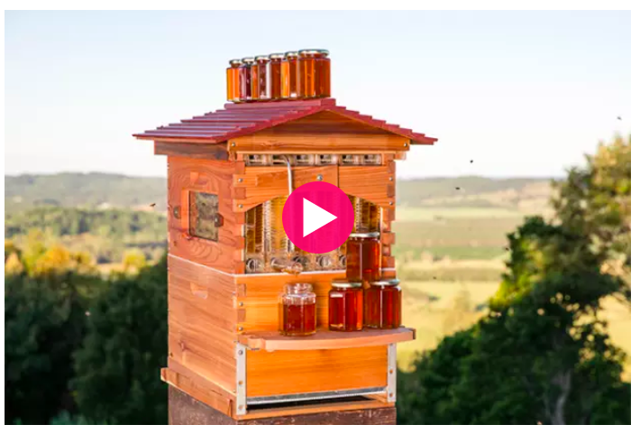
Please follow this link: https://XXXXXXXXXXXXXXXXXXXXXXXXXXX
(Indiegogo, no date)
Figure 6. How XXX Hive Works
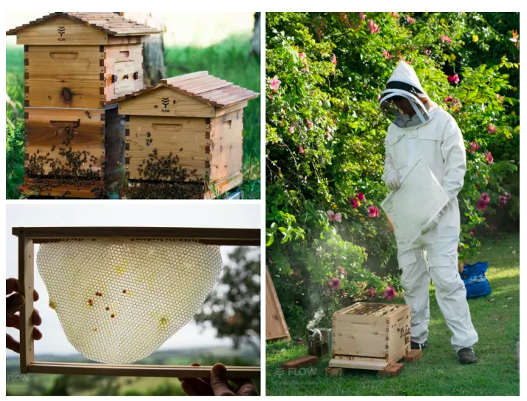
(Indiegogo, no date)
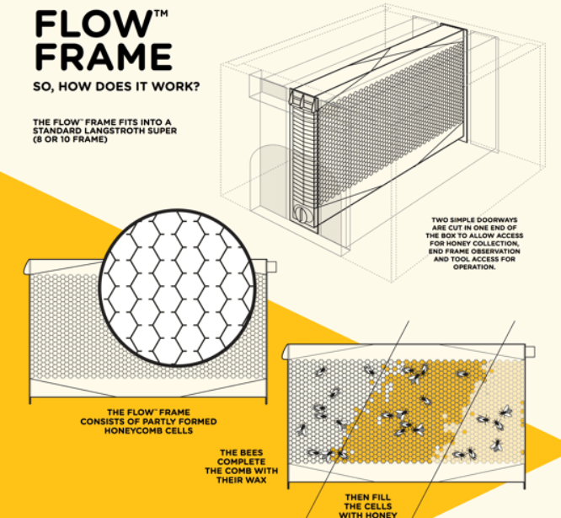
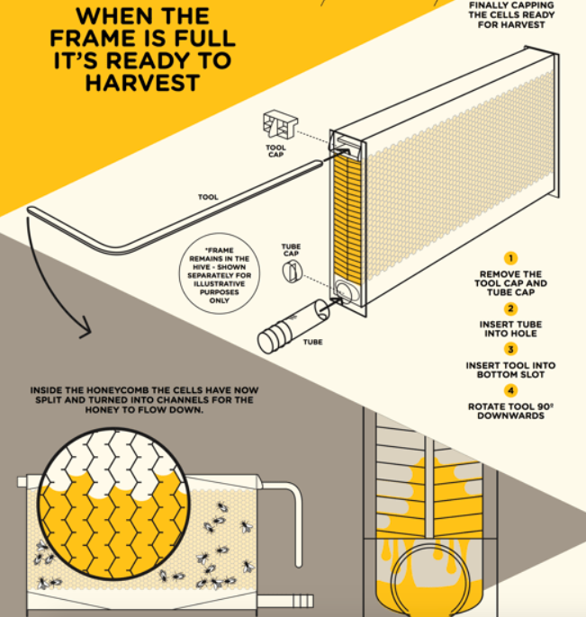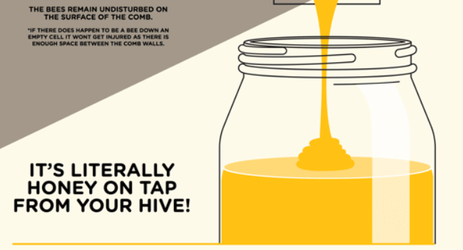
(Indiegogo, no date)
Figure 7. Facebook Page
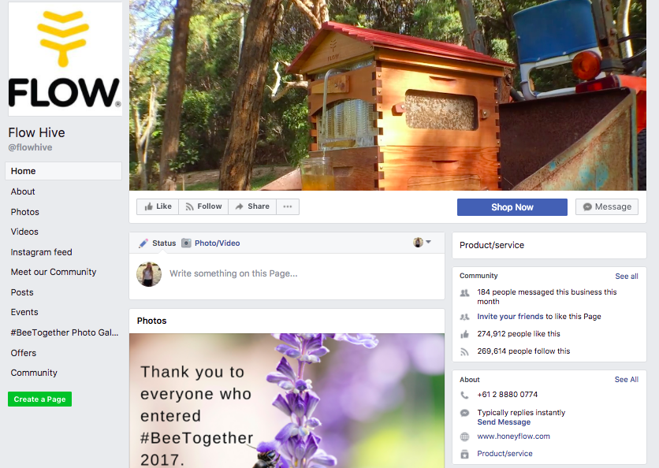
Figure 8. Twitter Page
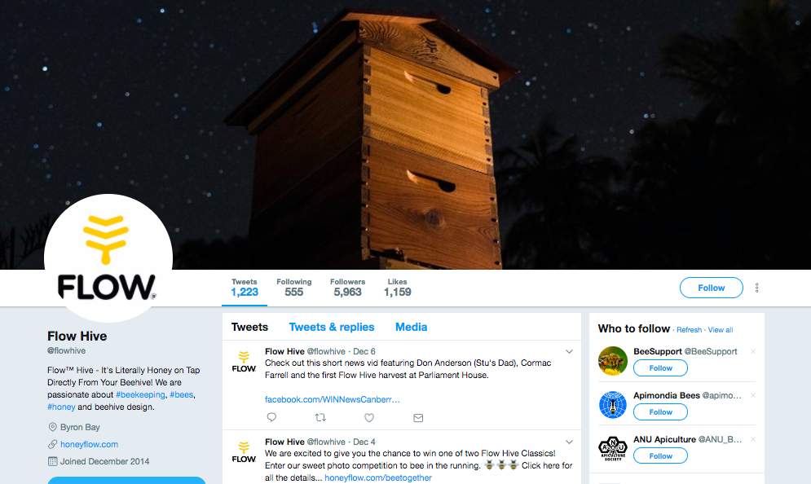
  - Appendix 5 – Circular Economy Model
The circular economy is an alternative to the linear economy, it is based on the three main concepts of RETAKE, REMAKE and RESTORE. The circular economy model states that resources should be use for a longer period of time and extract their value while they are still usable. When their life ends, then products or materials should be recovered and regenerated to produce new products. This model addresses waste problems, scarcity of resources and environmental impact (Benton, Hazell & Julie, 2015).

Figure 9. The Circular Economy Model
(Adapted from Benton, Hazell & Julie, 2015)

XXX has put in action the concept of circular economy in the production of the Pollinator Houses, in fact to reduce waste they repurpose unused resources, such as Western Red Cedar timber offcuts, unused panels and bamboo coming from the manufacturing warehouse. Their idea of reducing the environmental footprint turned into the creation of XXX Pollinator Houses to host pollinators (XXX, no date).

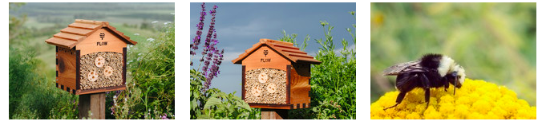
  - Appendix 6 – Sustainability at XXX
Figure 10. XXX Pollinator House
(XXX, no date)

Figure 11. Western Red Cedar & Araucaria Hoop Pine Products
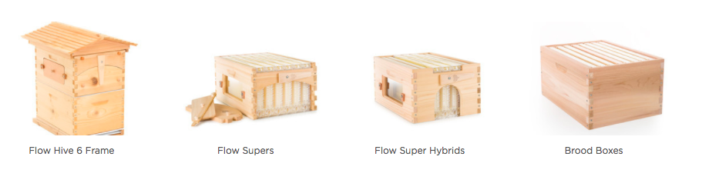(XXX, no date)

Figure 12. Organic Cotton Suits
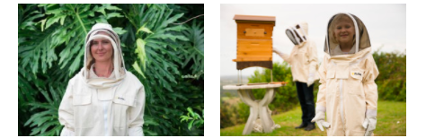
(XXX, no date)
  - Appendix 7 – Studies on Climate Change
It is proven that climate change can have a negative effect on bees concerning their behaviour and distribution. The European honey bees have naturally developed an adaptation to hot environments and deserts, however climate change are making these environments even hotter and drier, leading to the disappearance of honey bees because of their inability to migrate to more climate favourable areas. A major effect on honey bees is the change in distribution of flower and plant species, which honey bees depend nectar and pollen on. For instance, heavy rain leads acacia flowers to dilute too much nectar, making them unattractive to bees. On the other side, if the weather is too dry, certain species of flowers are unable to produce nectar indispensable for bees to harvest. Global warming is therefore guiding honeybees outside their current distribution range (Le Conte & Navajas, 2008).

  - Appendix 8 – Cradle to Cradle Design Framework
The Framework is characterised by three principles. Starting from the first principle, everything is resource for something else meaning that it can be disassembled and can return to soil or can be re-utilised in the production of other materials. XXX applies the first principle with unused materials to produce the Pollinator House (McDonough & Braungart, 2002).

The second principle states to use clean and renewable energy, such as solar, wind, gravitational and geothermal energy to support human activities and environmental health. XXX has potential of achieving this by implementing solar ventilation powered by solar energy in the beehives (McDonough & Braungart, 2002).

The final principle promotes diversity, including economic, social, cultural values and eco-systems. Overconsumption and waste can damage land, which is not a renewable resource. For XXX, replacing their use of plastic with other materials or techniques, can represent a step ahead in promoting diversity (McDonough & Braungart, 2002).

Figure 13. Cradle to Cradle Design Framework

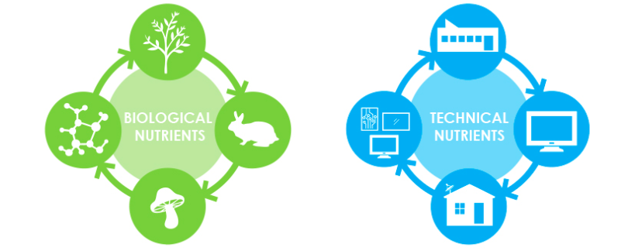
(McDonough & Braungart, 2002)
  - Appendix 9 – Leighton Buzzard & Sainsbury’s Case Studies

Leighton Linslade is a town that built a bees’ conservation work in 2012. It set up a campaign “Keep the Buzz in Leighton Buzzard” supported by the council and Greensand Trust. The campaign was dedicated to the transformation of eight sites across the town with pollinator-friendly plants and a wildflower area. They also created a permaculture garden with organic vegetables and bee-friendly flowers, to assist the works, students were involved to encourage their learning about pollinators. In 2013, the town received a bee-friendly town award and in 2014 the council partnered with Wildlife Trusts to train the council’s members on biodiversity management.
(The Wildlife Trusts, no date)
Leighton Buzzard

Sainsbury’s
In the last few years, Sainsbury’s established a programme, called “Happy Bee” and it has been working for the creation of bee-friendly and sustainable habitats with suppliers, customers and staff. In order to increase the availability of nest sites for solitary bees, it instituted a network of “Bee Hotels” (space for solitary bees made from juice cartons) with a real beekeeper that maintains the network. Another initiative was to share expertise about pollinators with schools and students by inspiring them to build their bee habitats. By 2020, Sainsbury’s would like to be the largest “Bee Hotels” owner.
(The Wildlife Trusts, no date)

