Name: Samuel Darragh
Institution: The University of Bath
Level: Postgraduate Masters
Title: An ethical evaluation of the corporate decision to construct an oil pipeline
Word count excluding summary, references, and appendices: 2602

Executive Summary
This paper investigates the corporate decision to construct an oil pipeline running from North Dakota to Illinois in 2017. Concerns surrounding the sustainability of the project, namely social and environmental considerations, called into question the business ethics of the development. Many commentators argued that the project itself was unlawful and amoral. This paper analysis the pipeline through a utilitarian lens in attempt to justify whether the pipeline can be deemed ethical. The paper focuses on social issues, environmental issues and future considerations. Social issues included the route of the pipeline and the rights of indigenous populations; environmental issues included again the route with particular insight to Lake Oahe; future considerations included the implications to future generations. In summary, the paper found the pipeline from utilitarian perspective unethical. Limitations of the findings of the investigation are also considered at the end of the paper.

“In one day, our sacred land has been turned into hollow ground” stated Archambault, tribal chief, to describe events at Standing Rock (Garcia, 2016). This time however it is not General George A. Custer and his 7th Cavalry, but large corporations, and their associates.
One of these corporations, established in 1995 and headquartered in Dallas, Texas, is a natural gas and propane company whose total revenues exceeded US$ 9 billion in December 2016 and are forecast to triple to approximately US$ 28 billion in 2017 (Financial Times, 2017). The corporation is the parent company of the firm responsible for the development of the controversial 1,172-mile, 12-30-inches diameter pipeline (USFWS, 2016) running from North Dakota to Illinois.
Figure 1: Transporting oil by pipeline the most economically viable method (Philips, 2016)
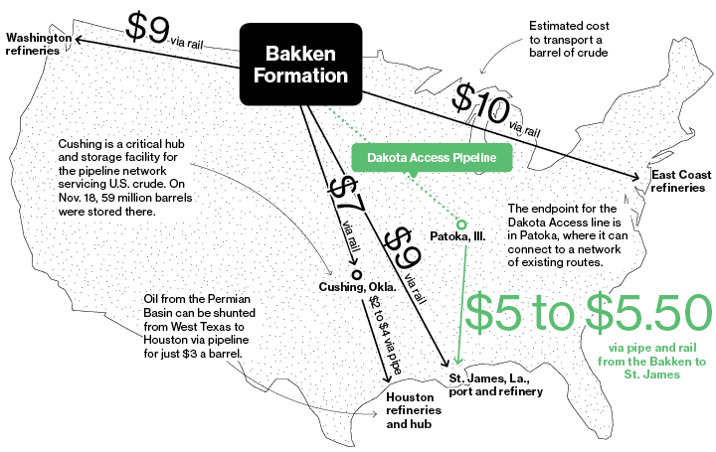

Many argue the decision by the corporation to construct the pipeline was principally, if not solely, economic, given that it is predicted the least expensive means of transporting oil (figure 1). At operating level, the pipeline is expected to carry “470,000 barrels per day, at a rate of $8 per barrel, [meaning] the company should gross about $1.37 billion per year” (Thompson, 2016). The project’s completion in June 2017 was attributed to significant U.S. Government abutment in ensuring its accomplishment (Wong & Levin, 2017). The bakken shale oil contributes towards Government objectives to attain resource securities, wane dependency off foreign reserves, and reach salient domestic energy demands. The American Petroleum Institute estimated the construction of 1,200 miles of pipeline “every year for the next two decades” (Nemec, 2017, pg20) a prerequisite to accommodate for rising domestic energy demand. In this regard, given the oil would serve the national interest (Trump, 2017), the bakken shale was coming out the ground one way or another.
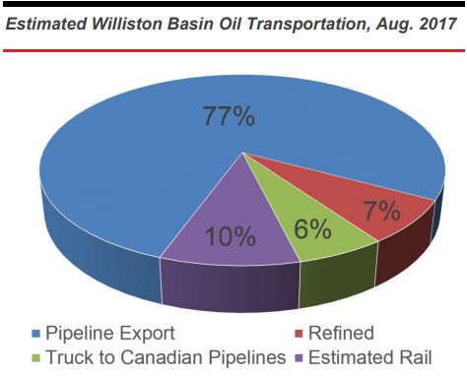
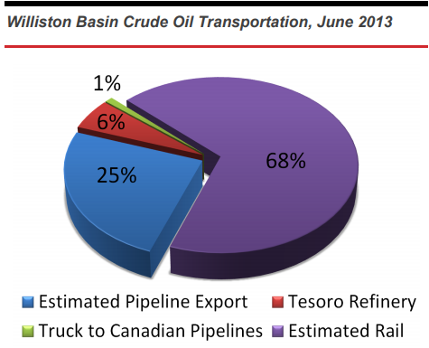
Figure 2: Methods of oil transportation between 2013-17 (Kringstad, 2013; 2017)

This investigation will assess the ethics of the decision by the corporation to construct a pipeline, and its implemented route, to transport North Dakota bakken shale oil across four states. Although we have identified the pipeline can be justified financially as a means of transporting oil (figure 1) in comparison to alternative methods (figure 2), this paper will examine if the decision can also be justified ethically.
In analysing the ethics of the pipeline, a utilitarian lens will frame debate throughout. Utilitarianism, influenced by the works of Bentham and Stuart-Mill is essentially founded on a greatest happiness principle, a philosophy that exempts beings “as far as possible from pain, and as rich as possible in enjoyments, both in point of quantity and quality” (Mill, 1863, pg17). Unlike egoism which assumes the pursuit of self-interest will lead to desirable outcomes for the majority (Smith, 1776), utilitarianism attempts to measure the “collective welfare that is produced by a certain decision” (Crane & Matten, 2016, pg98) to justify its morality. Using this consequential model, this paper will conclude with a pleasure-pain analysis, evaluating the impacts of the pipeline, to investigate whether the development can be considered ethical.
The initial proposed-route for the pipeline ran in close proximity to the city of Bismarck, North Dakota, (reference removed for confidentiality reasons) where the local community and regulators voiced concerns regarding potential adversity to drinking water in the event of pipeline spill. In response the corporation diverted the route away from Bismarck to avoid potential deterioration to the wellbeing of the residents, which could be perceived as morally responsible. However, the proposed and approved new route navigated through disputed Sioux territory which attracted unprecedented universal protest.
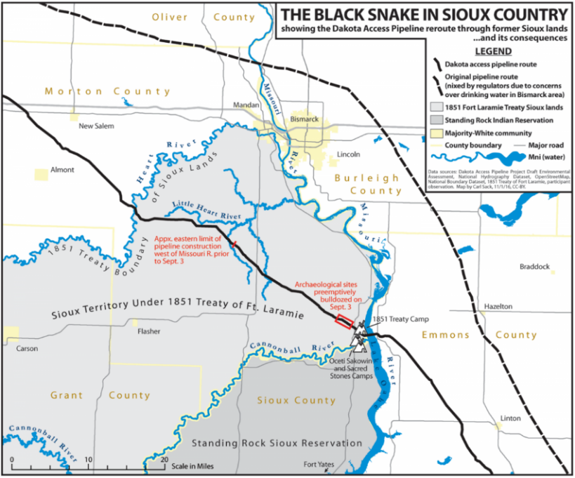
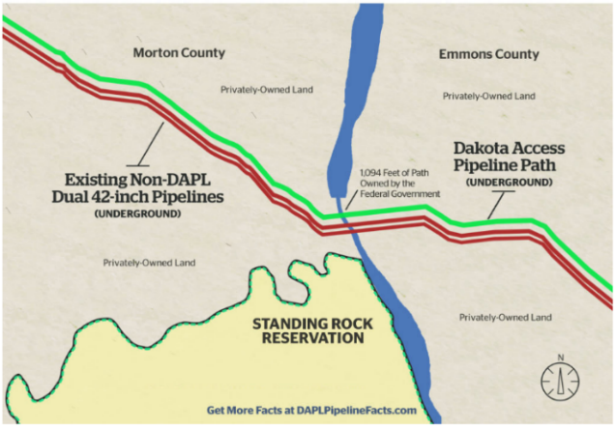
Figure 3: The pipeline route: Left (Sack, 2016) Right (reference removed for confidentiality reasons)

The Treaty of Fort Laramie (TFL) signed in 1851 established territorial claims between the native tribes and the United States Government in an attempt to end confrontations among the parties. The treaty was revised in 1868 in which the U.S. Government ceded land (the Black Hills and rights in Montana, South Dakota and Wyoming) to the Sioux nation. Historians argue the treaty was breached shortly after its inauguration through a mixture of inter-tribal disputes and skirmishes, violating the treaty and its credibility (Dorst, 1999). Consequently, the corporation assert the TFL annulled and therefore state the claim by protestors the pipeline runs through Sioux territory a “myth”, since it circumvents the standing rock reservation (figure 3). Despite the case made by historians, there remains a strong sentiment that the landed claims (Akhtar, 2011) and hunting rights (Hoffmann, 2017) outlined in the 1868 treaty remain valid and offer perspective the pipeline is amoral given it erodes the wellbeing of the “land’s rightful owners” (Wade & Scheyder, 2016).
Ethical assessment of this scenario is troublesome, given that utilitarian theory includes “not solely the pursuit of happiness, but the prevention or mitigation of unhappiness” (Mill, 1863, pg18). In assuming the pipeline was constructed along the “safest” route, and the TFL annulled, the corporation’s compliance with protestors resulting in another pipeline diversion could have led to a suboptimal route in comparison to the former. This may have presented a greater quantity and severity of pains to the collective which would be amoral from utilitarian perspective. On the other hand, if the TFL was proven to still be honourable, the pipeline is amoral because it nullifies an agreement designed to protect an indigenous way of life.
There remains utilitarian thought that when individuals surrender their rights to the state, who is best-positioned to act in the interests of the majority, collective wellbeing is enhanced (Rousseau, 1762) (Hobbes, 1651). In this regard, we could argue that the decision by the U.S. Government to sanction the pipeline, and ignore the interests of indigenous groups, was moral because the state perceived it as a positive outcome for the majority. On the contrary we could argue whether Rousseau and Hobbes utilitarian school of thought is applicable in this circumstance. For instance, there remains valid concern whether the state’s decision to approve the pipeline may have been susceptible to bias, given the state was a prime beneficiary to its implementation.
There is no doubt the pipeline will provide economic benefits which will improve the financial wellbeing of many in the local and wider community (appendix 2). However, utilitarian scholars note that “longer-term consequences of actions are as important as the immediately pleasing consequences of actions” (Fieser, 2001, pg193) and to this end there lies concern for those involved in the construction of the pipeline. Benhabib and Spiegel argue an educated workforce “is better at creating, implementing, and adopting new technologies, thereby generating growth” (Benhabib & Spiegel, 1994, pg144). The pipeline may stunt potential growth given that young workers will leave, or never attend, further education influenced by the attractive high-salaries in the shale boom industry (Rickman, et al., 2017). Concerns are magnified when despite the thousands involved in constructing the pipeline, only forty persons will be employed when fully operational (Saha, 2016).
In this circumstance, although there are initial economic ‘pleasures’ for the local communities during the construction phase, long-term economic ‘pleasures’ of implementing the pipeline would seem to solely reward the corporation and forty workers. While operational tax-related spill-overs will continue to indirectly benefit the collective, the severity of employment-unsustainability casts doubt over the ethics of this perceived social benefit.
There is also a vast array of environmental concerns associated to the pipeline. Despite the “559 meetings with community leaders, local officials and groups to hear concerns and fine-tune the route [and asking and receiving] a tougher federal permitting process at sites along the Missouri River” (McCoy, 2017, pg2), environmentalists argue the pipeline still runs hazardously close to waterways (Levin, 2017).
Lake Oahe (appendix 3), the fourth-largest reservoir in the U.S. by volume, is a substantial source of the debate given the value the lake contributes to the surrounding area (appendix 4, 5). Under the Obama administration the Army Corps of Engineers revoked pipeline “construction beneath Lake Oahe, saying an alternative route needed to be considered” (Pipeline & Gas Journal: Staff Report, 2017, pg25), a decision which would be reversed and spurred on with easement under President-Elect Trump and an anti-environmentalist sentiment.

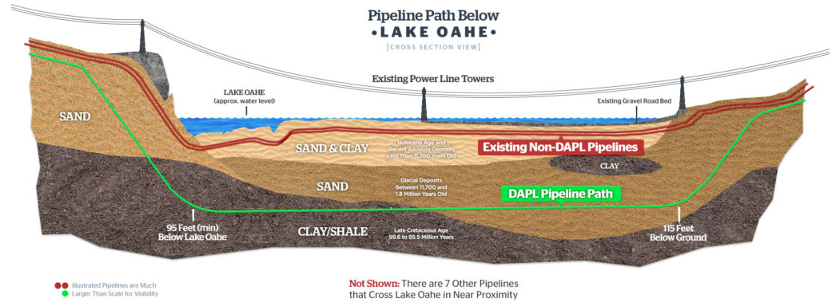
Figure 4: Pipelines under Lake Oahe (reference removed for confidentiality reasons)

Advocates of the project note that competitor’s pipelines already exist under the lake and because the pipeline in question runs significantly deep to meet strict environmental standards (figure 5), degradation to “water quality or the environment is negligible, if it exists at all” (Investors Business Daily, 2016). Environmentalists could state this argument a social-weighting ethical rationalization attempt to mitigate criticism through justification that ‘others are worse than we are’. In addition, although there may be negligible effects to water quality, there are several other water related stresses that are created or enhanced as a direct result of the pipeline (appendix 6). This adds concern to the wellbeing of those that directly rely on the water in the region. Given utilitarian philosophy aims to maximise welfare for all beings (Visak, et al., 2011), pipeline outcomes should further account for the wellbeing of animals and plants whose concerns are often marginalised.
On the contrary, supporters argue that the pipeline is a safer alternative (USFWS, 2016) to transporting via rail and would lead to less trains hauling oil (Horn & Mikulka, 2017). In this regard the pipeline would in fact lessen ecological pains and improve wellbeing. However, the degree of factuality to these claims remains uncertain given in 2015 there were 252 pipeline spills versus 44 for the rail industry reported to the Pipeline and Hazardous Materials Administration (Hampton, 2016), and that the Sierra Club discovered no evidence that the pipeline will reduce rail shipments of oil (Sierra Club Iowa Chapter, 2016). Subsequently we could argue that the corporation’s decision to allegedly fabricate claims to promote pipeline implementation is amoral as it restrains public freedom (Bentham, 1789) to make informed and credible assessment from information presented.
On 6th April 2017 prior to being fully operational the pipeline experienced the first documented spill, 84 gallons of crude oil at a South Dakota pump station (Levin, 2017). In Ackerman’s report he notes that once the pipeline is fully operational, there would be accidental releases of 4,000 barrels of oil and total accident-related costs of $15 million every year (Ackerman & Knight, 2017) based on the current U.S. pipeline averages. Utilitarian thought could interpret the environmental pains justifiable in presence of greater economic pleasures as the philosophy sanctions exploitation, as long as the outcomes matter (Crowther, 2015, pg80). For instance, the corporation’s improved economic gains from utilising a pipeline, the cheapest means to transport oil, could increase investment in renewable energy sources. In turn this may result in faster innovations and creative destruction, and therefore environmental degradation is morally justified in the pursuit of improved collective wellbeing.
Regardless the argument of investment in renewable technologies, the pipeline houses serious sustainability implications. For every year the pipeline is operational it is estimated to be a “source of carbon emissions equivalent to nearly 30 coal plants… [and emissions may continue to occur] 20, 30 or 40 years from now” (Stockman, 2016). In this regard recognition should be made as to whether to include the interests of future generations in this utilitarian assessment. Some scholars argue we have no moral justification to “the welfare of remote future generations” (Schwartz, 1979, pg181) as future wellbeing is unaffected by the choice of decision made in present day. Schwartz outdated assertions can no longer be deemed credible given increased scientific understanding in anthropogenic activity. Consequently, this utilitarian analysis will include ethical consideration of future generations. An argument can be made that employment opportunities in construction may provide a future father or mother the opportunity to create an education fund for an unborn child which otherwise may not have been accessible, and thereby improve the wellbeing of future generations. However, this would only present a case for the minority, and the argument for the majority that the pipeline will contribute to escalating the hazardous outcomes of climate change for decades to come, is far more substantial.
In taking all these considerations into account, this paper was able to form a utilitarian analysis regarding the pipeline. Please refer to appendix 7 for information and detail on how this was calculated.
.
Figure 5: Summarised utilitarian calculation of the pipeline.

 | Pleasure |  | Pain
 | Short-term | Long-term | Short-term | Long-term
Total | 16 | 58 | 22 | 114
Total | 73 |  | 136

The utilitarian pleasure-pain analysis concluded 73-136, suggesting that the pipeline is unethical. However, before concluding it would be valuable to note the limitations of this ethical assessment.
First, utilitarian analysis ethics is justified through quantity which often negates severity. For example, in diverting the pipeline away from Bismarck pleasure was gained by 71,000 and pained to 8,000. Given that a greater proportion of people experienced pleasure rather than pain, this comparison through simple utilitarian calculation is deemed ethical. However, many would argue that the Sioux attachments to TFL land (spiritual and ancestry) are far greater pains relative to the fears of adverse drinking water quality which Bismarck may never have experienced. Classic utilitarian philosophy does not account for such concerns and argues regardless the measure of violations or degradations, so long as the outcome benefits the collective the cause is just. In such cases there maintains the morale debate whether the ends always justify the means?
Secondly, utilitarian analysis may not forecast ancillary benefits or damages which occur immediately, several years later, or a hundred years later. As such, although utilitarian analysis forms a decision as to whether a development is ethical or unethical, the outcome of this assessment is not resolute, and could be subject to change in light of further variables. For example, this utilitarian analysis did not consider the potential for oil spill under Lake Oahe which could affect the fish; their role in the ecosystem/food chain, tourism loss, local business loss of custom, the livelihoods of those working in fisheries, the quality of remaining fish-stocks and consumer wellbeing. Although it could be argued that to undertake this amount of assessment is somewhat speculative, if not far-fetched, it would provide greater ethical assessment.
Finally is the perspective of the author, whose assessments of pleasure and pain are largely based on assumption, empathy, and a fragile attempt to associate to ‘activities’ which the author may never truly understand or experience. In this regard scoring pleasure/pain could be widely inaccurate, bolstered by perspective, prejudice and unconscious-bias in evaluation. For instance, the author has given erosion of Sioux values a 9, when in truth it could be 5 or 10 depending on perspective. In addition, we could debate whether it is even ethical to make assessment on the perceived pain of another. There is an amoral arrogance in deciding the degree, extent and limit of pain victims should feel, when the author has never experienced these pains first-hand.
In conclusion, the utilitarian analysis this paper constructed argues that the corporation’s decision to build the pipeline was unethical. The paper took into account ten significant sources of pleasure and pain in order to justify this outcome. Utilitarian analysis was arguably the best way to conduct ethical assessment of this business development because of the variety and complexity of stakeholder concerns. However, this fact also leads to the papers greatest limitation. The volume of stakeholder concerns and uncertainties make ethical assessment challenging, particularly when we consider additional ancillary effects and factors outside the ten issues discussed. A large portion of argument can be made around possibilities and not guarantees, namely if the pipeline does spill, and whether the land outlined in the TFL still resides under Sioux ‘ownership’. These considerations have the potential to dramatically alter the calculations impacting the ethical outcome of the pipeline.

Appendices
Appendix 1: Original assignment brief
This assignment asks you to pick any real-life business decision made in the last 10 years that is of interest to you (such as a company’s decision to offshore its manufacturing operations to another country), and evaluate whether you think the company made the right decision from a moral perspective. Thus, you are being asked to critically evaluate a particular decision that has been made by a particular company and whether, based on your analysis, they have made the right moral choice. You can choose any decision you like, and this includes decisions made many years ago or those that are more recent. You will be expected to have looked at multiple sources to conduct your analysis. Therefore, when selecting the decision and company, it will be easier if you select a decision where there is lots of information available about the situation such as media coverage, NGO reports etc, but not so much that it is impossible to say anything original about the case. In this way, you can evaluate the decision from a number of different angles, before you complete your analysis.
Appendix 2: Economic benefits of pipeline
- The “pipeline is a $3.7 billion investment that will create 8,000 to 12,000 local jobs during construction” (reference removed for confidentiality reasons)
- During construction the pipeline is estimated to produce “$156 million in sales and income taxes” (reference removed for confidentiality reasons) and once operational “$55 million annually in property taxes – for services to support schools, roads, emergency services” (reference removed for confidentiality reasons).
- Huge quantities of the materials needed for the project were sourced locally resulting in a collective “total impact of about $20 billion on the economy” (Nemec, 2016).

Appendix 3: The Location of Lake Oahe
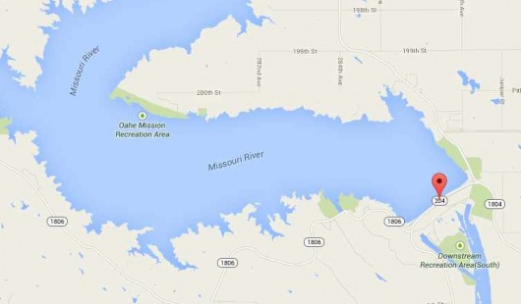
The dam attracts 1.5 million visitors a year, is home to endangered species, is a water-source for the Sioux peoples, “supplies irrigation, conservation, and electric power to many Midwestern states” (Goodman, 2012) and is one of four dams responsible for the creation of freshwater fisheries throughout the Missouri River (South Dakota Department of Tourism, 2017).
Image source: Google maps

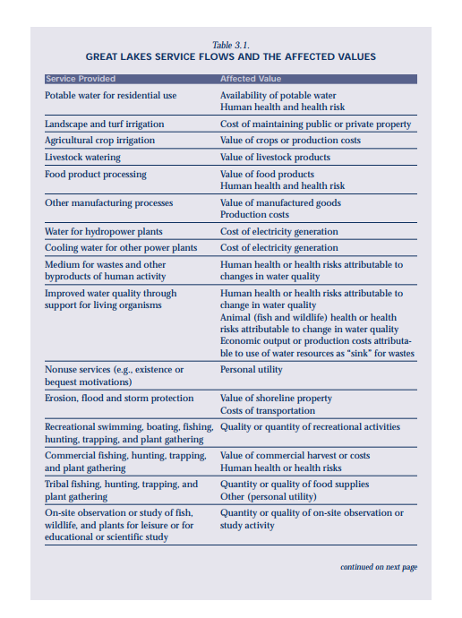
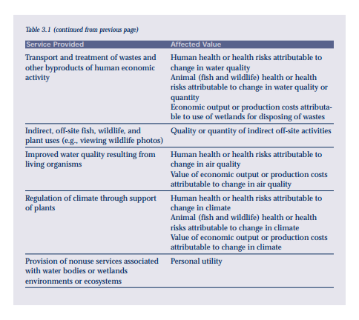
Appendix 4: U.S. great lakes service flows and the affected values (The Northeast-Midwest Institute et al., 2001)

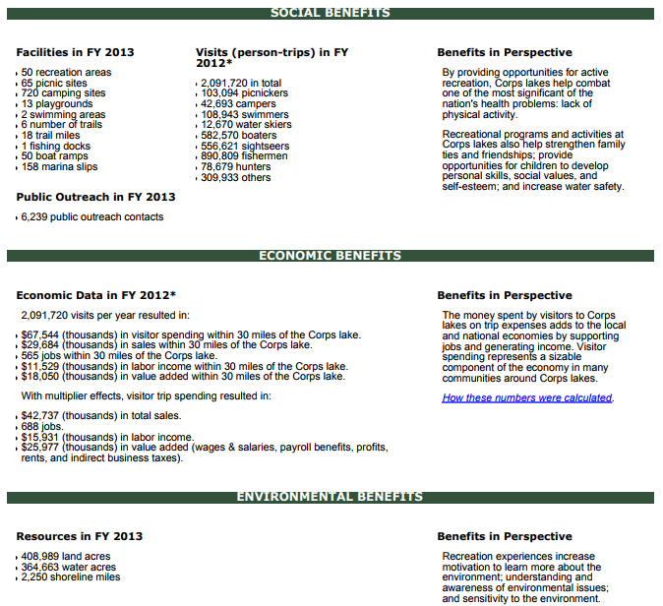
Appendix 5: Lake Oahe social, economic & environmental benefits (US Army Corps of Engineers, 2013)

Appendix 6: Water stresses as a result of pipeline
In addition to incidents, environmentalists have identified several water resource stresses, created or enhanced, as a result of the pipeline: (Shrestha, et al., 2017)
- Water demand due to large volumes of maintenance water to avoid salinity build-up
- Excessive domestic water consumption due to temporary oilfield workers
- Unusual levels of salinity in produced water that minimize its recycling options
- Intense pressure of the existing infrastructure (trucking and piping) to transport produced water from oil wells to deep injection wells
- Large brine spills due to truck accidents and pipeline breaks during transport of produced water
- High flammability of Bakken oil that poses explosion risks

Appendix 7: The Utilitarian analysis calculation
A utilitarian analysis of the pipeline grounded on the issues identified in this paper. The analysis is a pleasure-pain wellbeing-rating, but also includes short-term and long-term measures. Analysis is constructed on a 0-10 scale where 0 equates to no significant impact and 10 overwhelming impact to the wellbeing of stakeholders. Short-term activities in this study are defined as those which occur within five years, while long-term activities are those greater than five years. Long-term activities can be considered more degradative or beneficial to wellbeing because their effects are more long-lasting. To account for this, this paper has included a long-term weighting where the effects of long-term activity count as double when factored into calculation.

Activity | Pleasure |  | Pain
 | Short-term (> five years) | Long-term (< five years with x2 weighting in end calculation) | Short-term (> five years) | Long-term (< five years with x2 weighting in end calculation)
Corporation profitability | 0: No significant impact | 4: Company receives US$ 1.37 billion annually, benefits: employment, taxes, etc.  6: Profits used to invest into renewable sources of energy. | 2: Initial investment by the company in constructing the pipeline US$ 3.7 billion. | 0: No significant impact
The route of the pipeline | 1: Approx. 71,000 Bismarck residents avoided adverse-outcomes of construction process (noise, traffic, etc.) | 5: Approx. 71,000 Bismarck residents ensured safe water quality for consumption.  4: Government sanctioned the route and the state is best positioned to decide what is best for the majority. | 1: Approx. 8,000 Sioux natives experience pipeline construction (noise, traffic).  5: Ignoring the Treaty of Fort Laramie debate, calling into question the credibility of similar treaties towards indigenous/aboriginal groups. | 9: Approx. 8000 Sioux native values, way of life, customary rights, spiritual and ancestry connections eroded.  9: Pipeline still runs close to water-ways and under Lake Oahe. Significant social and environmental concerns should spill occur.
Fiscal benefits | 3: US$ 156 million in sales and income taxes during construction. | 4: US$ 55 million annually in property taxes. | 0: No significant impact | 1: Tax revenues are not efficiently utilised and so optimum potential benefits are not achievable.
Local economic spill-over benefits | 3: Initial construction benefits. | 3: US$ 20 billion estimated the economic benefit of construction. | 0: No significant impact | 2: Economic spill-over benefits are not sustainable.
Potential employment creation | 3: 8,000 – 12,000 jobs created during pipeline construction. | 1: 40 permanent jobs created post-construction in the operational management of the pipeline. | 1: Construction workers suffer physical and verbal abuse and threats from protestors. | 5: 8,000 – 12,000 individuals may defer education to work in construction industry.  5: 8,000 – 12,000 individuals absorbed into an industry which is considered a ‘sunset industry’.  1: No jobs created in rail transport industry.
Meetings with community leaders, officials and groups | 5: Variety of stakeholder concerns are discussed and sought solutions. | 0: No significant impact | 5: Meetings were considered not beneficial, did not address concerns and did not occur on the scale suggested. | 0: No significant impact
Water-related stresses | 0: No significant impact | 0: No significant impact | 1: Excessive domestic water consumption due to temporary oilfield workers. | 4: Increased water demand in operational maintenance, waste water, associated concerns in water transportation.
Animal and plant wellbeing | 0: No significant impact | 1: Less trains needed to transport oil and so less noise pollution produced. | 2: Animal habitats destroyed in construction pipeline.  2: Construction noise and human population may scarce animals, or cause them to leave current local ecosystems. | 8: Pipeline spill has potential to destroy or wipe-out entire eco-systems. Particular concern surrounding waterways.
Falsified information to encourage pipeline implementation | 1: Ensured pipeline would be implemented to enable benefits of company profitability. | 0: No significant impact | 2: Public protest that they have manipulated.  1: Company reputational damage. | 4: Public loss of trust in the industry.
Future generations | 0: No significant impact | 1: Born into wealthier families. | 0: No significant impact | 9: Climate change concerns
Total | 16 | 58 (including multiplier affect) | 22 | 114 (including multiplier affect)
Total | 73 |  | 136

References

Ackerman, F. & Knight, P., 2017. (reference removed for confidentiality reasons)
Akhtar, Z., 2011. Curse of the Black Hills: breach of treaty and due process under the 5th Amendment. The International Journal of Human Rights, 15(3), pp. 397-415.
Benhabib, J. & Spiegel, M. M., 1994. The role of human capital in economic development evidence from aggregate cross-country data. Journal of Monetary Economics, 34(2), pp. 143-173.
Bentham, J., 1789. An Introduction to the Principles of Morals and Legislation. Oxford: Clarendon Press.
Crane, A. & Matten, D., 2016. Business Ethics. 4 ed. Oxford: Oxford University Press.
Crowther, D., 2015. Chapter 5 The Utilitarian Fallacy. In: Governance in the Business Environment. s.l.:Bingley, U.K.; Emerald, pp. 71-91.
Dorst, J. D., 1999. Looking West. Philadelphia: Univeristy of Pennsylvania Press.
Fieser, J., 2001. Moral Philosophy Through the Ages. s.l.:Mayfield Publishing Company.
Financial Times, 2017. (reference removed for confidentiality reasons)
Garcia, F., 2016. (reference removed for confidentiality reasons)
Goodman, W., 2012. South Dakota’s Great Places: Oahe Dam. [Online]
Available at: http://news.sd.gov/newsitem.aspx?id=12672
[Accessed 20 November 2017].
Hampton, L., 2016. (reference removed for confidentiality reasons)
Hobbes, T., 1651. Leviathan or The Matter, Forme and Power of a Common-Wealth Ecclesiasticall and Civil. s.l.:s.n.
Hoffmann, H. M., 2017. Fracking the sacred: Resolving the tension between unconventional oil and gas development and tribal cultural resources. Denver University Law Review, 94(2), pp. 319-362.
Horn, S. & Mikulka, J., 2017. (reference removed for confidentiality reasons)
Investors Business Daily, 2016. (reference removed for confidentiality reasons)
Kringstad, J. J., 2013. Monthly Update: June 2013 Production and Transportation, s.l.: North Dakota Pipeline Authority.
Kringstad, J. J., 2017. Monthly Update: August 2017 Production and Transportation, s.l.: North Dakota Pipeline Authority.
Levin, S., 2017. (reference removed for confidentiality reasons)
McCoy, S., 2017. (reference removed for confidentiality reasons)
Mill, J. S., 1863. Utilitarianism. London: Parker, Son and Bourn, West Strand.
Nemec, R., 2016. (reference removed for confidentiality reasons)
Nemec, R., 2017. (reference removed for confidentiality reasons)
NoiseCat, J. B., 2017. (reference removed for confidentiality reasons)
Parfit, D., 1984. Reasons and Persons. Oxford: Clarendon Press.
Philips, M., 2016. North Dakota’s Pipe Dreams Are the Key to Its Future. [Online]
Available at: https://www.bloomberg.com/news/articles/2016-12-01/north-dakota-s-pipe-dreams-are-the-key-to-its-future
[Accessed 18 November 2017].
Pipeline & Gas Journal: Staff Report, 2017. Dakota Access Moving Forward - Thousands of Barrels at a Time. Pipeline & Gas Journal, 244(5), pp. 24-26.
Rickman, D. S., Wang, H. & Winters, J. V., 2017. Is shale development drilling holes in the human capital pipeline?. Energy economics, Volume 62, pp. 283-290.
Rousseau, J.-J., 1762. Du contrat social; ou Principes du droit politique. s.l.:s.n.
Sack, C., 2016. (reference removed for confidentiality reasons)
Saha, D., 2016. (reference removed for confidentiality reasons)
Schwartz, T., 1979. Welfare judgments and future generations. Theory and Decision, 11(2), pp. 181-194.
Shrestha, N. et al., 2017. Potential water resource impacts of hydraulic fracturing from unconventional oil production in the Bakken shale. Water research : Journal of the International Association on Water Pollution Research & Control, Volume 108, pp. 1-24.
Sierra Club Iowa Chapter, 2016. (reference removed for confidentiality reasons)
Smith, A., 1776. The Wealth of Nations. London: W. Strahan and T. Cadell.
South Dakota Department of Tourism, 2017. Central Region. [Online]
Available at: https://www.travelsouthdakota.com/things-to-do/recreation/fishing/fishing-central-region
Stockman, L., 2016. (reference removed for confidentiality reasons)
The Northeast-Midwest Institute; The National Oceanic & Atmospheric Administration, 2001. Revealing the economic value of protecting the great lakes. s.l.:The Northeast-Midwest Institute; The National Oceanic & Atmospheric Administration.
Thompson, J., 2016. (reference removed for confidentiality reasons)
Trump, D. J., 2017. (reference removed for confidentiality reasons)
US Army Corps of Engineers, 2013. Lake Level Report OAHE DAM LAKE OAHE SD AND ND. [Online]
Available at: http://www.corpsresults.us/recreation/fastfacts/lake_pdf.cfml?lakeID=315
[Accessed 21 November 2017].
USFWS, 2016. (reference removed for confidentiality reasons)
Visak, T., Duwell, M. & Marcellinus, V., 2011. Killing happy animals : Explorations in utilitarian ethics, s.l.: Utrecht University.
Wade, T. & Scheyder, E., 2016. (reference removed for confidentiality reasons)
Wong, J. C. & Levin, S., 2017. (reference removed for confidentiality reasons)

