Student Name:
Anushka Patil

Institution:
London College of Fashion, University of the Arts London

Title of Work:
Sustainable Fast Fashion Brands,
a call for transparency in sustainable production claims
A ZARA Case Study.

Abstract

The aim of this case study was to critically analyse the anticipated business problem for Zara, in relation to their sustainability goals of no waste and sustainable production by 2025. The business problem was identified by conducting two consumer interviews, wherein their perception of Zara, sustainability and their engagement in sustainable consumption was identified. The anticipated business problem identified was lack of transparency and sustainable production as per consumers expectations. The goals Zara has set for themselves might not be accomplished within the time frame and consumers trust in their goals was low due to lack of transparency. The business problem was further analysed using academic resources in barriers to sustainable production and transparency. To conclude, potential solutions of the fast fashion and growth business model are briefly discussed to improve environmental impact, gain consumer trust, and set an example for the industry.

Table of Contents

- Introduction | 04
- Business Problem | 07
2.1 Barriers in Sustainable Production and Transparency | 09
2.1.a Barriers in Sustainable Production | 10
2.1.b Barriers in Transparency | 12
- Conclusion | 16
- References | 18
- Appendices | 32
5.1 Appendix 1 – Original Assignment Brief | 32
- Appendix A | 35
5.3 Appendix B | 36
5.4 Appendix C | 37

Introduction

To define sustainability is complex, and is often broken into three pillars of economic, social, and environmental value emerged from continuous critique on the subject (Purvis, et. al., 2018). According to Brundtland Commission Report (1987, pp. 41) sustainability can be measured in terms of development of its economy and society. Sustainable Development entails to meet the needs of the economy but as a society to not comprise the needs of those of future generations (ibid).

Sustainability in Fashion is an emerging concept that focuses on the industry to be less harmful to the people and the planet (Mukendi, et. al., 2020). Mintel report (2021) stated that consumers are increasingly leaning towards shopping sustainably for fashion items due to increase in media exposure about items that end up in landfill and ill treatment of workers in factories employed by these fashion brands. 60% of the UK consumers consider sustainability when buying fashion products (Mintel, 2021).

Circular economy is a concept from sustainability, but not all sustainable activities are circular in nature (Sillanpää and Ncibi, 2019, pp. 282 - 286). Circular economy refers to a closed loop cycle of three R principles – reuse, recycle, and reduce (Kirchherr et. al., 2017). Circular fashion is the process of designing and using products and materials for as long as possible through the principles of three Rs, thus, designed out of the waste closing the loop (Common Objective, No Date).

Fast fashion brands are at a high risk due to increase competition, greater demand in transparency, and shift to sustainable practices (Gazzola, et. al., 2020). Charlotte Turner stated (in Chan, 2019) that there is a lack of agreement on the meaning of sustainability, and brands need to take well informed and genuine approach towards reducing the environmental impact, which is difficult with a high-volume business model. Though, Amina Razvi states “Sustainability is a journey”, (Chan, 2019, para 4) brands taking action to influence consumer choices, and encouraging sustainable consumption is considered a sustainable business practice (World Business Council for Sustainable Development, 2008).

Zara, a subsidiary of Inditex group, and the pioneer of the fast-fashion business model from the late 1980s (Schiro, 1989) in 2018 pledged to circular fashion and aims to produce 100% sustainable clothing by 2025 (Inditex, No Date). Sustainability in business can create long term value, it also allows to be competitive (Hannaes, 2016). Zara has created a 5-year plan to base on circular economy. This is due to the increasing importance of sustainability for their stakeholders such as from customers to partner organisations. (Inditex, 2020).

Presently, the business models are all activities that support creation of services or products that is sold to the consumers in exchange for financial value (Ovans, 2015).
Sustainable Business model comparatively are all activities that support the creation of services or products that is sold to the consumers and is added value for all stakeholders while protecting the environment, social and economic resources (Breuer, and Lüdeke-Freund, 2014). Main cause of environmental damage by the apparel industry is due to unsustainable production practices (Krajnc and Glavič, 2003). Sustainable development will be possible only when businesses take lead in creation of sustainable production. Zara is fulfilling some of the sustainable production conditions (ibid) by closing the loop, zero-waste, and recycling products (Inditex, No date). Sustainable production and use of recycled materials are still new and not produced at a scalable size (Silva, et. al., 2014). Zara’s commitment to no waste by 2025, might need a scalable technology and production using only recycled materials. Being an industry leader, with innovative technology, Zara needs to be transparent about their knowledge for the industry to follow suit (Appendix B).

Transparency is a key driver towards sustainable production encouraging all stakeholders towards the change (Mol, 2015). Transparency and Traceability by some researchers are considered as dimensions to pursue common goal of sustainability (Egels-Zanden et al., 2015; Garcia-Torres et al., 2019). Traceability is to trace the supply chain (Agrawal and Pal, 2019) and transparency to communicate traceability to the public (Mejias et al., 2019). To understand the impact of Zara’s sustainability claims on its brand image, interviews were conducted, and a common theme of consumer expectation was identified. Consumers expect Zara to be transparent about its sustainability goals, and supply chain to be able to trust the brand (Appendix B).

However, there are substantial barriers in sustainable production and transparency that Zara will need to overcome in order to change their business model from growth focused to sustainable. This case study will critically analyse sustainable production and transparency and consider the barriers to holistically understand the business problem.

Business Problem

Zara’s Business Model and Sustainability

Zara is a fast fashion brand that is to create inexpensive clothing from highly efficient supply chains, with high turnover marketed to the fashion-conscious consumers (Gheorghe and Matefi, 2021). It’s business model is customer and cost driven (Osterwalder, et. al, 2010) with high automation and integrated supply chain from the designers to the manufacturing (Scholssberg, 2015). The growing pressure and demand for ready to wear products at accessible pricing, has made fashion products disposable and a reaction of overconsumption and production (Fletcher, 2014). The short trend cycles have led to overproduction in the apparel industry. 85% of garments produced end up in the waste every year (Vemulakonda, 2021). This can be demonstrated in the case of Zara, as they produce approximately 1.6 billion items per year.(Inditex,2020).
Moreover, consumers are highly becoming aware of the problems in over consumption and need for sustainability in fashion (Mintel, 2021). This has led Zara to commit to producing all collections from 100% sustainable fabrics by 2025 (Conlon, 2019) and nothing goes to landfill by 2023 as part of their closed loop production (Inditex, No Date). Zara has already taken a step towards fulfilling their commitment by launch of ‘join-life collection’ (Zara, No Date). However, Zara’s business model prioritises financial growth (Inditex, 2020). The sustainable fabrics in question are synthetic or semi-synthetic in nature (Appendix C). The fabrics are cheap and accessible for production of fast fashion items (Kassia, 2019). The synthetic fibres pose toxicity threat to humans (Singh and Bhalla, 2017) and the environment, caused due to microfibre pollution at all stages of production and use of the item (Muthu and Gardetti, 2020).

There is lack of evidence from Zara, on their sustainable claims. Thus, there is also an issue of transparency in their collection (Appendix B). 85% consumers will continue their relationship with the brand if they have been transparent, although only 15% consider brands to be delivering transparency (Gilpin, 2018). Additionally, Zara’s image of fast fashion brand contradicts to their sustainable efforts and hence the claims are not believed (Appendix B).

Participant had stated: “… Zara came from a place where it was very toxic fast fashion … and they want to be fully on sustainable then you (Zara) need to have some backup in those statement that you (they) make by being transparent” (Appendix B). Another participant has also stated “…I think there's a long way to for fashion to be transparent…” (Appendix B).

It is evident that consumers trust is important to sustain a business, it is often achieved through transparency in the supply chain of the apparel businesses (Bhaduri, and Ha-Brookshire, 2011). From the Fashion Transparency Index (Fashion Revolution, 2021) it is noted that Zara has highest decrease in transparency score by (-)8% from the previous year. It is only 36% transparent, which is lower than its competitor H&M at 68% and ASOS at 47%. The brand showcases high commitments for societal and environmental welfare to the consumers at 89%, higher than its competitors. However, traceability for the commitments falls at only 1%, which is lower than the competitors such as ASOS at 62% and H&M at 81% (Fashion Revolution, 2021).

Therefore, the anticipated business problem for Zara, will be in relation to 100% sustainable production and providing transparency to the consumers to support their claims.

Barriers to Transparency and Sustainable Production

Zara’s pledge to becoming sustainable and no waste production has led to many critics, consumers, and experts alike to consider it as greenwashing due to the fact that fashion circularity and sustainability messaging promotes guilt free consumption and continue production at a high rate (Chua, 2018). The growth of fashion businesses has led many experts to believe the sustainability goals will not be met due to the fashion’s growth model (Kent, 2020). Executives from fashion companies do not consider it overproduction if there is an equal demand for it. The business model the companies are leaning towards is based on how many times can revenue be produced from the same item (ibid).

Sustainability goals of Zara are particularly based on circularity which encompasses mainly recycling and no waste generated goal. The recycling is of the fabrics provided by the consumers through their clothes collection programme and creating new raw materials from it to produce the new items (Zara, No Date). However, there are barriers to production from recycling, circularity, and sustainable business model implementation.

Barriers in Sustainable Production

- The change from a growth-based business model to a sustainable business model requires organisational change that can lead to individual resistance from top down (Oreg, 2003). Thus, the business itself requires an additional satisfactory motive to drive the change (Zhu, et. al.,2011).

- There is an attitude behaviour gap in consumers, they often do not follow on their actions to be more sustainable due to multitude of reasons (Bray, et. al, 2011). Consumers being the most important stakeholders within the fashion industry can be a barrier. Consumers often do not find recycled made items appealing as consider it to be made from waste (Kim, et. al, 2021).

- Recycled textiles are more expensive than the regular textiles, this can increase the price of the products (Valle, 2005). This can directly impact Zara’s positioning in the market as a fast fashion brand and cost driven selling products at accessible prices (Appendix B). Sustainable business practices are competitive, and brands need to keep their positioning in the market, but brands tend to focus on short term goals rather than long term vision (Pedersen, 2018).

- Ability to recycle the products responsibility lies on the manufacturers and the manufacturing companies usually don’t have the knowledge or the resources to select the best technologies for recycling (Kirchherr et al., 2018). This has led to 75% of textile waste in landfill (Elander et al., 2017; Park and Evans, 2017)

- Environmental Barrier to recycling and use of alternative plastic or recycled fabrics is also microplastic pollution (Muthu and Gardetti, 2020). Polyester or recycled polyester is continued to be the popular material to be used in sustainable collection, also seen in the Zara’s sustainable collection (Appendix C).

- The recycled yarn, to maintain cost and quality are often needed to be used with a mix of pure yarn which becomes a barrier in recycling after one use due to the lack of ability to recycle blended materials (Lewis, et. al., 2016).

- Lack of governmental policies and trust in sustainable development in the manufacturing countries can be barrier for entirely sustainable production. Institutional incentives are required for long lasting and impactful change (Fischer and Pascucci, 2017)

- Sourcing of recycled material is complex, and thus, lacks traceability (Lakhal, et. al, 2008). The items must be transported between countries to be disseminated and then transported again for production of new products. Sorting and collection needs to be error free and can be a time-consuming process (Probst, et. al., 2016) thus, increasing Zara’s expense impacting price of the items.

- A scalable technology and system are required to use recycling technology at a wider scale including for blended materials, especially for the scale at which Zara operates. This technology is in progress (Silva, et. al., 2014) and might soon exist with large fashion companies turning to recycling and sustainable production but at present is a barrier.

Barriers in Transparency

Transparency increases reliability, loyalty and improves brand image (Lin, et. al., 2017) but also improves working conditions, and environmental protection (Modi and Zhao, 2020). It is challenging in the fashion industry to be transparent due to vast network of supply chain process, situated in multitude of countries (Dyer and Ha-Brookshire, 2008).

Although, consumers want brands to be transparent they do not have trust over brand’s transparency claims. Also, they want the transparency information to be accessed easily that is embedded in their shopping journey rather than having to search for that information (Bhaduri, and Ha-Brookshire, 2011). Important determinants of consumers shopping behaviour is also price and quality (McNeill and Moore, 2015), supported by participants (Appendix B):

“…I kind of now like my shopping behaviours more driven to like more minimalist clothing and sometimes price and quality…”

“…that is like extra point but if I really like the design and if it if there's no information mentioned there, I would still buy it if the price the quality or the design fits…”.

This is a barrier for brands that do provide transparency but if the quality of the product and accessibility is low, it can deter the consumers from purchasing from that brand. Zara is attractive for its low pricing and quality (Appendix B), but the sustainable collection will increase cost of the items (Appendix C) and might impact quality.
Another barrier to transparency is the value of competitive advantage that brands risk of losing. Brands can face a threat of losing their suppliers and manufacturers, to their competitors if they expose their supply chain for public information. This does not satisfy any economic or profit goals for the company (Bateman and Bonanni, 2019). There are also anti-competition laws that prevent transparency (Human Rights Wages, 2019). It will also expose the working conditions throughout the supply chain which exposes brands to criticism (Bateman and Bonanni, 2019). The costs associated with auditing and traceability are high in comparison to the benefits (Egels-Zandén et al.,2015).

Additionally, suppliers and manufacturers might not be willing to share or be transparent about their activities due to threat of disclosing information and they are not capable to answer if issues arise out of transparency due to lack of training, incentives, and protection from the companies (Mol, 2015). Manufacturing units in different countries might be controlled by one supplier and by being transparent they risk of losing their business directly of the manufacturers cutting out the middleman (Egels-Zandén et al.,2015). Laws and policies may not protect these suppliers or manufacturers from being exploited (Majumdar and Sinha, 2018). Economic, Environmental, Social Transparency is impacted by not being value led by the top management in brands due to low business need. Transparency costs to the business and as it not imperative with high risk of exposing their data, top executives are reluctant to making business supply chain transparent (Gold and Heikkurinen, 2018).

Outlook

There are internal and external barriers in transparency and sustainable production. Some of these barriers are in terms of Zara’s use of recycling as means of closed loop production and risk of using recycled textiles. Executives and consumers are at opposing views in the need for transparency, though some companies have found a middle ground from transparency and gained consumer trust (Appendix B).

Many critics have stated that though circularity programmes and no waste goals are adopted by fast fashion brands, overproduction is still an issue (Williams, 2017; Fullerton, 2021) which will lead to waste due to barriers in recycling (Kirchherr et al., 2018). Circular fashion’s objective is also to consume less clothing (Global Fashion Agenda, 2020) which will demand fast fashion to slow down (Advaya, 2020, 17:54). Promoting consumers to shop responsibility and consciously (Dory, 2018).

There is an opportunity for other business models to be considered rather than just circularity. Collaboration and partnerships are essential due to the nature of the business model. Consumers are often willing to trust brands with certified seal verified the business to be transparent (Bhaduri, and Ha-Brookshire, 2011). Transparency is possible due to legal implications faced by larger brands (Ma, et. al., 2015) but it will impact small independent brands as they do not directly have control over their suppliers (Human Rights Wages, 2019). Thus, it remains a complex issue for Zara and other brands alike.

Conclusion

This case study initially started with broader perspective on sustainability and sustainable development. Many fast-fashion brands are committing to sustainable practises in response to increased internet scrutiny and the competitive benefit of a sustainable business model, as customer behaviours evolve (Perez, 2021). Zara, one of the fast fashion brands, who have recently committed to sustainability was analysed for this case study. Business Problem was identified through consumer interviews. A common theme emerged was consumer expectation towards transparency to support the claims. Zara, as an industry leader with breakthrough technologies, must be upfront about their expertise for the industry to also follow suit. Transparency is a critical driver of sustainable manufacturing, encouraging all stakeholders to embrace the change (Mol, 2015). Zara will need to overcome significant challenges in sustainable production and transparency to shift their business strategy.

Though there are multitude of barriers in sustainable production, and transparency, more companies producing their products with 10 percent recycled material is highly impactful than a single company producing only from recycled material (Larney and Aardt, 2009) showcasing a significant step towards sustainable development. The urgency of depletion of earth’s resources and its impact for example seen as climate change (Le, 2020), it’s a necessity to adapt to new business models that focuses on sustainability rather than on short term financial goals (Global Fashion Agenda, 2020).

Growth of the economies is measured through GDP, yet it does not measure the growth of human well-being (Kapoor and Debroy, 2019), income equality (The Economist, 2016) and green growth (OECD, No Date). A potential solution is for planned action to slow down the growth of overconsumption (Advaya, 2020, 17:54) and production especially in fast fashion brands that rely on short life cycle of production and consumption and continue to support their sustainability initiatives for greater healthy impact on the environment (Segran, 2019).

References

Advaya (2020) Jason Hickel: Economics in an age of climate breakdown. 16 January 2020. Available at: https://youtu.be/V-2gN31R0O4 (Accessed: 21 November 2021)

Agrawal, T.K. and Pal, R. (2019), ‘Traceability in textile and clothing supply chains: classifying implementation factors and information sets via Delphi study’, Sustainability, 11(6), doi: 10.3390/su11061698.

Bateman, A. and Bonanni, L. (20 August 2019) What Supply Chain Transparency Really Means Available at: https://hbr.org/2019/08/what-supply-chain-transparency-really-means (Accessed: 29 November 2021)

Bhaduri, G. and Ha-Brookshire, J.E. (2011) ‘Do Transaprent Business Practices Pay? Exploration of Transparency and Consumer Purchase Intention’, Clothing and Textiles Research Journal, 29(2), pp. 135-149, doi: 10.1177/0887302X11407910

Bray, J., Johns, N., and Kilburn, D. (2011) ‘An exploratory study into the factors impeding ethical consumption’, Journal of Business Ethics, 98(4), pp. 597–60 , doi: 10.1007/s10551-010-0640-9

Breuer, H. and Lüdeke-Freund, F. (2014) ‘Normative Innovation for Sustainable Business Models in Value Networks’, Innovation for Sustainable Economy and Society. pp. 1-18 Available at: https://www.researchgate.net/publication/278683781_Normative_Innovation_for_Sustainable_Business_Models_in_Value_Networks (Accessed: 21 November 2021)

Bruntland, G. H. (1987). Report of the World Commission on environment and development; our common future, Bruntland report. New York: UN Documents

Chan, E. (23 August 2019) Is fast fashion taking a green future seriously? Available at: https://www.vogue.fr/fashion/article/how-effective-are-fast-fashion-brands-sustainability-initiatives (Accessed: 20 November 2021)

Chua, J.M. (12 June 2018) Circularity: Sustainable Fashion’s Holy Grail or Greenwashing? Available at: https://www.businessoffashion.com/articles/sustainability/circular-economy-the-holy-grail-of-sustainable-fashion/ (Accessed: 28 November 2021)

Common Objective (No Date) What is Circular Fashion? Available at: https://www.commonobjective.co/article/what-is-circular-fashion (Accessed: 20 November 2021)

Conlon, S. (17 July 2019) Zara clothes to be made from 100% sustainable fabrics by 2025 Available at: https://www.theguardian.com/fashion/2019/jul/17/zara-collections-to-be-made-from-100-sustainable-fabrics (Accessed: 26 November 2021)

Dory, K. (27 June 2018) Why fast fashion needs to slow down Available at: https://www.unep.org/news-and-stories/blogpost/why-fast-fashion-needs-slow-down (Accessed: 29 November 2021)

Dyer, B. and Ha‐Brookshire, J. E. (2008) ‘Apparel import intermediaries' secrets to success’, Journal of Fashion Marketing and Management: An International Journal, 12(1), pp.51–67, doi:10.1108/13612020810857943

Egels-Zandén, N., Hulthén, K. and Wulff, G., (2015) ‘Trade-offs in supply chain transparency: the case of Nudie Jeans Co.’ Journal of Cleaner Production, 107(16), pp.95-104, doi: 10.1016/j.jclepro.2014.04.074

Elander, M., Tojo, N., Tekie, H., and Hennlock, M. (2017) Impact assessment of policies promoting fiber-to-fiber recycling of textiles, Stockholm.

Fashion Revolution (2021) Fashion Transparency Index 2021 Available at: https://www.fashionrevolution.org/about/transparency/ (Accessed: 27 November 2021)

Ferdows, K.; Lewis, M.; & Machuca, J.A.D. (2003) ‘Zara’, Supply Chain Forum: An International Journal, 4(2),pp. 62-67, doi: 10.1080/16258312.2003.11517121
Fischer, A., and Pascucci, S. (2017) ‘Institutional incentives in circular economy transition: The case of material use in the Dutch textile industry.’ Journal of Cleaner Production, 155, pp. 17–32. doi:10.1016/j.jclepro.2016.12.038
Fletcher, K. (2014) Sustainable Fashion and Textiles: Design Journeys, 2nd edn, Abingdon, UK: Routledge

Fullerton, A. (6 November 2021) What exactly is ‘de-growth’, and how can it make the fashion industry sustainable? Available at: https://www.glamourmagazine.co.uk/article/fashion-degrowth-explained (Accessed: 30 November 2021)

Garcia-Torres, S.; Albareda, L.; Rey-Garcia, M. and Seuring, S. (2019), ‘Traceability for sustainability – literature review and conceptual framework’, Supply Chain Management: International Journal, 24(1), pp. 85-106, doi: 10.1108/SCM-04-2018-0152.

Gazzola, P; Pavione, E; Pezzetti, R; and Grechi, D. (2020) ‘Trends in the Fashion Industry. The Perception of Sustainability and Circular Economy: A Gender/Generation Quantitative Approach’, Sustainability, 12 (7), pp. 2-19, doi: 10.3390/su12072809

Ghemawat, P. and Nueno, J.L. (1 April 2006) Zara: Fast Fashion Available at: https://store.hbr.org/product/zara-fast-fashion/703497 (Accessed: 24 November 2021)

Gheorghe, C.A. and Matefi, R. (2021) ‘Sustainability and Transaprency – Neessary Conditions for the Transition from Fast to Slow Fashion: Zara Join Life Collection’ Analysis’ Sustainability, 13, pp. 2 – 16, doi: 10.3390/su131911013

Gilpin, J. (19 September 2018) Toward a new model of business transparency Available at: https://sproutsocial.com/insights/new-model-of-business-transparency/ (Accessed: 27 November 2021)

Global Fashion Agenda (2020) CEO Agenda 2020 Available at: https://www.globalfashionagenda.com/report/ceo-agenda-2020/ (Accessed: 21 November 2021)

Gold, S. and Heikkurinen, P. (2018), ‘Transparency fallacy: unintended consequences of stakeholder claims on responsibility in supply chains’, Accounting, Auditing and Accountability Journal, 31(1), pp. 318-337, doi: 10.1108/AAAJ-06-2015-2088.

Hannaes, K. (November 2016) Why all businesses should embrace sustainability Available at: https://www.imd.org/research-knowledge/articles/why-all-businesses-should-embrace-sustainability/ (Accessed: 21 November 2021)

Harris, F. Roby, H., and Dibb, S. (2016) ‘Sustainable clothing: challenges, barriers and interventions for encouraging more sustainable consumer behaviour’, International Journal of Consumer Studies, 40(3), pp. 309-318, doi: 10.1111/ijcs.12257

Human Rights Wages (18 December 2019) Surge in Garment Industry Transparency Available at: https://www.hrw.org/news/2019/12/18/surge-garment-industry-transparency (Accessed: 29 November 2021)

Inditex (2020) Annual Report Available at: https://www.zara.com/uk/en/sustainability-annual-report-mkt1450.html?v1=967754 (Accessed: 20 November 2021)

Inditex (No Date) COLLECT, REUSE, RECYCLE Available at: https://www.inditex.com/our-commitment-to-the-environment/closing-the-loop/collect-reuse-recycle (Accessed: 26 November 2021)

Inditex (No Date) TOWARDS A CIRCULAR ECONOMY Available at: http://static.inditex.com/annual_report_2016/en/our-priorities/commitment-to-the-excellence-of-our-products/towards-a-circular-economy.php (Accessed: 20 November 2021)

Kapoor, A. and Debroy, B. (4 October 2019) GDP Is Not a Measure of Human Well-Being Available at: https://hbr.org/2019/10/gdp-is-not-a-measure-of-human-well-being (Accessed: 21 November 2021)

Kassia, St.C. (2019) The golden thread: how fabric changed history London: John Murray

Kent, S. (21 January 2020) Fashion’s Growth-Focused Business Model Is Not Sustainable. What’s the Solution? Available at: https://www.businessoffashion.com/articles/sustainability/fashions-growth-focused-business-model-is-not-sustainable-whats-the-solution/ (Accessed: 28 November 2021)

Kim, I., Jung, H.J., and Lee, Y. (2021) ‘Consumers’ Value and Risk Perceptions of Circular Fashion: Comparison between Secondhand, Upcycled, and Recycled Clothing’, Sustainability, 13 (1208), pp. 2 – 23, doi: 10.3390/su13031208

Kirchherr, J.; Piscicelli, L.;Bour, R., Kostense-Smit, E., Muller, J., Huibrechtse-Truijens ,A. and Hekkert, M. (2018) ‘Barriers to the Circular Economy: Evidence From the Eurpoean Union (EU)’, Ecological Economics, 150, pp.264-272, doi: 10.1016/j.ecolecon.2018.04.028.

Kirchherr, J.; Reike, D.; and Hekkert, M. (2017) ‘Conceptualizing the circular economy: An analysis of 114 definitions’, Resources, Conservation & Recycling, 127, pp. 221-232, doi: 10.1016/j.resconrec.2017.09.005

Krajnc, D. and Glavič, P. (2001) ‘Indicators of sustainable production’, Journal of cleaner production, 9(6), pp.519-549, doi: 10.1016/S0959-6526(01)00010-5

Lakhal, S. Y., Sidibe, H., and H’Mida, S. (2008) ‘Comparing conventional and certified organic cotton supply chains: the case of Mali.’ International Journal of Agricultural Resources, Governance and Ecology, 7(3), pp. 243–255. Doi:10.1504/ijarge.2008.018328

Larney, M and Aardt, A.M. (2009). ‘Case study: Apparel industry waste management: A focus on recycling in South Africa’, Waste management & research: the journal of the International Solid Wastes and Public Cleansing Association, 28, pp. 36-43. Doi: 10.1177/0734242X09338729.

Le, N. (20 July 2020) THE IMPACT OF FAST FASHION ON THE ENVIRONMENT Available at: https://psci.princeton.edu/tips/2020/7/20/the-impact-of-fast-fashion-on-the-environment (Accessed: 21 November 2021)

Lewis, T.L., Park, H., Netravali, A., and Trejo, H.X. (2016) ‘Closing the loop: a scalable zero waste model for apparel reuse and recycling’, International Journal of Fashion Design, Technology, and Education, 10(3), pp.353-362, doi: 10.1080/17543266.2016.1263364

Lin, J.; Lobo, A.; and Leckie, C. (2017) ‘The role of benefits and transparency in shaping consumers’ green perceived value, self-brand connection and brand loyalty’, Journal of Retailing and Consumer Services, 35, pp. 133-141, doi: 10.1016/j.jretconser.2016.12.011

Ma, Y.J.; Lee, H.H. and Goerlitz, K. (2015) ‘Transparency of Global Apparel Supply Chains: Quantitative Analysis of Corporate Disclosures’, Corporate Social Responsibility and Environmental Management, 23(5), pp.308-318, doi: 10.1002/csr.1378

Majumdar, A. and Sinha, S.K., (2018).’ Analyzing the barriers of green textile supply chain management in Southeast Asia using interpretive structural modeling’, Sustainable Production and Consumption, 17, pp.176-187, doi: 10.1016/j.spc.2018.10.005

McNeill, L., and Moore, R. (2015) ‘Sustainable fashion consumption and the fast fashion conundrum: Fashionable consumers and attitudes to sustainability in clothing choice’, International Journal of Consumer Studies, 39(3), pp. 212–222, doi:10.1111/ijcs.12169

Mejıas, A.M., Bellas, R., Pardo, J.E. and Paz, E. (2019), ‘Traceability management systems and capacity building as new approaches for improving sustainability in the fashion multi-tier supply chain’, International Journal of Production Economics, 217, pp. 143-158, doi: 10. 1016/j.ijpe.2019.03.022

Mintel (2021) Fashion & Sustainability – UK – 2021 Available at: https://data-mintel-com.arts.idm.oclc.org/databook/1049485/ (Accessed: 20 November 2021)

Modi, D. and Zhao, L. (2020) ‘Social media analysis of consumer opinion on apparel supply chain transparency’, Journal of Fashion Marketing and Management, 25(3), pp.465-481, doi: 10.1108/JFMM-09-2019-0220

Mol, A. P. J. (2015) ‘Transparency and value chain sustainability’, Journal of cleaner production, 107, pp.154-161, doi: 10.1016/j.jclepro.2013.11.012

Mukendi, A., Davies, I., Glozer, S., & McDonagh, P. (2020). ‘Sustainable fashion: current and future research directions.’, European Journal of Marketing, 54 (11), pp. 2874 – 2909, doi: 10.1108/EJM-02-2019-0132

Muthu, S.S. and Gardetti, M.A. (2020) Sustainability in the Textile and Apparel Industries: Sourcing Natural Raw Materials, Switzerland: Springer International Publishing AG

OECD (No Date) What is green growth and how can it help deliver sustainable development? Available at: https://www.oecd.org/greengrowth/whatisgreengrowthandhowcanithelpdeliversustainabledevelopment.htm (Accessed: 21 November 2021)

Oreg, S. (2003) ‘Resistance to change: Developing an individual differences measure.’, Journal of Applied Psychology, 88(4), pp. 680–693, doi:10.1037/0021-9010.88.4.680

Osterwalder, A.; Clark, T. and Pigneur, Y. (2010) Business model generation: a handbook for visionaries, game changers, and challengers, Hoboken, N.J. : John Wiley and Sons

Ovans, A. (23 January 2015) What Is a Business Model? Available at: https://hbr.org/2015/01/what-is-a-business-model (Accessed: 21 November 2021)

Park, C., and Evans, S. (2017) TransTextile Project Report: High Value Innovation for Industrial Textile Waste in Sri Lanka, Cambridge.

Pedersen, C.S. (2018) ‘The UN Sustainable Development Goals (SDGs) are a great gift to business’, 25th CIRP Life Cycle Engineering Conference, pp.21-24, doi: 10.1016/j.procir.2018.01.003

Perez, I. G. (7 April 2021) Clothing Firms Face Environmental Scrutiny Costs, Moody’s Says Available at: https://www.bloomberg.com/news/articles/2021-04-07/clothing-firms-face-environmental-scrutiny-costs-moody-s-says (Accessed: 20 November 2021)

Probst, L.; Frideres, L.; Cambier, B.; PwC Luxembourg; Solberg, S.; Lidé, S. and PwC Sweden (2016) Business Innovation Observatory Sustainable supply of raw materials – Optimal recycling Available at: https://ec.europa.eu/docsroom/documents/16588/attachments/1/translations/en/renditions/native (Accessed: 30 November 2021)

Purvis, B; Mao, Y.; and Robinson, D. (2018) ‘Three pillars of sustainability: in search of conceptual origins’, Sustainability Science, 14, pp. 681-695, doi: 10.1007/s11625-018-0627-5

Schiro, A (31 December 1989) Fashion; Two New Stores That Cruise Fashion’s Fast Lane Available at: https://www.nytimes.com/1989/12/31/style/fashion-two-new-stores-that-cruise-fashion-s-fast-lane.html (Accessed: 20 November 2021)

Scholssberg, M. (20 December 2015) This Spanish retailer with the ‘best business model’ in apparel is scaring Gap, Abercrombie & Fitch, and J.Crew Available at: https://www.businessinsider.com/zara-has-the-best-business-model-2015-12?r=US&IR=T (Accessed: 26 November 2021)

Segran, E. (24 July 2019) Zara built a $20B empire on fast fashion. Now it needs to slow down Available at: https://www.fastcompany.com/90379824/zara-built-a-20b-empire-on-fast-fashion-now-it-needs-to-dismantle-it (Accessed: 21 November 2021)

Sillanpää, M. and Ncibi, C. (2019) The Circular Economy: Case Studies about the Transition from the Linear Economy, San Diego: Elsevier Science and Technology
Silva, R. De.; Wang, X., and Byrne, N. (2014) ‘Recycling textiles: The use of ionic liquids in the separation of cotton polyester blends’, RSC Advances, 4, pp.29094–29098. Doi:10.1039/c4ra04306e
Singh, Z. and Bhalla, S. (2017) ‘Toxicity of Synthetic Fibres & Human Health’, Advance Research in Textile Engineering, 2(1), pp. 1 -4, doi: 10.26420/advrestexteng.2017.1012

The Economist (20 April 2016) The trouble with the GDP Available at: https://www.economist.com/briefing/2016/04/30/the-trouble-with-gdp (Accessed: 21 November 2021)

Valle, P. O. D., Rebelo, E., Reis, E., and Menezes, J. (2005) ‘Combining behavioral theories to predict recycling involvement’, Environment and Behavior, 37(3), pp. 364– 396m doi: 10.1177/0013916504272563

Vemulakonda, S. (7 June 2021) WHY WE SHOULD BE TALKING ABOUT DEGROWTH IN FASHION Available at: https://remake.world/stories/news/why-we-should-be-talking-about-degrowth-in-fashion/ (Accessed: 27 November 2021).

Williams, C. (18 November 2017) The Devil Wears Zara: Threat of Climate Change from Fast Fashion is Heating Up Available at: https://digital.hbs.edu/platform-rctom/submission/the-devil-wears-zara-threat-of-climate-change-from-fast-fashion-is-heating-up/ (Accessed: 30 November 2021)

World Business Council for Sustainable Development (2008) Sustainable Consumption Fact and Trends From a Business Perspective Available at: https://www.wbcsd.org/Archive/Sustainable-Lifestyles/Resources/Sustainable-consumption-facts-trends (Accessed: 20 November 2021)

Zara (No Date) Circularity Available at: https://www.zara.com/uk/en/z-join-life-mkt1399.html (Accessed: 28 November 2021)

Zara (No Date) Join Life - Circularity Available at: https://www.zara.com/uk/en/z-join-life-mkt1399.html (Accessed: 26 November 2021)
Zhu, Q.; Sarkis, J. and Geng, Y. (2011) ‘Barriers to environmentally-friendly clothing production among Chinese apparel companies’, Asian Business & Management, 10(3), pp. 425-452, doi: 10.1057/abm.2011.15

Appendices

Appendix 1 – Original Assignment Brief
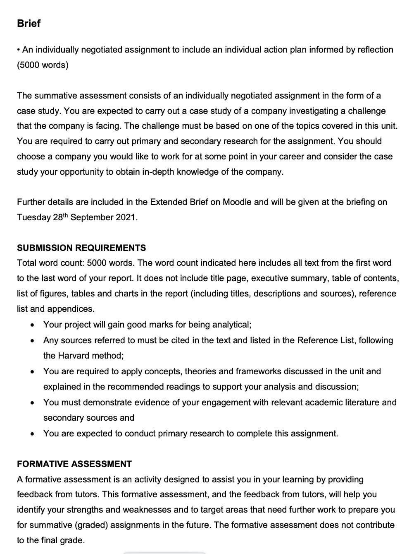
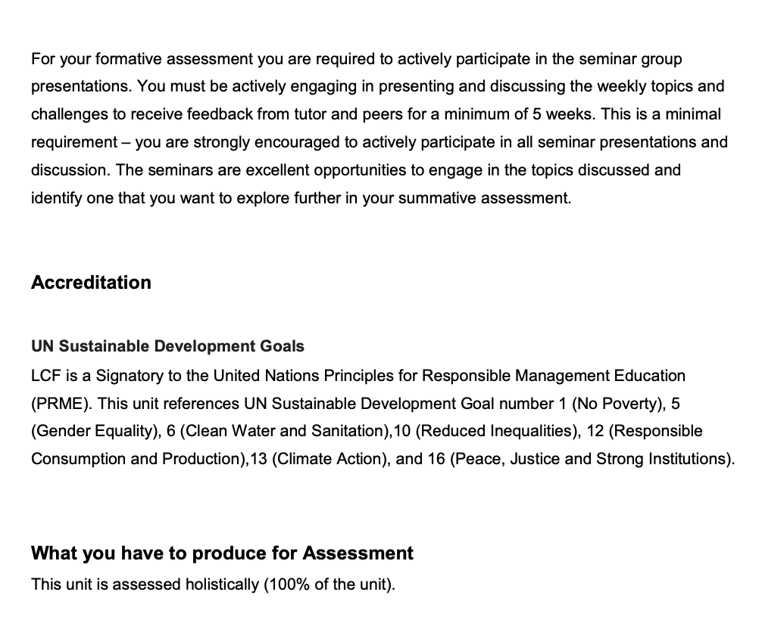

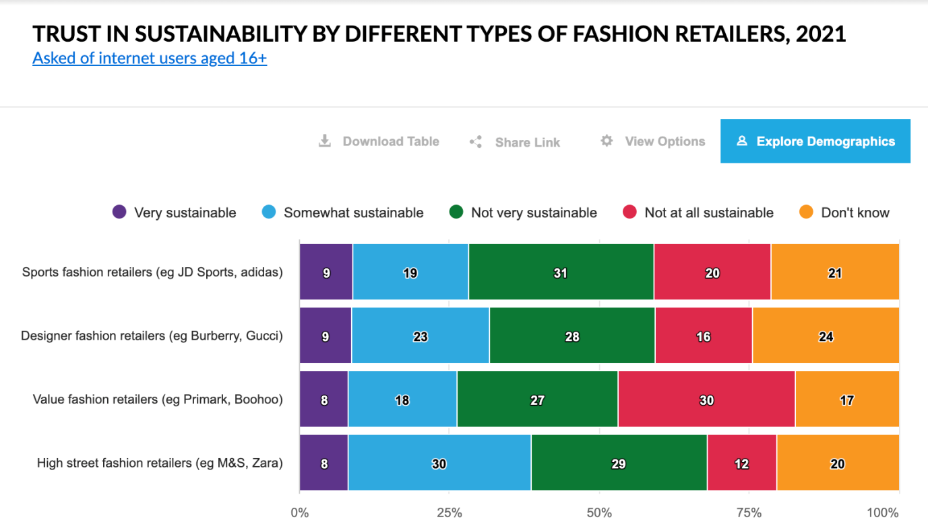
Appendix A

(Mintel, 2021).

Appendix B

Two consumer interviews were conducted to understand the consumer perception of sustainable initiatives taken by Zara and how it impacts Zara’s brand image and influence their shopping behaviour.

Data Table

Responses  Participant A & B | Code | Item
A “two to three times per month”  B “it twice a month probably” | Shopping Frequency | Sustainable Consumption
A” because it is a bit cheaper … more accessible to me” ”.. and I would want to buy from a sustainable brand …I don't have the resources to pay an extra”  B “sale happens it increases desire” | Accessibility
A “I see a product that's sustainable” “organic, materials, sustainable recycled ones plus and if they are not plastic”  B “the care labels sometimes I want something that can be like easy cared like for example” | Product Material
A “to some charitable organisations”” give them to either friends family”” like buying from a thrift store”  B “like give to some relatives”” second-hand clothing” ”we sold it on vestiaire collective”” we sold it on vestiaire collective” Buyback programme “I think there's like a shift of like in minds like all my mindset like from fast fashion to slow fashion now I'd rather invest in more long lasting clothing rather” | End of Use Product / Engagement in Circular
A” I already love Zara … not like the best made garments”  B “Zara used to be my favourite or like go to brand for like fast fashion”” Zara has everything to offer”” it's a place where I like to get inspiration” | Likeability | Zara’s Brand Image
A” because … Zara I don't really trust”  B “slightly a bit more expensive like on their sustainable line.. I think there's like a shift of like in minds like all my mindset like from fast fashion to slow fashion now I'd rather invest in more long-lasting clothing rather” “… but to me gives me an impression of a fast fashion.. don't really convince me” | Sustainability
A” be more transparent with..”” if you're not that transparent I think it doesn't really matter because people will not believe”  B “as consumers we always blame brands.. demand and supply are like interconnected..”” and you can't be like 100% transparent “ | Expectation
..would change your favourite brands quickly?  A “yes…” “if they would change their policies and try to be more sustainable I will I will probably at one point only buy from Zara”  B not loyal or frequent shopper of zara “it's a place where I like to get inspiration”” my mindset like from fast fashion to slow fashion now I'd rather invest in more long lasting clothing rather” | Loyalty

The consent form and original transcription has been removed for confidentiality purposes.

Appendix C

Zara’s Join Life Collection pieces as an example of fabric content in their sustainable collection.
(Zara, No Date)
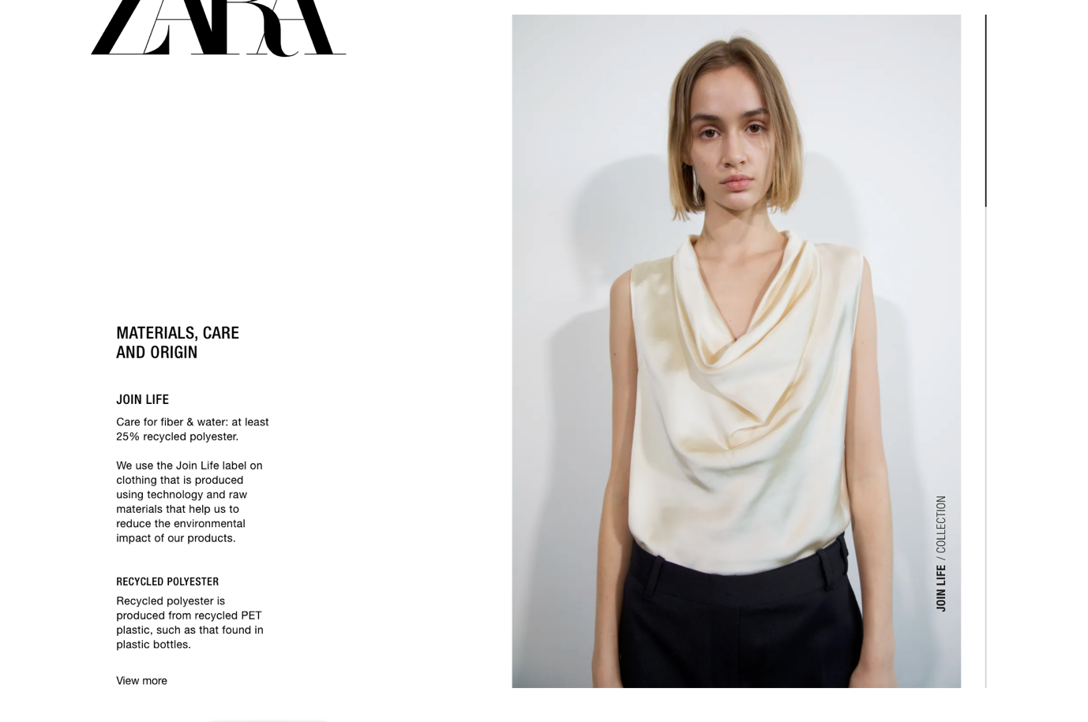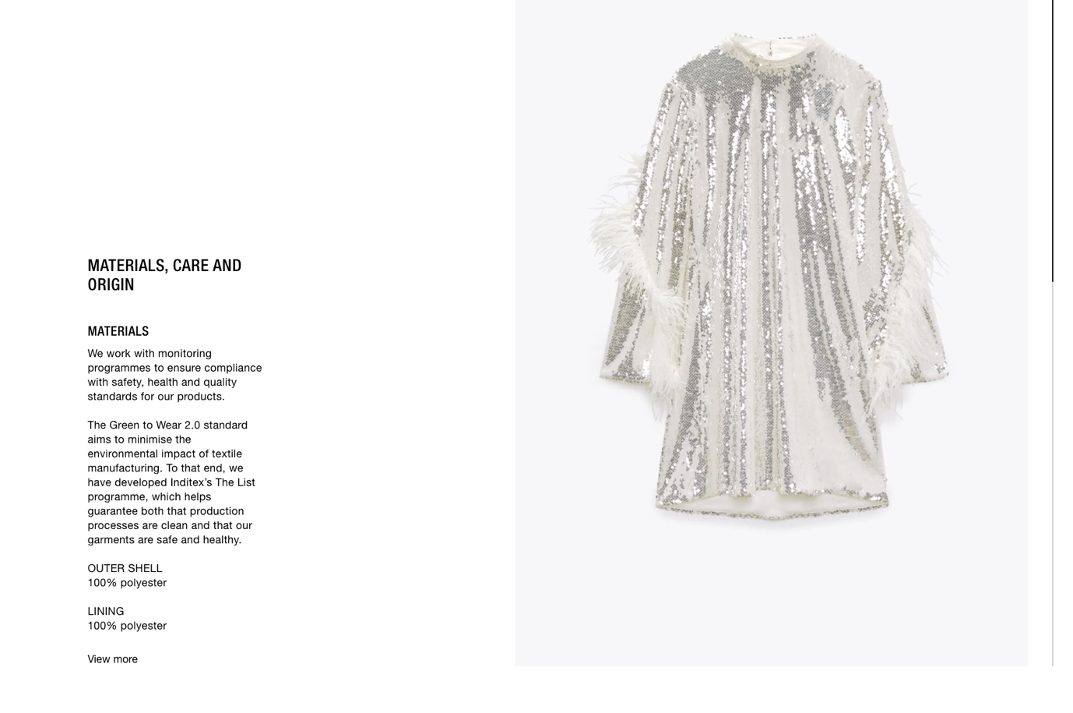
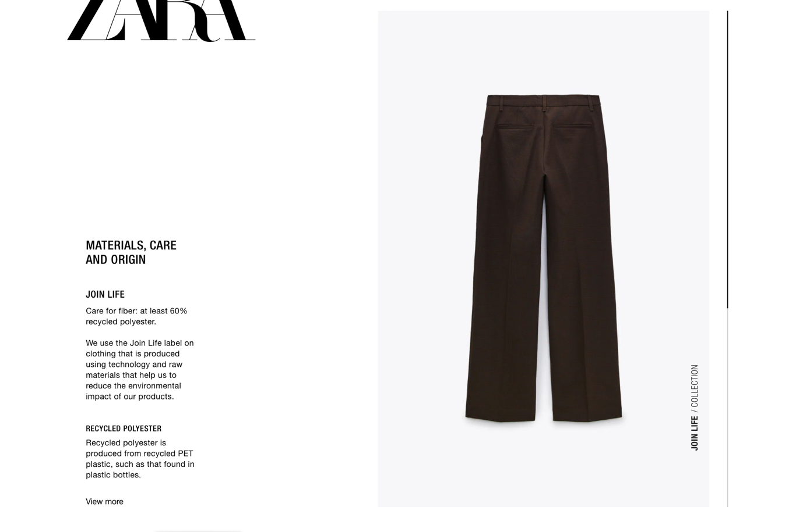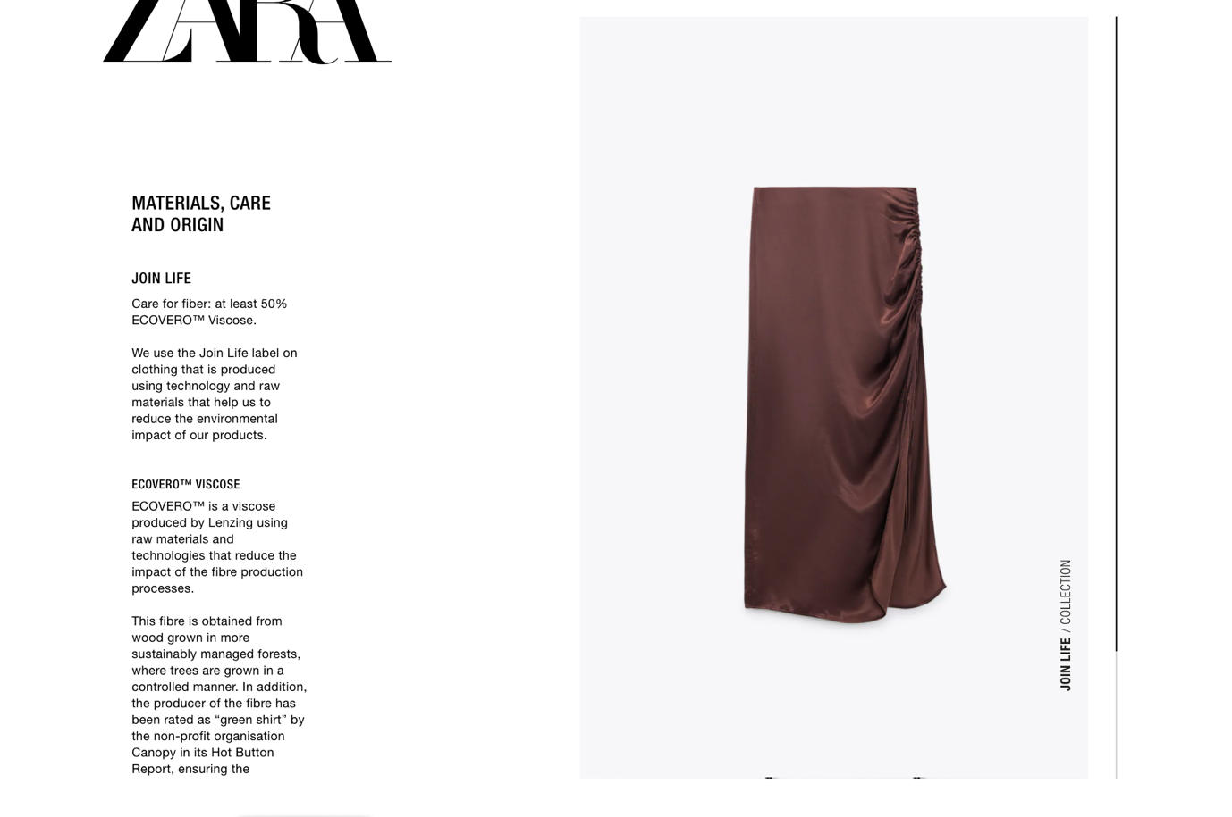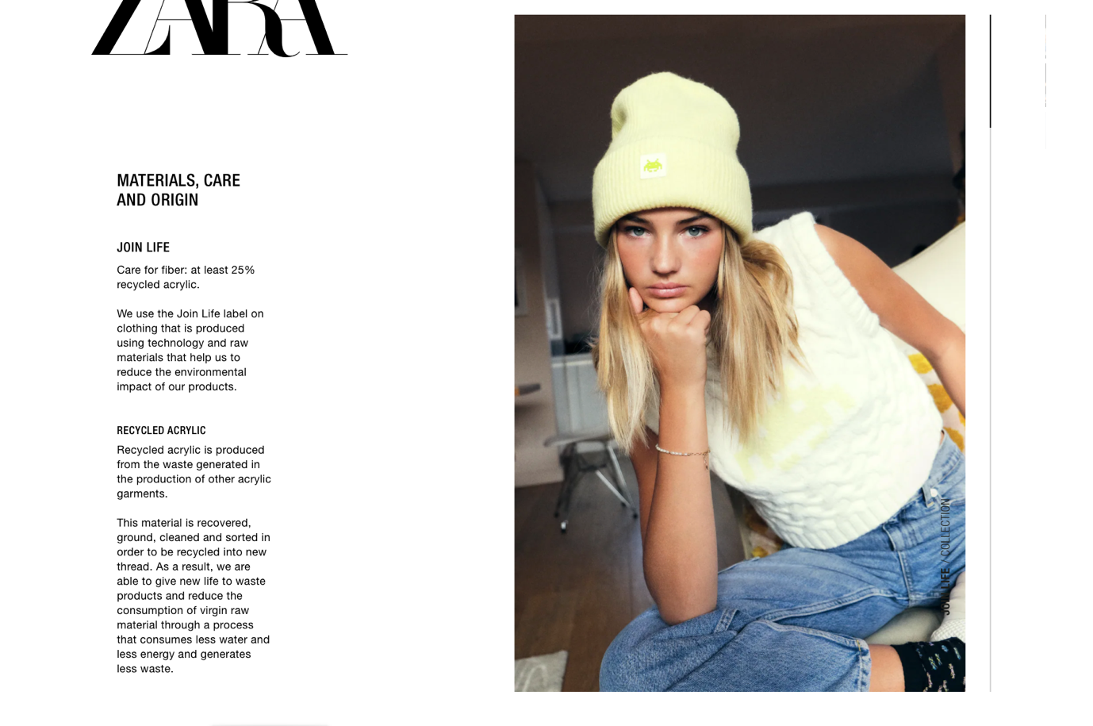
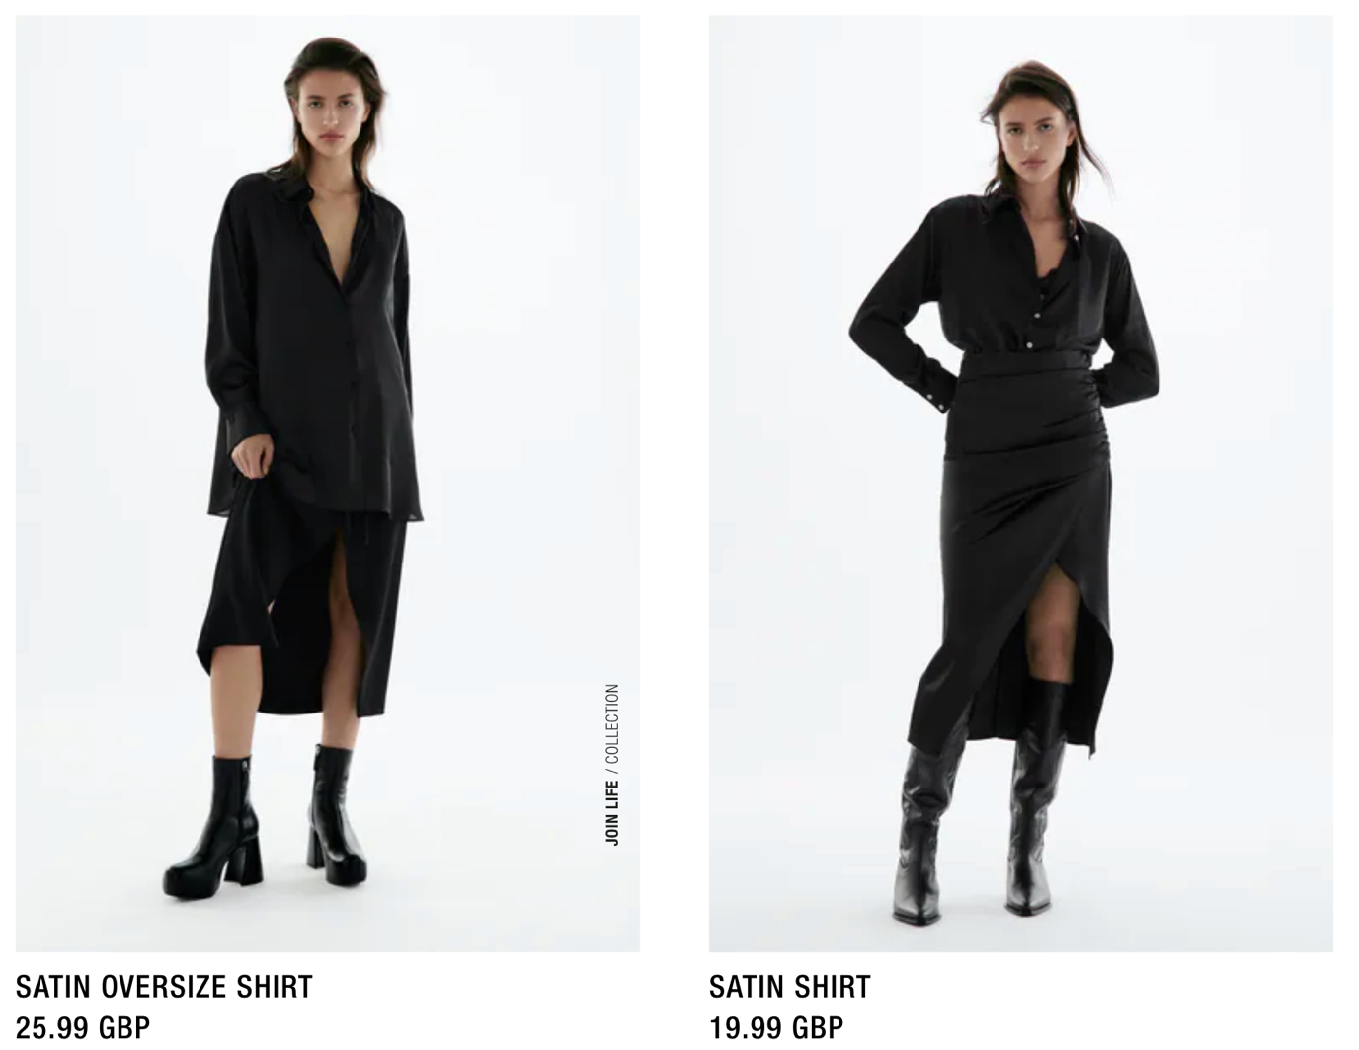
Join Life (left), Regular (right) – price comparison of ‘black satin shirt’.
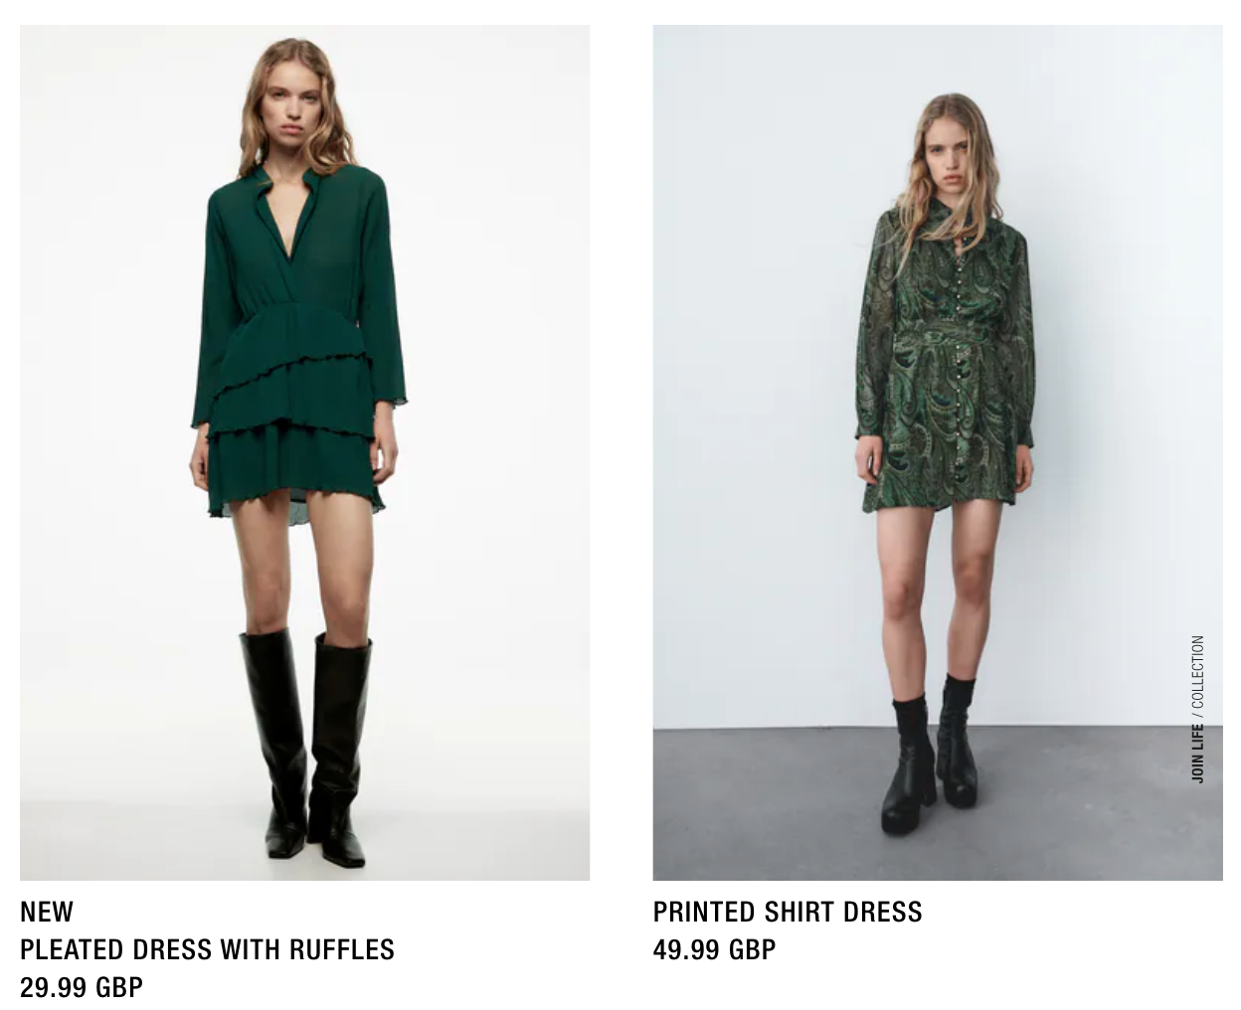
Join Life(right) Regular (left) – price comparison of ‘green dress’

