SUSTAINABILITY IN AFTERCARE: AN ANALYSIS OF CONSUMER INTENTION TO FOLLOW PRO-ENVIRONMENTAL CARE LABEL GUIDANCE

Heather Anne Portbury

***Course: MSc International Fashion Management***

***Institution: The London College of Fashion***

***University of the Arts London***

Entry: Postgraduate Dissertation Entry

Word Count: 2,743

**i. Declaration:**

*I, Heather Anne Portbury, certify that this is an original piece of work. I have acknowledged all sources and citations and no section of this MSc project has been plagiarised. No portion of the work referred to in this dissertation has been submitted in support of an application for another degree or qualification of this institution or any other university or other institution of learning.*

**iii. Abstract**

**Research Context and Purpose:** Accounting for a significant part of the environmental impact of clothing, environmental issues surrounding the Use phase and the aftercare of garments is beginning to be recognised by both consumers and fashion retailers. With an increase in fashion retailers implementing pro-environmental care label communication strategies such as ‘Think Climate – Wash at 30°C’ and lack of clarity regarding their success, with the use of academic literature on pro-environmental behaviour theory, this study proposes a novel theoretical framework to understand ‘what drives consumer intention to follow pro-environmental care label guidance?’. This research aims to contribute to achieving two of the UN Sustainable Development Goals; “To ensure sustainable consumption and production patterns” and “To take urgent action to combat climate change and its impacts” (UN, 2018).

**Contribution**: This research contributes to pro-environmental behaviour studies by offering an insight into a significantly underexplored topic area of pro-environmental laundry behaviour. Furthermore, the theoretical model proposed embodies a novel understanding of previously identified factors that predict pro-environmental behavioural intention and furthers research in understanding the drivers behind pro-environmental behaviour. Thereby, the research findings provide valuable information for both UK and International Fashion Management on pro-environmental care label communication strategies from a millennial consumer perspective. In this way, this research contributes to the UN Sustainable Development Goals by providing specific empirical research relating to encouraging pro-environmental behaviour and thereby reducing the impact of climate change and encouraging the responsible and sustainable consumption of clothing.

**Keywords:** Care label, Sustainability, Pro-environmental behaviour, Aftercare, Laundry behaviour.

**iv. Table of Contents**

CHAPTER ONE: INTRODUCTION 6

1.0 Background 7

1.1 Rationale 11

1.1.1 UK Consumers 12

1.1.2 Millennials 13

1.1.3 Domestic Machine Washing 14

1.1.4 Pro-environmental Care Label Guidance 15

CHAPTER TWO: RESEARCH AIMS AND OBJECTIVES 16

2.0 Research Aims and Objectives 17

CHAPTER THREE: LITERATURE REVIEW SUMMARY19

3.0 Literature Review Summary - Theoretical Concepts and Frameworks 20

CHAPTER FOUR: OVERVIEW OF RESEARCH DESIGN21

4.0 Overview of Research Design22

CHAPTER FIVE: OVERVIEW OF RESEARCH FINDINGS24

5.0 Overview of Research Findings25

REFERENCE LIST26

APPENDICES35

APPENDIX 1: INDIVIDUAL LEARNING AGREEMENT 36

APPENDIX 2: RESEARCH ETHICS APPROVAL FORM 37

v. List of Figures

Figure 1.1- Contribution of each lifecycle stage to the carbon footprint of UK clothing in 2012 and 2016 9

Figure 1.2- Results from The Nielson Global Home-Care Survey in 201513

Figure 1.3- Aims and Objectives 18

**Chapter One**

**INTRODUCTION**

**CHAPTER ONE: INTRODUCTION**

**1.1. Background**

According to the World Economic Forum, environmental concerns now [dominate the most dangerous risks facing the world](https://www.weforum.org/agenda/2018/01/humanity-s-most-existential-risks-are-getting-worse-heres-why) (World Economic Forum, 2018). Euromonitor’s 2018 global trend report further identifies environmental concern as a pressing issue in today’s business climate, asserting that “sustainability and social responsibility is no longer enough, and in 2018 consumers will seek more radical transparency from brands” (Euromonitor International, 2018). The urgency for sustainable action has been further stressed by the UN Sustainable Development Goals, in which both the need for action against climate change and responsible consumption and production has been identified as a target to “achieve a better and more sustainable future for all” (UN, 2018).

Widely defined using the definition from the Brundtland Commission (1987) as, “the ability to meet the needs of the present without compromising the ability of future generations to meet their own needs” (Brundtland Commission (1987, p.16), sustainability is predicted to be at the centre of innovation in the fashion industry in 2018 (Business of Fashion and McKinsey & Company, 2017). It said to evolve from being fragmented initiatives to being an “integral and defining part across the entire fashion value chain” (Business of Fashion and McKinsey & Company, 2017).

With a predicted rise in sustainable spending (Stott, 2017b) and identified as a retail priority in 2018 (WGSN, 2018a), there are numerous potential benefits of a business adopting a sustainable approach, including; increased revenue growth, competitive advantages, fostering of innovations, higher productivity, increased consumer base, cost advantages, gained consumer loyalty and a wider talent pool (Business of Fashion and McKinsey & Company, 2017; Passport, 2017; Accenture, 2018).

In an attempt to be more sustainable, numerous fashion brands have used the lifecycle assessment as a measurement tool to quantify the environmental impact of garments (Kering, 2010; Marks and Spencer, 2015; H&M, 2018; Stella McCartney, 2018a; Levis Strauss & Co, 2018b). However often overlooked, the Use phase within this model, which encompasses the washing drying and ironing of clothes (Carbon Trust, 2011; Muthu, 2015; WWF, 2017), plays a significant part in the environmental impact of clothing (DEFRA, 2009; Carbon Trust, 2011; Wrap, 2017; ECAP, 2017; UKFT, 2017).

In a life cycle assessment study on a cotton T-shirt by the Carbon Trust, the Use phase was found to have the highest CO**2** emissions out of all other clothing supply chain activities combined (Carbon Trust, 2011). Furthermore, as depicted in Figure 1.1, a study by Waste and Resources Action Programme (Wrap) supported by the European Clothing Action Plan (ECAP), highlighted the significant contribution of the Use phase in comparison to the other lifecycle stages within the UK from 2012 to 2016 (Wrap, 2017).

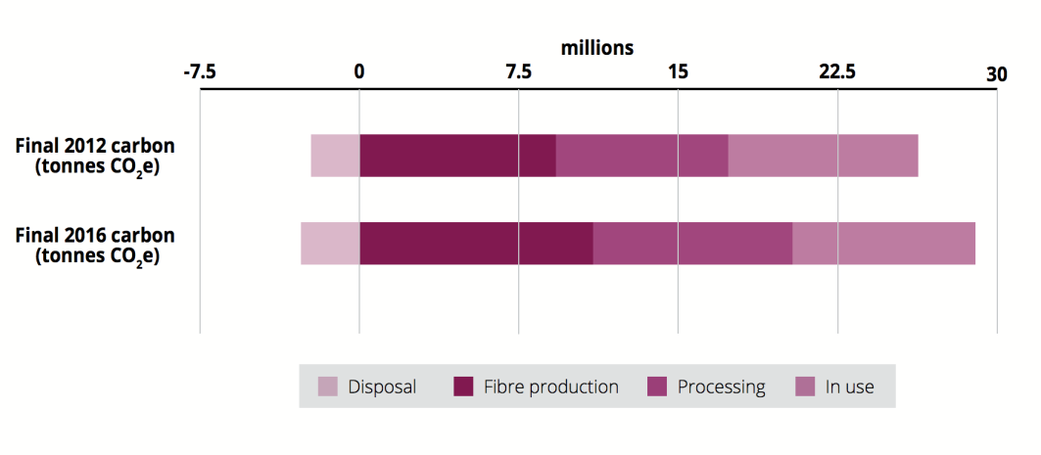

Figure 1.1 Contribution of each life cycle stage to the carbon footprint of UK clothing in 2012 and 2016 (Wrap, 2017)

The Department for Environment, Food and Rural Affairs (DEFRA), has also highlighted the environmental impacts of the washing, drying and Ironing of clothes and linked these to the consumption of water, energy, detergent and solvents (DEFRA, 2009). Differing on the nature and physical property of the clothing fibre mix, the environmental impacts can include: resource use, water pollution, eutrophication, greenhouse gas emissions and potential toxicity impacts (DEFRA, 2009).

Also termed garment aftercare (Stott, 2017a), the environmental implications of processes in the Use phase are beginning to be recognised by consumers, with LSN Global having identified ‘Conscious Aftercare’ as being a growing micro trend among consumers (Stott, 2017a). The UK Fashion and Textile Association (UKFT), has also highlighted that laundering in particular is now one of the areas that people are seeking to reduce their environmental impact (UKFT, 2017). In addition, there is progressive research relating to sustainability in aftercare, surrounding the issues associated with microfibres and machine washing (Ellen MacArthur Foundation, 2017; Patagonia, 2017; The Future Laboratory, 2017).

External to the fashion industry, campaigns have been developed to encourage consumers to be more environmentally conscious when washing, such as the ‘I prefer 30’ campaign (Iprefer30, 2017), AEG’s ‘Don’t Overwash’ campaign (AEG,2017a) and the ‘Turn to 30’ campaign led by Procter and Gamble UK (Procter and Gamble, 2018).

It is said that by directly communicating with the consumer at the point of action, care label instructions can significantly reduce the environmental footprint of a garment (Gardetti and Torres, 2017; Ross and Sopcich, 2017). Some fashion retailers have adopted care label communication strategies as a solution to the environmental problem of aftercare, displaying pro-environmental guidance such as ‘Think Climate – Wash at 30°C’ in attempt to encourage lower impact laundry behaviours (e.g. Marks and Spencer, 2007).

Whilst retailers such as Stella McCartney, H&M and New Look have adopted the ‘Clevercare’ care symbol on the care label to direct consumers to a website on the “best practices for sustainable textile care” (UKFT, 2017; New Look, 2018; Stella McCartney, 2018b), fashion companies such as Not Just a Label, Marks and Spencer, Levi’s and Reformation communicate pro-environmental guidance directly on to the care label (Marks and Spencer, 2007, Culotta, 2017; Not Just A Label, 2017; Levis Strauss & Co, 2018a).

Despite the increasing implementation of such campaigns, there is very little academic or industry research to determine whether or not this pro-environmental care label guidance would be, or indeed, is read and followed by the consumer. Furthermore, with research to suggest that many consumers laundry behaviours are engrained with habits and conventions (Rigby, 2013; AISE, 2015; AEG, 2017b; The Future Laboratory, 2017; Wrap, 2017), this research seeks to explore and explain relevant factors that can influence consumer intention to follow pro-environmental care label guidance, posing the research question ‘what drives consumer intention to follow pro-environmental care label guidance?’.

**1.2 Rationale**

It is said that in order to effectively mitigate climate change, people need to adopt environmentally-friendly actions (Werff et al., 2014). Within academia, pro-environmental behaviour can be defined as “behaviour that consciously seeks to minimise the negative impact of one’s actions on the natural or built world” (Kollmuss and Agyeman 2002, p. 240) where “behaviour” in this instance refers to those personal actions that are directly related to environmental improvement (Stevenson et al., 2014). Within the context of this study, the pro-environmental behaviour of interest is following pro-environmental care label guidance resulting in the reduction of domestic washing machine temperature, as an example.

Within academic literature, several socio-psychological theories and models have evolved to explain and predict pro-environmental behaviour (e.g. Olander and Thøgersen, 1995; Kolmuss and Agyeman, 2002; Phipps et al., 2013). Supporting empirical research in this context is largely focused on analysing the determinants of various pro-environmental behaviours such as recycling, green purchasing and energy reduction (e.g. Kinnear et al., 1974; Ellen et al., 1991; Knussen and Yule, 2008; Paul et al., 2016). However, there is a significant gap within the literature, with very little both, credible and empirical academic research on pro-environmental behaviour in relation to laundry behaviours and laundry habits. Furthermore, there is a significant lack of research from a UK consumer perspective.

This study seeks to address these issues and to contribute to both theory and management by the development of a statistically tested theoretical framework, embodying a unique and novel understanding of consumer intention to follow pro-environmental care label guidance. On a basis of the findings of this research, UK and International Fashion Management can gain an in-depth understanding into factors that form a consumer’s intention to follow pro-environmental care label guidance and further benefit from the contribution of original ideas proposed as reliable recommendations. The findings of this research also seeks to assist understanding of the managerial implications applicable to implementation of pro-environmental care label communication strategies.

In summary, it can therefore be seen that there is clear and credible evidence to support furthering research on pro-environmental care label guidance, and thereby contribute to the theoretical and managerial understanding of this subject area. The following sections define and provide the rationale for the scope of this research.

*1.2.1 UK Consumers*

Research suggests that laundry practices tend to differ considerably depending on the location of the consumer (AISE, 2014; Iprefer30, 2015; The Nielson Company, 2016; Ross and Sopcich, 2017). Figure 1.2 shows the results from Nielson’s study which highlights the differences in laundry habits across different regions of the world. Greenearth Cleaning generalises that in developed countries, as machine wash temperatures decrease, laundry detergent use increases and that within the EU, consumers frequently wash clothes on two basic cycles, ‘whites’ and ‘colours’ (Ross and Sopcich, 2017).

In light of this research identifying these differing global laundry practices, and to ensure reliable recommendations, this research is therefore based on the UK consumer response only.

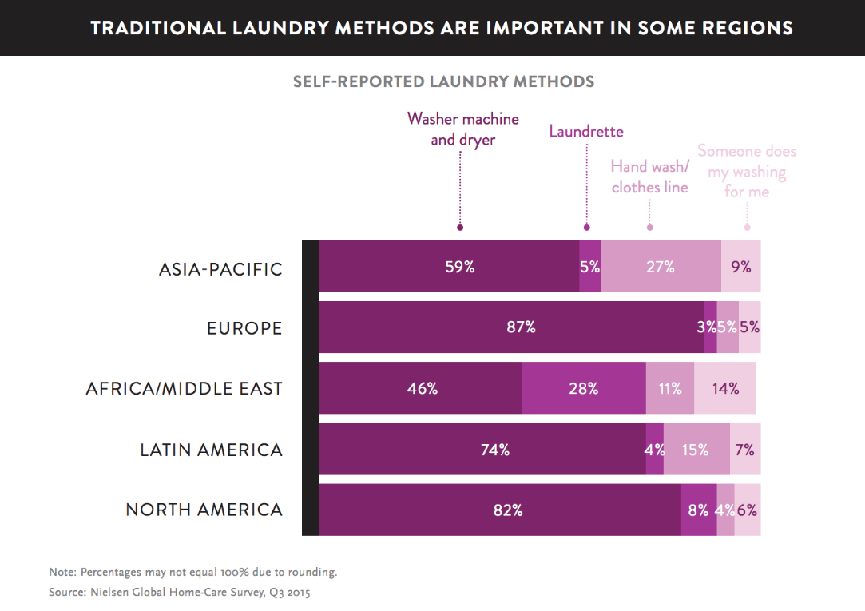

Figure 1.2 Results from The Nielson Global Home-Care Survey in 2015 (The Nielson Company, 2016)

*1.2.2 Millennials*

Millennials present an important consumer group for businesses seeking to adopt a sustainable approach (Morgan Stanley, 2017; WGSN, 2018b). Results from the World Economic Forum's Global Shapers Survey 2017 reports that nearly half (48.8%) of the participants aged 18-35, chose climate change as their top concern, and 78.1% said they would be willing to change their lifestyle to protect the environment (World Economic Forum, 2017).

Furthermore, Business of Fashion claims that 66% percent of global millennials, defined as those born between 1982-1999, are willing to spend more on brands that are sustainable (Business of Fashion and McKinsey & Company, 2017). This is further supported by the findings of the results of Nielsen’s survey, claiming that millennials, defined as between the ages of 21-34 in 2014, represent 51% of the global respondents who were willing to pay extra for sustainable products (The Nielsen Company, 2014).

Millennials are therefore a highly relevant consumer group from a business perspective in relation to this research context, and in recognition of this, the sample population for this research was formed of millennials only. With no consistent definition of the age specification of millennials, and in order to inclusively encompass the millennial age ranges typically specified within industry reports, this research uses Mintel Academic’s definition of millennials as “those born between 1980-1999”, therefore aged between 19-38 in 2018 (Mintel Academic, 2017). This age range represents 26% of the UK population in 2016 based on data from the Office of National Statistics (ONS, 2018).

*1.2.3 Domestic Machine Washing*

With 97% of households in the UK owning a washing machine in 2016 (ONS, 2017a), it can be determined that domestic machine washing is likely to be a common laundry practice for the average UK citizen. It was therefore decided that it would be most relevant to define the scope of this study to pro-environmental care label guidance that is focused on domestic machine washing only. This choice can be further supported by research that suggests the use of washing machines is predicted to increase on a global scale by 2030 as a result of a predicted rise of the global middle class (The Nielsen Company, 2016).

*1.2.4 Pro-environmental Care Label Guidance*

This research will example pro-environmental care label guidance that seeks to reduce one of the most environmentally demanding aspects of machine washing, the heating of the water (Dupont Industrial Biosciences, 2012; EPA, 2014; Iprefer30, 2017; Ariel, 2018).

Persuading the consumer to reduce the washing machine temperature from 40°C to 30°C is strongly encouraged by both environmental research bodies and detergent leaders, Unilever and Procter and Gamble (DEFRA, 2009; Energy Saving Trust, 2017; Wrap, 2017; Ariel, 2018; Persil, 2018). According to this research, it is said that if all UK citizens washed their clothes at 30°C instead of 40°C, the UK would save 12% of the energy that is currently consumed on clothes washing annually (DEFRA, 2009). It can also be said that washing at lower temperatures can help to improve the longevity of the garment (AEG, 2017a; Iprefer30, 2017; Ross and Sopcich, 2017; Ariel, 2018; Persil, 2018).

**Chapter Two**

**RESEARCH AIMS AND OBJECTIVES**

**2.0 Research Aims and objectives**

The purpose of this study was to quantitatively analyse the consumer intention of UK millennials to follow pro-environmental care label guidance. To achieve this, a critical review of existing theories and models on pro-environmental behaviour has identified relevant factors to consumer intention to follow pro-environmental care label guidance. The research hypotheses and theoretical framework formed on the basis of this literature review was tested to analyse their predictive ability on consumer intention to follow pro-environmental care label guidance. Furthermore, the moderating role of habitual behaviour was further tested on the relationships between the identified factors and consumer intention to follow pro-environmental care label guidance. The results of these findings were used to inform suggestions and recommendations on pro-environmental care label communication strategies for both UK and International Fashion Businesses.

Figure 1.3 below provides a summary of the aims and objectives for this research study.

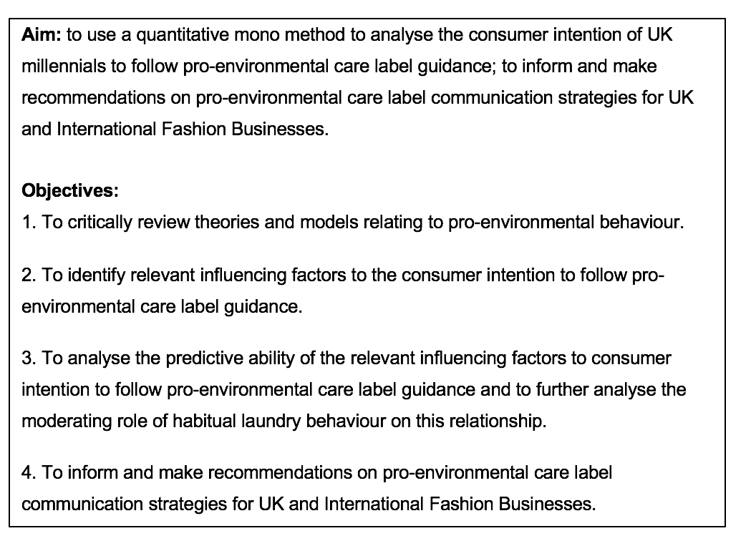 Figure 1.3 Aims and Objectives

**Chapter Three**

**LITERATURE REVIEW SUMMARY**

**3.0 Literature Review Summary - Theoretical Concepts and Frameworks**

Ajzen’s Theory of Planned Behaviour states that the strongest predictor of a given behaviour is the individual’s intention to perform this behaviour (Ajzen, 1985; 1991). Within the context of this study, this intrinsic link between intention and behaviour identified in the Theory of Planned Behaviour forms the basis for the literature review and the theoretical framework proposed. However, the Theory of Planned Behaviour has been critiqued by theorists such as Kollmuss and Agyeman (2002) and Phipps et al. (2013) for not accounting for various personal (e.g. motivation, emotion, awareness or attitudes) and situational (e.g. social norms, other attractive choices or economic constraints) factors which are directly relevant within the context of pro-environmental behaviours. This research therefore further examines relevant theory and models and identifies factors that are considered likely to predict a consumer’s intention to follow pro-environmental care label guidance. In recognition of pro-environmental theories proposed by both Phipps et al. (2013) Reciprocal Determinism Theory and Ölander and Thøgersen’s (1995) Motivation-Opportunity-Abilities (MOA) model which consider habitual behaviour, this study further considers the influence of habitual laundry behaviour.

**Chapter Four**

**OVERVIEW OF RESEARCH DESIGN**

**4.0 Overview of Research Design**

Based on the ‘Research Onion’ by Saunders et al. (2015), the research philosophy for this research is to adopt the position of a positivist (Saunders at al., 2015). As the aim and the objectives of this research were to test theory, a deductive approach was implemented (Bryman and Bell, 2015; Saunders et al., 2015). In line with this deductive approach, a mono-method quantitative research design was chosen (Saunders et al., 2015) with a survey strategy used in order to collect the necessary data to test the hypotheses within the theoretical framework and to meet the objectives.

The survey strategy employed an online self-completion questionnaire in order to collect data from the millennial population (Saunders et al., 2015). As often employed in a survey strategy (Saunders et al., 2015), the time horizon of this study was cross sectional (Saunders et al., 2015). In order to obtain the data on the millennial population, non-probability convenience sampling technique was used (Bryman and Bell, 2015; Saunders et al., 2015). A convenience sample was obtained by sharing a questionnaire on online platforms that were suitable to the millennial population. Measures were taken to make the sample as representative and accurate of the UK millennial population as possible (Saunders et al., 2015) and to reduce the social desirability bias.

Responses obtained from the online self-completion questionnaire and the data collected was analysed with both Multiple Linear Regression and Moderated Multiple Regression using SPSS software to test the hypotheses within the theoretical framework and to meet the objectives.

**Chapter Five**

**OVERVIEW OF RESEARCH FINDINGS**

**5.0 Overview of Research Findings:**

Result findings support previous theoretical and empirical research to suggest that perceived consumer effectiveness, trust and habitual behaviour significantly predict pro-environmental behaviour. Specifically, both trust in the care label and perceived consumer effectiveness positively predict and habitual laundry behaviour negatively predicted consumer intention to follow pro-environmental care label guidance. A further critical finding from the study found was that, although 80% of the millennial sample population would be more likely than not to follow pro-environmental care label guidance, 68% of the respondents stated either ‘sometimes’ or ‘no’ to reading the care label.

This research contributes to pro-environmental behaviour studies by offering an insight into a significantly underexplored topic area of pro-environmental laundry behaviour. Furthermore, the theoretical model proposed embodies a novel understanding of previously identified factors that predict pro-environmental behavioural intention and furthers research in understanding the drivers behind pro-environmental behaviour. Thereby, the research findings provide valuable information for both UK and International Fashion Management on pro-environmental care label communication strategies from a millennial consumer perspective.

**REFERENCE LIST**

**REFERENCE LIST**

Accenture (2018) *Why a Sustainable Supply Chain is Good Business.* Available at: <https://www.accenture.com/gb-en/insight-outlook-why-sustainable-supply-chain-is-good-business>. (Accessed: 11 May 2018).

AEG (2017a) *We Want to Break Today’s Care Habits.* Available at: <https://www.aeg.co.uk/care/inspiration/care-label-project/> (Accessed: 16 April 2018).

AEG (2017b) *The Care Label Project.* Available at: <https://www.aeg.co.uk/siteassets/common-assets/04.-care/inspiration/clp/care_label_project_lookbook.pdf> (Accessed: 16 April 2018).

AISE (2014) *Pan-European Consumer Survey on Sustainability and Washing Habits.* Available at: <https://www.aise.eu/documents/document/20151020151708-aise_consumershabitssurvey_summary2015-def.pdf> (Accessed: 16 April 2018).

AISE, (2015) *I Prefer 30° Campaign Close Out Report October 2015.* Available at: <https://www.aise.eu/documents/document/20151102163916-ip30-report-2015_full_version_no_annexes.pdf> (Accessed: 16 April 2018).

Ajzen, I. (1985) *From intentions to actions: A theory of planned behavior*. Heidelberg: Springer.

Ajzen, I. (1991) ‘The theory of planned behavior’, *Organizational Behavior and Human Decision Processes*, 50(2), pp.179-211.

Ariel (2018) *How to save energy.* Available at: <https://www.ariel.co.uk/en-gb/about-ariel/sustainability/your-commitment-how-you-can-save-energy> (Accessed: 16 April 2018).

Brundtland Commission. (1987) *Our Common Future.* Oxford: Oxford University Press.

# Bryman, A. and Bell, E. (2015) *Business research methods*. Cambridge; New York: Oxford University Press. 4th edn.

# Business of Fashion and McKinsey & Company (2017) *The State of Fashion 2018.* Available at: <https://cdn.businessoffashion.com/reports/The_State_of_Fashion_2018_v2.pdf> (Accessed: 14 April 2018).

Carbon Trust (2011) *Clothing*. Available at: <https://www.carbontrust.com/media/38358/ctc793-international-carbon-flows-clothing.pdf> (Accessed: 16 April 2018).

Culotta, D. (2017) *Care For What You Wear: An Interview with Reformation’s Kathleen Talbot.* Available at: <https://a.eecosphere.com/articles/care-for-what-you-wear-an-interview-with-reformations-kathleen-talbot>. (Accessed: 16 April 2018).

DEFRA (2009). *Reducing the environmental impact of clothes cleaning.* Available at: randd.defra.gov.uk/Document.aspx?Document=EV0419_8628_FRP.pdf (Accessed: 14 April 2018).

Dupont Industrial Biosciences (2012) *Why Wash at 30*[°C.](http://fhc.biosciences.dupont.com/30for30/30-for-30-laundry-challenge-archive/why-wash-at-30oc/30for30/30-for-30-laundry-challenge/why-wash-at-30oc/soil-removal/)Available at:<http://fhc.biosciences.dupont.com/30for30/30-for-30-laundry-challenge-archive/why-wash-at-30oc/> (Accessed: 14 April 2018).

ECAP (2017) *Mapping Clothing Impacts in Europe (2017)* Available at: <http://www.ecap.eu.com/wp-content/uploads/2017/12/Mapping-clothing-impacts-in-Europe.pdf> (Accessed: 16 April 2018).

Ellen MacArthur Foundation (2017) *A New Textiles Economy: Redesigning Fashion’s Future.* Available at: <https://www.ellenmacarthurfoundation.org/assets/downloads/A-New-Textiles-Economy_Full-Report_Updated_1-12-17.pdf>. (Accessed: 16 April 2018).

Ellen, P. S. et al. (1991) ‘The role of perceived consumer effectiveness in motivating environmentally conscious behaviors’, *Journal of Public Policy and Marketing*, 10, pp.102-117.

Energy Saving Trust (2017) *Save Energy In Your Home.* Available at: <http://www.energysavingtrust.org.uk/sites/default/files/reports/EST_11120_Save%20Energy%20in%20your%20Home_15.6.pdf> (Accessed: 14 April 2018).

EPA (2014) ‘Earth Month Tip: Wash your clothes in cold water’, *The EPA Blog,* 30 April. Available at: https://blog.epa.gov/blog/2014/04/earth-month-tip-wash-your-clothes-in-cold-water/ (Accessed: 16 April 2018).

Euromonitor International (2018) ‘Top 10 Global Consumer Trends for 2018’. Available at: <http://go.euromonitor.com/white-paper-economies-consumers-2018-global-consumer-trends-EN.html> (Accessed: 14 April 2018).

Gardetti, M. and Torres, A. (2017) *Sustainability in Fashion and Textiles: Values, Design, Production and Consumption.* New York: Routledge.

H&M (2018) *How we report.* Available at: <http://sustainability.hm.com/en/sustainability/downloads-resources/about-our-reporting/how-we-report.html> (Accessed: 11 May 2018).

Iprefer30 (2015) *I Prefer 30° Campaign Close Out Report October 2015* Available at:<https://www.aise.eu/documents/document/20151102163916-ip30-report-2015_full_version_no_annexes.pdf> (Accessed: 16 April 2018).

Iprefer30 (2017) *Low Temperature Washing - I Prefer 30*. <http://www.iprefer30.eu/animations/UK/wash-brochure-uk.pdf> (Accessed: 14 April 2018).

Kering (2010) *Puma’s new packaging and distribution system to save more than 60% of paper and water annually.* Available at: http://www.kering.com/en/press-releases/pumas_new_packaging_and_distribution_system_to_save_more_than_60_of_paper_and_water (Accessed: 11 May 2018).

Kinnear, T.C. et al. (1974) ‘Ecologically concerned consumers: who are they?’, *Journal of Marketing*, 38 (2), pp.20-24.

Knussen, C. and Yule, F. (2008) ‘I'm not in the habit of recycling', The role of habitual behavior in the disposal of household waste. *Environment and Behavior*, 40, pp. 683-702.

Kollmuss, A. and Agyeman, J. (2002) ‘Mind the Gap: Why do people act environmentally and what are the barriers to pro-environmental behavior?’, *Environmental Education Research,* 3(8), pp.240-260.

Levis Strauss & Co (2018a) *Sustainability.* Available at: <http://www.levistrauss.com/sustainability/planet/#consumer-care> (Accessed: 16 April 2018).

Levis Strauss & Co (2018b) *Sustainability: Lifecycle Assessment.* Available at: <http://www.levistrauss.com/sustainability/planet/lifecycle-assessment/> (Accessed: 11 May

# Marks and Spencer (2007) *M&S Helps Customers To ‘Think Climate’ By Relabelling Clothing* [Press release]. 23 April. Available at: <https://corporate.marksandspencer.com/media/press-releases/archive/2007/23042007_mshelpscustomerstothinkclimatebyrelabellingclothing> (Accessed: 14 April 2018).

Marks and Spencer(2015) *how we define Plan A product attributes.* Available at: https://corporate.marksandspencer.com/documents/plan-a-our-approach/how-we-define-plana-product-attributes-june2015.pdf (Accessed: 11 May 2018).

Mintel Academic (2017) ‘Marketing to Older and Younger Millennials’. Available at: <http://academic.mintel.com.arts.idm.oclc.org/display/826619/> (Accessed: 24 April 2018).

Morgan Stanley (2017) *Sustainable Signals.* Available at:<http://www.morganstanley.com/pub/content/dam/msdotcom/ideas/sustainable-signals/pdf/Sustainable_Signals_Whitepaper.pdf> (Accessed: 11 May 2018).

Muthu, S. (2015) *Handbook of Life Cycle Assessment (LCA) of Textiles and Clothing.* Cambridge: Woodhead Publishing. 1st edn.

New Look (2018) *Changing our ways.* Available at: <http://www.newlookgroup.com/sustainability/environment> (Accessed: 16 April 2018).

Not Just A Label (2017) *What Is The Care Label Project And Why You Should Care?*. <https://www.notjustalabel.com/editorial/what-is-the-care-label-project-and-why-you-should-care> (Accessed: 16 April 2018).

Ölander, F. and Thøgersen, J. (1995) ‘Understanding Consumer Behaviour as Prerequisite for Environmental Protection’, *Journal of Consumer Policy*, 18, pp. 345-385.

ONS (2017a) *Family spending in the UK: financial year ending March 2016.* Available at: <https://www.ons.gov.uk/peoplepopulationandcommunity/personalandhouseholdfinances/expenditure/bulletins/familyspendingintheuk/financialyearendingmarch2016> (Accessed: 14 April 2018).

ONS (2018) *Population Estimates for UK, England and Wales, Scotland and Northern Ireland.* Available at: <https://www.ons.gov.uk/peoplepopulationandcommunity/populationandmigration/populationestimates/datasets/populationestimatesforukenglandandwalesscotlandandnorthernireland> (Accessed: 1 May 2018).

Passport (2017) ‘How to Incorporate the Sustainable Development Goals into Business Strategy’.Available at: [https://www.portal.euromonitor.com/portal/analysis/tab#](https://www.portal.euromonitor.com/portal/analysis/tab) (Accessed: 16 April 2018).

Patagonia (2017) *An Update on Microfiber Pollution.* Available at: <https://www.patagonia.com/blog/2017/02/an-update-on-microfiber-pollution/> (Accessed: 14 April 2018).

Paul, J. et al. (2016) ‘Predicting green product consumption using theory of planned behavior and reasoned action’, *Journal of Retailing and Consumer Services*, 29, pp.123-134.

Persil (2018) *What Temperature Should I Use to Wash Clothes & Towels?.* Available at: https://www.persil.com/uk/laundry/laundry-tips/washing-tips/temperature-use-wash-clothes-towels.html (Accessed: 16 April 2018).

Phipps et al. (2013) ‘Understanding the inherent complexity of sustainable consumption: A social cognitive framework’, *Journal of Business Research*, 66(8), pp.1227-1234.

Procter and Gamble (2018) *Sustainability: Products and Packaging.* Available at: <https://www.pg.com/en_balkans/sustainability/products_packaging.shtml> (Accessed: 16 April 2018).

Rigby, E. (2013) *Laundry Behaviour.* Available at: <http://textiletoolbox.com/research-writing/design-reduce-energy-and-water-part-2/> (Accessed: 16 April 2018).

Ross, A. and Sopcich, S. (2017) *Caring for Clothes – The International Guide.* Rev. edn. Kansas City: Greenearth Cleaning.

Saunders, M. et al. (2015) *Research methods for business students.* New York: Pearson Education. 7th edn.

Stella McCartney (2018a) *Measuring our impact.* Available at: https://www.stellamccartney.com/experience/en/sustainability/measuring-our-impact/ (Accessed: 11 May 2018).

Stella McCartney (2018b) *The Clevercare Series.* Available at: <https://www.stellamccartney.com/experience/en/the-clevercare-series/> (Accessed: 4 December 2017).

Stevenson, R. et al. (2014) *International Handbook of Research on Environmental Education.* London: Routledge.

Stott, R. (2017a) Conscious Aftercare. Available at: <https://www-lsnglobal-com.arts.idm.oclc.org/micro-trends/article/21436/conscious-aftercare> (Accessed: 1 December 2017).

Stott, R. (2017b) Sustainable Spending. Available at: <https://www-lsnglobal-com.arts.idm.oclc.org/micro-trends/article/21661/sustainable-spending> (Accessed: 1 December 2017).

# The Future Laboratory (2017) *Sustainability Futures.* Available at: <https://info.thefuturelaboratory.com/hubfs/Sustainability%20Futures%20Report.pdf?submissionGuid=aa544ac2-1856-4fbe-b794-e227b28dcea2> (Accessed: 16 April 2018).

The Nielsen Company (2014) *Doing Well by Doing Good. Increasingly, Consumers Care About Corporate Social Responsibility, But Does Concern Convert to Consumption?* Available at: https://www.nielsen.com/content/dam/nielsenglobal/apac/docs/reports/2014/Nielsen-Global-Corporate-Social-Responsibility-Report-June-2014.pdf (Accessed: 14 April 2018).

The Nielsen Company (2016) *The Dirt On Cleaning Home Cleaning/Laundry Attitudes And Trends Around The World.* Available at: <http://www.nielsen.com/content/dam/nielsenglobal/eu/docs/pdf/Nielsen%20Global%20Home%20Care%20Report.pdf> (Accessed: 14 April 2018).

UAL (2018) *Code of Practice on Research Ethics.* Available at: <http://www.arts.ac.uk/media/arts/research/research-degrees/Code-of-Practice-on-Research-Ethics.pdf> (Accessed: 16 April 2018).

UAL (2018b) *University of the Arts London Guidance for Research Ethics Approval*. Available at: <https://www.falmouth.ac.uk/sites/default/files/download/2012-13%20Guidance%20on%20Ethics%20Approval.pdf> (Accessed: 16 April 2018).

UKFT (2017) *Care Labelling – washing and the environment.* Available at: <http://www.care-labelling.co.uk/washingandenvironment.html>. (Accessed: 27February 2018)

UN (2018) *About the Sustainable Development Goals*. Available at: <https://www.un.org/sustainabledevelopment/sustainable-development-goals/> (Accessed: 21December 2018)

Werff, E. et al. (2014), ‘I am what I am, by looking past the present: The influence of biospheric values and past behavior on environmental self-identity’, *Environment and Behavior*, 46, pp.626-657.

WGSN (2018a) *Retail Priorities 2018.* Available at: <https://www-wgsn-com.arts.idm.oclc.org/content/board_viewer/#/76043/page/5> (Accessed: 11 May 2018).

WGSN (2018b) *Shopper Forecast 2018.* Available at: <https://www-wgsn-com.arts.idm.oclc.org/content/board_viewer/#/76629/page/15> (Accessed: 11 May 2018).

World Economic Forum (2017) *Global Shapers Survey.* Available at: <http://www.shaperssurvey2017.org/static/data/WEF_GSC_Annual_Survey_2017.pdf> (Accessed: 14 April 2018).

World Economic Forum (2018) *The Global Risks Report 2018 13th Edition*. Available at: <http://www3.weforum.org/docs/WEF_GRR18_Report.pdf> (Accessed: 14 April 2018).

Wrap (2017) *Valuing Our Clothes: the cost of UK fashion.* Available at: <http://www.wrap.org.uk/sites/files/wrap/valuing-our-clothes-the-cost-of-uk-fashion_WRAP.pdf> (Accessed: 16 April 2018).

WWF (2017) *Changing fashion: The clothing and textile industry at the brink of radical transformation.* Available at: <https://www.wwf.ch/sites/default/files/doc-2017-09/2017-09-WWF-Report-Changing_fashion_2017_EN.pdf> (Accessed: 16 April 2018).

**APPENDICES**

**APPENDIX 1: INDIVIDUAL LEARNING AGREEMENT**



**APPENDIX 2: RESEARCH ETHICS APPROVAL FORM**





