Student Name: | Yaping Chen
Institution: | Queen’s University Belfast

CSR in the Post COVID-19 Era: An Old-fashioned Term or a Broadened Concept?
Abstract
As an important business concept, corporate social responsibility (CSR) has long been discussed since the 1950s. This ongoing discussion has led to various perspectives on how to define a responsible business. In recent years, terms such as Sustainable Development Goals (SDGs) and environmental, social, and governance (ESG) have attracted extensive public attention. The term “CSR” is less used and seems old-fashioned in the meantime. Moreover, in the challenging post COVID-19 conditions where businesses tend to deprioritise costly CSR initiatives and practices, the question arises as to whether CSR can keep momentum. This article explores the question by reviewing the research literature relevant to the evolving conceptualisation of and recent changes in “CSR”. The author argues that “CSR” may eventually be replaced by other trending terms. However, the conceptualisation of responsible business does not cease, and our understanding of CSR has been broadened. A conceptual framework (Figure 3) is proposed to show how SDGs, CSR, and ESG are interconnected and embedded into a responsible business’s module, strategy, activities, and long-term value creation process.
Keywords: Corporate social responsibility (CSR); Sustainable Development Goals (SDGs); Environmental, social, and governance (ESG); COVID-19; Responsible business.

The past decades have witnessed an ongoing debate on corporate social responsibility (CSR) among academics, corporate executives, government and policymakers, consultants, and practitioners. Meanwhile, relevant concepts have been created, discussed, and criticised, including business ethics, triple bottom line, corporate citizenship, and sustainable entrepreneurship. This intensive debate has led to various perspectives on how to define a responsible business. Recently, concepts such as Sustainable Development Goals (SDGs) and environmental, social, and governance (ESG) have attracted extensive attention, with relevant topics widely discussed in academic research, social media, policy papers and consultations, corporate reporting, and so on. As “SDGs” and “ESG” increasingly gain popularity, the term “CSR” is less used and seems old-fashioned nowadays. Moreover, given the financial crisis caused by COVID-19, businesses have deprioritised costly CSR initiatives and practices to overcome challenges including cost pressures and survival threats (Amankwah-Amoah, 2020). In the challenging conditions of the post-COVID-19 era, the question arises as to whether CSR, as a complex concept, can maintain momentum.
The origin of the debate on CSR in the modern era dates back to the 1950s when Bowen (1953) proposed the social responsibilities of a business. The continuous discussion has generated different views on “to whom an organisation has a responsibility” during the past decades (van Marrewijk, 2003, p. 96). Based on the classical view of CSR, the only responsibility of a business is to increase its profits (Friedman, 1962), and socially responsible activities are a major task of governments. This classical view indicates that companies only consider CSR to the extent that it contributes to the objective of business (i.e., to create wealth for their owners/shareholders).
The stakeholder view posits that companies should balance multiple stakeholder interests and be accountable not only to their shareholders, but also to various stakeholder groups that can affect or are affected by their business operation (Freeman, 1984). Originally formed in 1991, the well-known Carroll’s pyramid of CSR frames the nature of businesses’ responsibilities to society (Carroll, 1991), which is viewed as a “stakeholder framework” (Carroll, 2016, p. 6). The pyramid (Figure 1) encompasses, from bottom to top, four categories: economic responsibilities (“be profitable”), legal responsibilities (“obey laws and regulations”), ethical responsibilities (“do what is just and fair. Avoid harm”), and philanthropic responsibilities (“be a good corporate citizen”) (Carroll, 2016, p. 5). Each category addresses and balances different stakeholder priorities (Carroll, 2015; 2016). Economic responsibilities most significantly affect shareholders and employees, while legal responsibilities are important to business owners, employees, and consumers (Carroll, 2016). Ethical responsibilities are expected by society and typically affect employees, customers, and the environment, whereas philanthropic responsibilities largely affect the community, non-profit organisations, and employees (Carroll, 2016).
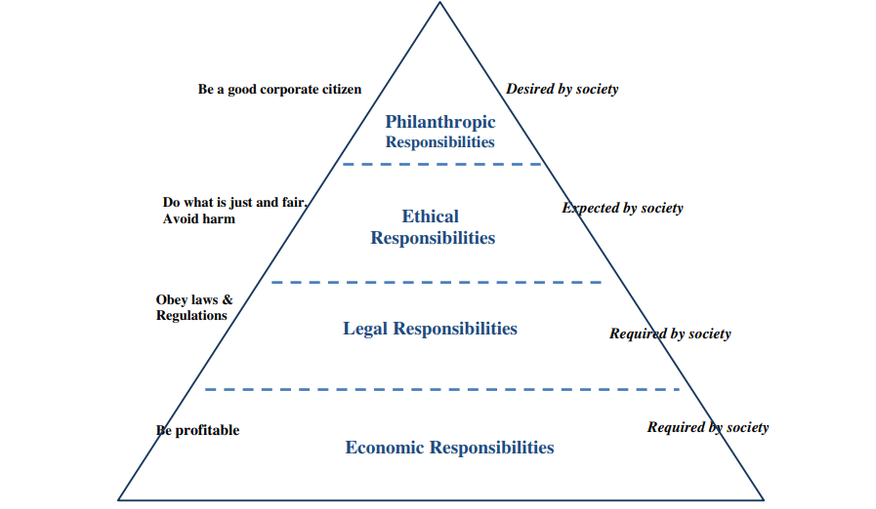
Figure 1: Carroll’s pyramid of CSR.
Source: Carroll (2016, p. 5).
The late 1990s saw the term “triple bottom line” (TBL) – coined by John Elkington in 1994 – take off (Elkington, 2013). Linked to CSR and sustainable development, the TBL represents a framework consisting of three dimensions of performance (social, environmental, and financial). It posits that companies should measure their social and environmental impacts, in addition to their financial performance, rather than merely focusing on profit maximisation (i.e., “the standard bottom line”) (Miller, 2020). With various stakeholder groups increasingly demanding information and benchmarking business performance, corporate management needs to progressively involve internal and external stakeholders, understand their legitimate needs, identify real priorities, and establish key CSR initiatives (Elkington, 2013). Both Carroll’s pyramid and Elkington’s TBL represent multidimensional definitional frameworks that have generated socially conscious semantics of a responsible business.
The societal (and broader) view of CSR considers companies responsible to society, of which they are an integral part (van Marrewijk, 2003). Public consent is regarded as a licence to operate. Companies can only continue to exist if society perceives them as adhering to a value system in line with society’s own value system (i.e., if they are perceived as legitimate by the public) (Gray et al., 2014). This societal view is a strategic response to new challenges faced by companies in this radically changing world, which requires them to rethink their business objectives and strategies. The evolution of CSR has been driven by factors including the growing concern about environmental and social issues, the shift in public opinion on corporate responsibility, and the promulgation of CSR-related regulations (Latapí Agudelo et al., 2019).
Notably, CSR is a broad concept lacking solid consensus which provides a foundation for action (Henderson, 2001). The terminology, definitions, and conceptual models of CSR are diverse and sometimes overlapping. Moreover, CSR is interpreted by various stakeholder groups (for example, employee unions, corporate managers, shareholders, investors, customers, governments, and non-governmental organisations) differently, and thus often biased towards specific stakeholder interests. The lack of a well-developed all-embracing definition may hinder the academic debate on, and the practical implementation of, CSR (Gobbels, 2002, van Marrewijk, 2003). On the other hand, van Marrewijk (2003) cations that an all-embracing definition can be too vague to be useful in theory and practice.
Relevant to CSR, terms such as “SDGs” and “ESG” have gained prevalence in recent years. At the heart of the 2030 Agenda for Sustainable Development [1], the 17 SDGs (Figure 2) [2] are an urgent call for action by all nations in a global partnership, which recognises that ending poverty and other deprivations must go together with strategies that improve health and education, reduce inequality, tackle climate change, preserve oceans and forests, and spur economic growth (United Nations, 2022a). According to KPMG (2022) [3], a significant majority of companies connect their business activities with the SDGs (particularly the ones linked to economic growth, climate change, and responsible consumption) in their corporate reporting.
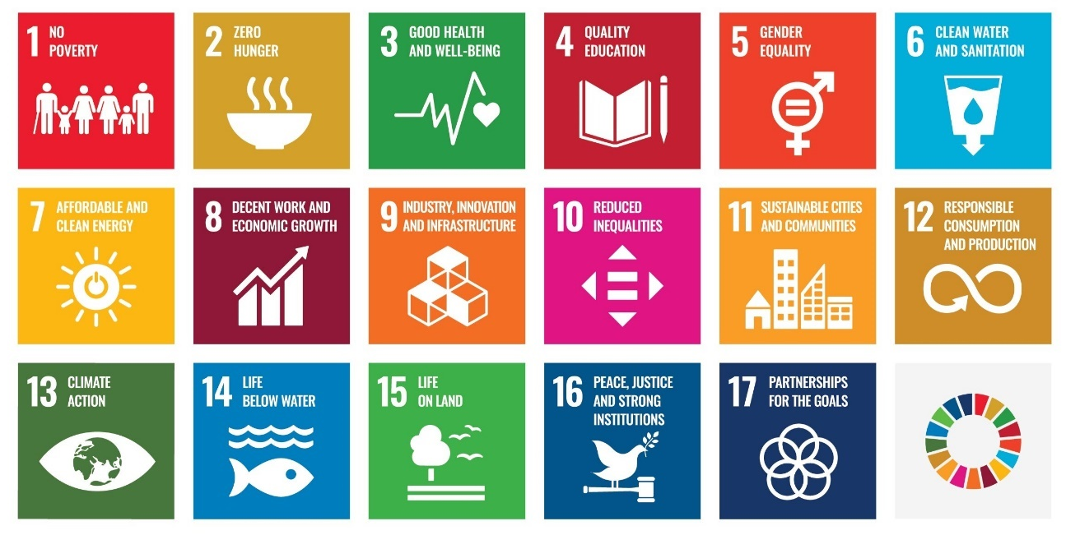
Figure 2: The UN SDGs
Source: United Nations (2022a).
ESG [4] is a generic term used in capital markets, which refers to the environmental, social, and governance factors when evaluating a company’s sustainability impact and future performance. With the growing awareness of sustainable development, more and more investors tend to become socially responsible and consider companies’ ESG performance in their decision-making. This interest in ESG investing leads to a great demand for ESG data and the proliferation of ESG agencies, ratings, rankings, and other products (Abhayawansa and Tyagi, 2021). Consequently, ESG investing is becoming mainstream. Moreover, the COVID-19 pandemic has amplified this momentum (Abhayawansa and Tyagi, 2021), with the number of ESG-related investment funds growing rapidly in the past two years and expected to continue rising in the next decade. With “SDGs” and “ESG” increasingly becoming top trends, “CSR” seems to be less frequently mentioned nowadays.
COVID-19 has brought new challenges to CSR implementations because of its negative effects on business activities and the global economy. Although companies increasingly adopt CSR initiatives and practices, these are often dropped as soon as they encounter unexpected difficulties and challenges such as plunges in sales and investments, cost pressures, and even existential crises (Amankwah-Amoah, 2020). For example, Anser et al. (2021) examine the effects of COVID-19 on carbon damage in 77 countries and find that amidst this unprecedented event companies tend to reduce CSR activities because of the surge in healthcare costs. There remains a significant challenge in maintaining momentum for CSR initiatives and practices well-rooted prior to COVID-19.
It is worth noting that business efforts to continue to be environmentally and socially responsible have paid off. Some recent research papers provide evidence of how CSR implementations can enhance business resilience, risk management, and market competitiveness, both during the turbulent times of COVID-19 and from a long-term perspective. Capital markets and investors have become the impetus for CSR implementations, with a growing interest in ESG investing (Mandal and Murthy, 2021). Companies with shareholders/investors who actively pay attention to CSR activities tend to gain positive abnormal stock returns during the COVID-19 pandemic (Qiu et al., 2021). Moreover, customers’ awareness of responsible and ethical consumption has enhanced during the pandemic (He and Harris, 2020). Customers prefer companies that show better CSR performance (Tong et al., 2021), particularly those performing well in philanthropic, ethical, and ecological aspects (Wild, 2021).
Employee attitudes toward CSR have also changed, as the importance of employee health, safety, and well-being has been highlighted since the outbreak of COVID-19 (Šain, 2021). Companies that emphasise their social commitment to employees tend to achieve higher employee engagement and loyalty (Athanasiadou and Theriou, 2021). Business efforts to help vulnerable citizens and benefit communities during the pandemic have also been recognised, through collaborations with governments and non-governmental organisations and the provision of food and healthcare services (Kim, 2022; Raimo et al., 2021). COVID-19 has highlighted the interconnections between the natural environment, health, poverty, climate change, and global financial stability (Adams and Abhayawansa, 2022). Responsible businesses are less exposed to systematic risks, ready for unexpected situations, and able to react well. Faced with the new challenges caused by COVID-19 corporate managers have to reconsider concepts such as double materiality [5], stakeholder inclusiveness, value creation, and the business model. This reconsideration will lead to ameliorated risk management plans and better CSR strategies, and thus further enhance business resilience.
CSR may seem like an old-fashioned term nowadays and will eventually be replaced by other trending terms/acronyms. However, the conceptualisation of responsible business does not cease. With growing awareness of the interconnections between people, the planet, prosperity, peace, and partnership, our understanding of CSR continues advancing. The recent prevalence of the SDGs and ESG reflects that our perspective on CSR has been broadened – beyond profit, compliance, ethics, and philanthropy – to include long-term value creation and sustainable development. Importantly, the SDGs have helped define the meaning of “doing business responsibly” by translating it into 17 goals (broken down into measurable targets) (Thomson and Bates, 2022). They become a new consensus, language, and “heroic” purpose for all organisations, including businesses (Thomson and Bates, 2022, p. 3).
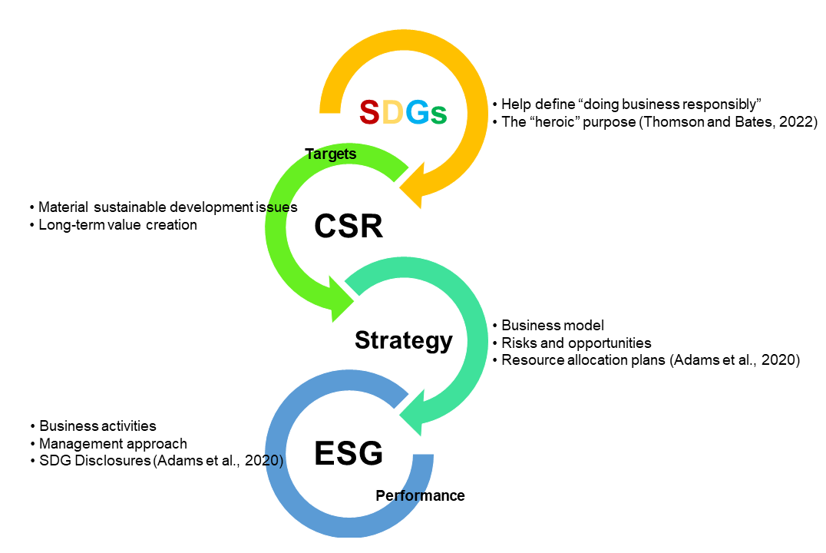
Figure 3: CSR: A Broadened Concept
Source: the author. Drawn on Abhayawansa and Tyagi, 2021; Adams and Abhayawansa, 2022; Adams et al., 2021; Adams et al., 2020; Carroll, 2016; Elkington, 2013; Kim, 2022; KPMG, 2022; Mandal and Murthy, 2021; Qiu et al., 2021; Raimo et al., 2021; Thomson and Bates, 2022; UN, 2022a; van Marrewijk, 2003.
Drawn on the previous research literature, Figure 3 shows CSR as a broadened concept informed by the SDGs and informing a company’s business strategy, activities, management approach, ESG performance, and SDG disclosures. While setting CSR targets, the company needs to consider the SDGs as a purpose and identify material sustainable development issues. This process includes exploring external sustainable development context and identifying short, medium, and long-term risks and opportunities (Adams et al., 2020). The CSR targets inform the company’s strategy addressing the material issues, which aligns with its business module and influences resource allocation plans. With sound governance and management approach, the company records and monitors its material impacts on sustainable development through business activities, discloses its CSR performance (according to ESG factors), and improves its business strategy based on the disclosures. Overall, CSR represents a process of creating long-term value for not only finance providers (e.g., investors, shareholders, etc.) but also wider stakeholder groups and society, while contributing to the achievement of the SDGs and a sustainable future.
At the beginning of 2023, we only have less than eight years to fulfil our commitment to the 2030 Agenda for Sustainable Development. Recent interlinked crises, dominated by COVID-19, climate change, and conflicts, have erased years of progress against all the SDGs and put the 2030 Agenda in grave danger (United Nations, 2022b). There is a collective urgency to deliver meaningful progress for people and the planet, and businesses should play their proper role herein. Every business – local companies and multinational enterprises, start-ups and centuries-old corporations – should act early and act soon, by taking small, simple, practical, and positive steps towards sustainability. Furthermore, every individual, organisation, and sector has transformative power. There is always something, big or small, that we can do to help shift our world onto a sustainable and resilient path – echoing what Thomson and Bates (2022, p. 10) advocate: “do what you can when you can, but do something.”

Notes
[1] Adopted by all United Nations Member States in 2015, the 2030 Agenda for Sustainable Development provides a shared blueprint for peace and prosperity for people and the planet, now and into the future (United Nations, 2022a). Sustainable development is commonly defined as the development that meets the needs of the present without compromising the ability of future generations to meet their own needs (World Commission on Environment and Development, 1987).
[2] The 17 SDGs are 1. No Poverty, 2. Zero Hunger, 3. Good Health and Well-being, 4. Quality Education, 5. Gender Equality, 6. Clean Water and Sanitation, 7. Affordable and Clean Energy, 8. Decent Work and Economic Growth, 9. Industry Innovation and Infrastructure, 10. Reduced Inequalities, 11. Sustainable Cities and Communities, 12. Responsible Consumption and Production, 13. Climate Action, 14. Life below Water, 15. Life on Land, 16. Peace, Justice, and Strong Institutions, 17. Partnerships for the Goals (United Nations, 2022a).
[3] This KPMG Survey was based on sustainability reporting from the largest 100 companies in each of 58 countries, territories, and jurisdictions: 5,800 companies in total (KPMG, 2022).
[4] According to KPMG (2022, p. 62), “the concept of ESG was first introduced by the United Nations in its 2006 publication Principles for Responsible Investing”. In recent years, ESG has become more prevalent, with an increasing number of companies using it as “the anchor for their sustainability reporting” (KPMG, 2022, p. 62).
[5] According to Adams et al. (2021, p. 5), the concept of “double materiality” was first formally proposed by the European Commission in June 2019. It extends “the materiality of financial information” (a key accounting concept) and encourages a company to judge materiality from two perspectives – 1) “the extent necessary for an understanding of the company’s development, performance and position” and “in the broad sense of affecting the value of the company”; 2) environmental and social impact of the company’s activities on a broad range of stakeholders (European Commission, 2019) – and assess the interconnectivity of the two (Adams et al., 2021, p. 5).
Word count = 2326

References
Abhayawansa, S. and Tyagi, S., 2021. Sustainable investing: the black box of environmental, social, and governance (ESG) ratings. The Journal of Wealth Management, 24(1), pp. 49-54.
Adams, C.A. and Abhayawansa, S., 2022. Connecting the COVID-19 pandemic, environmental, social and governance (ESG) investing and calls for ‘harmonisation’of sustainability reporting. Critical Perspectives on Accounting, 82. DOI: 10.1016/j.cpa.2021.102309
Adams, C.A., Alhamood, A., He, X., Tian, J., Wang, L. and Wang, Y., 2021. The double-materiality concept: application and issues. Global Reporting Initiative. Available at: https://www.globalreporting.org/media/jrbntbyv/griwhitepaper-publications.pdf (accessed 10/11/2022).
Adams, C. A., with Druckman, P. B., Picot, R. C., 2020. Sustainable Development Goal Disclosure (SDGD) Recommendations, published by ACCA, Chartered Accountants ANZ, ICAS, IFAC, IIRC and WBA. ISBN: 978-1-909883-62-8 EAN: 9781909883628. Available at: Adams_Druckman_Picot_2020_Final_SDGD_Recommendations1581066540.pdf (scaak.org) (accessed 10/11/2022).
Amankwah-Amoah, J., 2020. Stepping up and stepping out of COVID-19: New challenges for environmental sustainability policies in the global airline industry. Journal of Cleaner Production, 271. DOI: 10.1016/j.jclepro.2020.123000
Anser, M., Yousaf, S., Hyder, S., Nassani, A., Zaman, K. and Abro, M., 2021. Socio-economic and corporate factors and COVID-19 pandemic: a wake-up call. Environmental Science and Pollution Research, 28(44), pp. 63215-63226.
Athanasiadou, C. and Theriou, G., 2021. Corporate Social Responsibility (CSR) Employee Outcomes in the Aviation Industry during the COVID-19 Pandemic Era. A Conceptual Framework. Management and Business Research Quarterly, 18.
Bowen, H., 1953. Social responsibilities of the businessman. New York: Harper & Row.
Carroll, A. B., 1991. The pyramid of corporate social responsibility: toward the moral management of organizational stakeholders. Business Horizons, 34(4), pp. 39-48.
Carroll, A. B., 2015. Corporate social responsibility: The centerpiece of competing and complimentary frameworks. Organizational Dynamics, 44, pp. 87– 96.
Carroll, A. B., 2016. Carroll’s pyramid of CSR: taking another look. International Journal of Corporate Social Responsibility, 1(3). DOI: 10.1186/s40991-016-0004-6
Elkington, J., 2013. Enter the triple bottom line. In Henriques, A. and Richardson, J. (Eds), The Triple Bottom Line: Does It All Add up (pp. 1-16). Taylor & Francis.
European Commission, 2019. Guidelines on non-financial reporting: supplement on reporting climate-related information. Available at: https://eur-lex.europa.eu/legal-content/EN/TXT/?uri=CELEX%3A52019XC0620%2801%29 (accessed 10/11/2022).
Freeman, R. E., 1984. Strategic Management: A Stakeholder Approach. Pitman Publishing Inc., Marshfield.
Friedman, M., 1962. Capitalism and freedom: With the assistance of Rose D. Friedman. University of Chicago Press.
Gobbels, M., 2002. Reframing Corporate Social Responsibility: The Contemporary Conception of a Fuzzy Notion. Journal of Business Ethics, 44, pp. 95-105.
Gray, R., Adams, C., and Owen, D., 2014. Accountability, social responsibility and sustainability: Accounting for society and the environment. Pearson.
He, H. and Harris, L., 2020. The impact of Covid-19 pandemic on corporate social responsibility and marketing philosophy. Journal of Business Research, 116, pp.176-182.
Henderson, D., 2001. Misguided Virtue. False Notions of Corporate Social Responsibility. New Zealand Business RoundTable, Wellington.
Kim, S., 2022. The COVID-19 pandemic and corporate social responsibility of Korean global firms: from the perspective of stakeholder theory. Emerald Open Research, 4, 16.
KPMG, 2022. Big shifts, small steps: Global Survey of Sustainability Reporting 2022. Available at: https://home.kpmg/uk/en/home/insights/2022/10/global-survey.html (accessed 10/11/2022).
Latapí Agudelo, M., Jóhannsdóttir, L. and Davídsdóttir, B., 2019. A literature review of the history and evolution of corporate social responsibility. International Journal of Corporate Social Responsibility, 4(1), pp. 1-23.
Mandal, R. and Murthy, A., 2021. CSR in the post pandemic era: the dual promise of ESG investment and investor stewardship. Indian Law Review, 5(2), pp.229-249.
Miller, K., 2020. The Triple Bottom Line: What it is and Why it’s Important. Harvard Business School Online. Available at: https://online.hbs.edu/blog/post/what-is-the-triple-bottom-line (accessed 10/11/2022).
Qiu, S.C., Jiang, J., Liu, X., Chen, M.H. and Yuan, X., 2021. Can corporate social responsibility protect firm value during the COVID-19 pandemic? International Journal of Hospitality Management, 93, 102759.
Raimo, N., Rella, A., Vitolla, F., Sánchez-Vicente, M.I. and García-Sánchez, I.M., 2021. Corporate social responsibility in the COVID-19 pandemic period: A traditional way to address new social issues. Sustainability, 13(12), 6561.
Šain, M., 2021. Corporate social responsibility in times of crisis: Covid-19. EU and comparative law issues and challenges series (ECLIC), 5, pp. 706-727.
Thomson, I. and Bates, D., 2022. Urgent Business: Five Myths Business Needs to Overcome to Save Itself and the Planet. Bristol University Press.
Tong, Z., Xie, Y., and Xiao, H., 2021. Effect of CSR contribution timing during COVID-19 pandemic on consumers’ prepayment purchase intentions: Evidence from hospitality industry in China. International Journal of Hospitality Management, 97, 102997.
United Nations, 2022a. Do you know all 17 SDGs? Available at: https://sdgs.un.org/goals (accessed 10/11/2022).
United Nations, 2022b. The Sustainable Development Goals Report 2022. Available at: https://unstats.un.org/sdgs/report/2022/ (accessed 10/11/2022).
Van Marrewijk, M., 2003. Concepts and definitions of CSR and corporate sustainability: Between agency and communion. Journal of business ethics, 44(2), pp. 95-105.
Wild, P., 2021. Corporate social responsibility, cost structures, and COVID-19: Impact of passenger behavior on business models. Transportation Research Interdisciplinary Perspectives, 12, 100494.
World Commission on Environment and Development, 1987. Our Common Future. Oxford University Press.

Appendix One: Assignment Brief
This article was extracted from my Critical Literature Review submitted as part of the ACC7007 Module: Academic Research Project. The details of the assignment are as follows:
ELEMENT THREE: CRITICAL LITERATURE REVIEW (50%)
PRE-REQUISITES:
Students must successfully complete modules to the value of at least 60 CATS which must include ACC7002 Research Methods & Techniques and at least two modules from Semester 2 (January).
CO-REQUISITES:
- ACC7007 Element One: Auditing & Accountability (25%)
- ACC7007 Element Two: Ethics & Governance (25%)
TEACHER: Not applicable, supervisors chosen by student.
AIMS: The aim of this element of the module is to complete a Critical Literature Review on a chosen/given topic. This will provide students with the skills needed for conducting theoretical and literature-based research in accounting and finance.
LEARNING OUTCOMES:
On completion and submission of the Critical Literature Review, students will be equipped to:
- write well-structured and comprehensive academic essays through independent work,
- develop coherent thinking and consistent thoughts in the form of a literature review,
- conduct a critical review of literature, identifying limits and strengths of previous studies,
- identify possible research questions and gaps in the areas of accounting and finance and propose further research,
- discuss previous findings, critically evaluate theories and methodologies, and identify their limitations and potential developments.
ASSESSMENT CRITERIA:
The Critical Literature Review is marked according to a grading rubric which is in line with the conceptual equivalents scheme provided in the Postgraduate Student Handbook. The grading rubric is shown in the CLR Handbook. It is worth 50% of the final mark of the ACC7007 module. Students must successfully pass this element with a minimum mark of 50% to progress and graduate.
DESCRIPTION & REQUIREMENTS:
Students who have chosen the Academic Research Project route are required to write an original piece of Critical Literature Review as part of the ACC7007 module. This represents an individual and autonomous piece of work. The Critical Literature Review will draw on a topic proposed by accounting faculty. A Critical Literature Review should:
- present an exhaustive and comprehensive review of existing literature on the chosen topic, discussing previous studies, theoretical and methodological approaches used, limits of existing literature and possible research gaps,
- discuss reasons and rationales behind the importance of investigating the specific topic,
- assess and discuss critically existing evidence, providing suggestions on how to improve and continue study in the area. Students may want to focus on issues such as (but not only): contribution of alternative/new theories, new areas of empirical development, alternative methodologies or improvement of existing ones, data sources, etc.
Students should select a supervisor (i.e., one supervisor only) from the circulated list of supervisors/topics. The supervisor will be chosen using an online method in early 2022. Students will be allocated to supervisors on a first-come first-serve basis. The topics listed are not the exact title, which will be agreed with the supervisor. Several students can be allocated to the same topic, once the relative supervisor agrees. Changes to the topic and/or methodology will be allowed at the supervisor’s discretion. No change in the supervisor is allowed unless in the case of extraordinary circumstances. Students are permitted to contact their supervisor and start their dissertation after the second semester exam results are published.
All submissions are made and assessed through Canvas and are subjected to a check by Turnitin. The normal submission date is September 9th 2022, although this may be later if resit examinations must be completed. Coursework submitted after the submission deadline will be penalised at the rate of 5% of the total marks available for each late working day, up to a maximum of 5 working days, after which a mark of zero will be awarded.
You should also read the CLR Handbook for more detail.
Please note the following points on supervision:
- Students are entitled to a maximum of two face-to-face (individual or group) meetings with their supervisor.
- The supervisor exists to guide and help students with the overall approach and scope of the Critical Literature Review.
- The supervisor does not provide detailed guidance on the contents to be developed or what literature/data sources should be used.
- Feedback on the drafts of the Critical Literature Review will be not be provided.
- After having agreed the specific topic of the work in the first supervisory meeting, the second meeting is optional and is intended for the students to discuss possible doubts with their supervisor.
- Questions can be asked during the face-to-face meetings with the supervisor.
- Contact by email should be kept to a minimum and only to signal difficulties and/or reorganize meetings.
- Supervision will NOT be provided by email; supervisors will not answer questions on the content of the Critical Literature Review by email.
- It is the student’s responsibility to contact their supervisor in due time before the final deadline or to signal possible difficulties with their work.

This article has been accepted by Queen’s Management School’s https://www.qub.ac.uk/schools/QueensManagementSchool/About/ERS/ERSBlog/

