Title: Can Corporations Solve the Global Food Crisis?

Student Name: Lucy Baker
Institution: Durham University
Abstract
The global food crisis is one of the largest scale sustainability disasters that our planet is facing today. Interrelated with various other social and environmental malaises, the crisis is the root cause of a current global syndemic. A problem central to the food crisis is the lack of visibility surrounding its causes. The crisis is rooted in the industrial agriculture systems that have developed over the last century under neoliberal regimes. However, governments and institutions continually fail to address the systematic causes of the crisis, instead implementing market-based solutions that address symptomatic problems and are ultimately insufficient.

This paper analyses the causes and resultant problems of the food crisis, before evaluating various market-based and non market-based approaches to addressing the syndemic. Relevant literature and case studies are used to explore and exemplify solutions. While governments and institutions are currently focusing on market-based strategies to address the crisis, this paper argues that such approaches are inadequate. Market-based solutions cannot be used to successfully resolve a crisis that originates within and is maintained by the market. More radical, systematic changes are required to address the devastating impacts of our current food system.

Introduction
The current food system is underpinned by practices which are perpetuating a compounding humanitarian and environmental crisis. Whilst there is record food production, this is accompanied by record hunger, prices, and profit (Akram-Lodhi, 2022). Evidently, the system is in desperate need of reform.

This paper will evaluate the policy, market, and institutional failures that have contributed to the current food crisis, exploring the problems in relation to other global crises. Various approaches to tackling the food crisis will be considered, ranging from moderate reforms to radical systemic changes.

In the latter half of the paper, Olam International and iPES-Food’s contrasting approaches to transforming the food system will be evaluated. These approaches will be analysed alongside the broader challenges surrounding market and non-market approaches to reforming the system. Finally, the paper concludes that market-based solutions are insufficient, and that radical, systematic changes are required to tackle the food crisis.

Part A
Society and business operate within a neoliberal system; a fundamental problem is the disembedded nature of businesses within society and the use of profit as a measure of success. Kay (1997) highlights two modes of businesses with contrasting values and goals (see Table 1). Today’s neoliberal market encourages businesses to behave in line with Kay’s (1997: 426) ‘Mode 2’ category; organisations operate within a ‘deformed style of capitalism’, prioritising profit over non-economic concerns. In the agribusiness-based food system, the pursuit of profit results in negative externalities that perpetuate the current crisis. The food crisis is interconnected with many of the global problems addressed in the United Nations’ Sustainable Development Goals (SDGs) (see Figure 1).

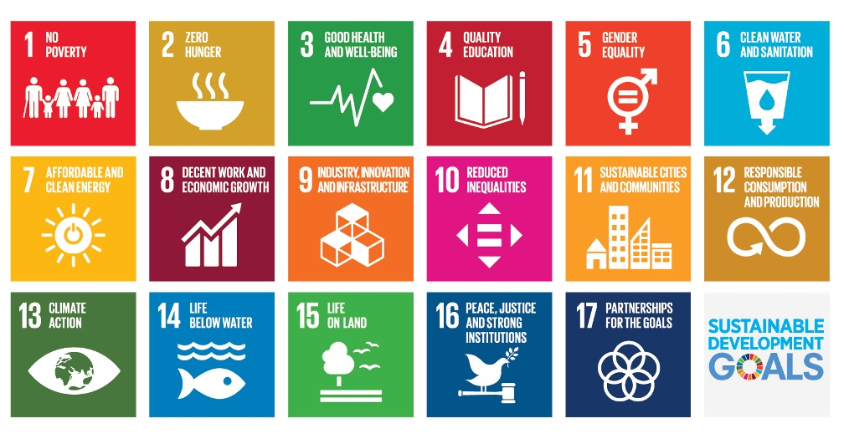
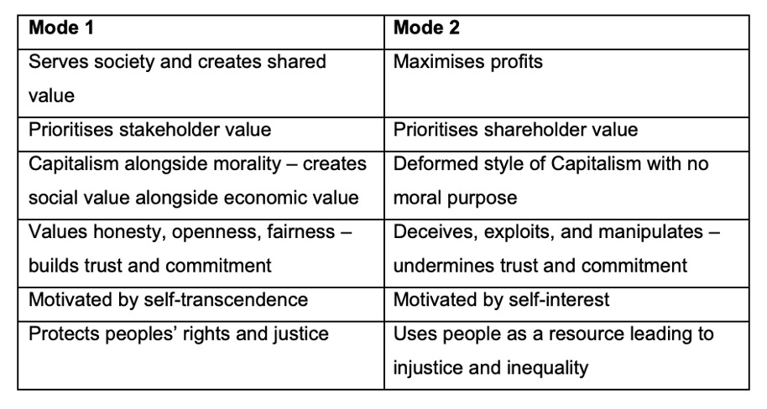
Table 1. Kay’s (1997) Modes of Business
Figure 1. Sustainable Development Goals (United Nations, 2015)

Total global food production is enough to feed 10 billion people, yet over 800 million people go hungry (Holt-Giménez, 2012; Action Against Hunger, 2022). This is the result of market failures. The food system diverts foodstuffs away from feeding people; crops are used to feed animals for meat production and to produce biofuels (Akram-Lodhi, 2022). Moreover, one third of food produced is wasted throughout the supply chain (IPCC, 2019). Alongside creating hunger through inefficient practices, the food system is simultaneously contributing to an obesity crisis. Government subsidies support the production of goods such as wheat and dairy products, keeping the prices of these products low (Wellesley and Benton, 2022). This promotes unhealthy diets and has led to soaring obesity rates which burden healthcare services and the economy.

The globalised nature of the food system – which developed due to cheaper production costs – causes further problems. Great power imbalances exist within the globalised system; a handful of market elites exert a disproportionate amount of control, supplanting local farmers (see Figure 2). Market domination increases inequalities, which is furthered by exploitative labour practices that create low paying work for millions of people (Akram-Lodhi, 2022). Globalisation also makes the system vulnerable to geopolitical instabilities. For example, the Ukraine war led to a 32% price increase in maize (United Nations, 2022).

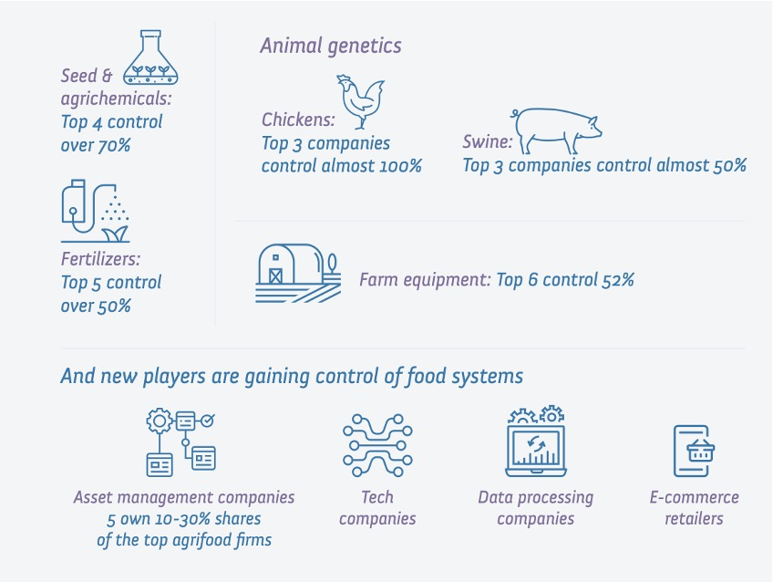
Figure 2. Corporate concentration in the food system (IPES-Food, 2021: 58)
Food prices are further aggravated by artificial price swings created by financial speculation. Excessive marketisation has led to human, economic, and natural capital becoming fictious commodities (Polanyi, 1957). Investors seek short term profits through financial speculation, which causes food price volatility. Thus, trade and prices are not confined to actual supply and demand but are also impacted by the financialisaton of food (Akram-Lodhi, 2022).

Furthermore, the food system is hugely environmentally damaging; it causes up to 80% of biodiversity loss and produces one third of greenhouse gas emissions (IPES-Food, 2022a). Despite this, agriculture has been largely excluded from global climate policy, illustrating a policy failure. The food system is threatened by the environmental damage it perpetuates; climate change has reduced agricultural productivity growth by 21%, causing further price increases (IPES-Food, 2022c). Small-scale farmers and indigenous people are more vulnerable to the impacts of climate disruption, which broadens social inequalities.

The food system also poses a health crises risk. New pathogens are bred through industrial livestock production (Akram-Lodhi, 2022). These diseases are exacerbated by antibiotic resistance produced in the application of antibiotics to animals. The regular, close interactions between people and animals in the food system allows pathogens to be transmitted, which can have catastrophic social and economic consequences, exemplified in the COVID-19 pandemic.

Poor state regulation of the food system illustrates policy and institutional failures in addressing the crisis. Globalised food supply chains are often long and complex, making regulation difficult. Moreover, neoliberal deregulation and budget constraints have resulted in self-regulation being heavily relied upon in corporate governance; companies thus face few legal consequences for irresponsible behaviour. When governments do introduce policies, they are often market-led and aim to increase growth, rather than implementing structural changes to address problems (Kumi et al., 2014). Furthermore, new policies are threatened by lobbying from businesses and farmers who benefit from the current system, which often sways governments against introducing changes (Wellesley and Benton, 2022).

Evidently, the food system perpetuates many interrelated problems. Approaches to tackling the crisis range from systematic reforms to individual changes. One method that agribusinesses could consider is tackling food waste by implementing closed loop systems, where end-of-life products are used as raw materials for other processes (Geyer and Jackson, 2004). Food waste could be used to support new food production (see Figure 4). However, while food waste forms a significant concern, addressing it alleviates a symptom, rather than a cause, of the food crisis.
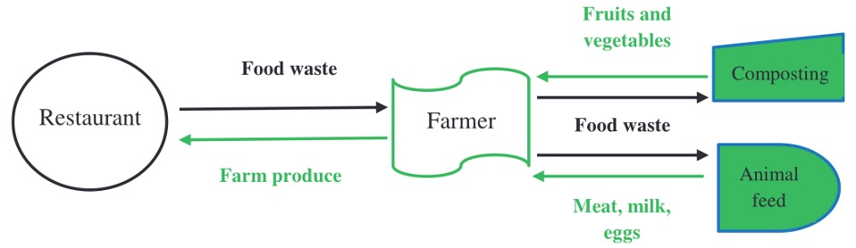

Figure 4. Closed-loop food waste system (Filimonau and Ermolaev, 2022: 471)

Improving corporate social responsibility (CSR) is an approach that could address root causes of the crisis. Polman and Winston (2021) outline the idea of a net positive company, a business approach that involves responsible leadership and creating shared value. Net positive organisations are aligned with Kay’s (1997: 426) ‘Mode 1’ behaviour; they are embedded within society and prioritise social purpose alongside profit. They undertake multi-stakeholder governance, engaging in Kantian values where all stakeholders are treated respectfully, and actions are taken with regards to morality.

Gond et al. (2011) explore the different means by which CSR can be supported by governments (see Table 2). For example, governments could provide subsidies to businesses that create shared value. Alternatively, stricter state regulation could be introduced to force companies to behave more responsibly. Consumers can pressure organisations to improve their CSR through non-violent resistance such as boycotts.
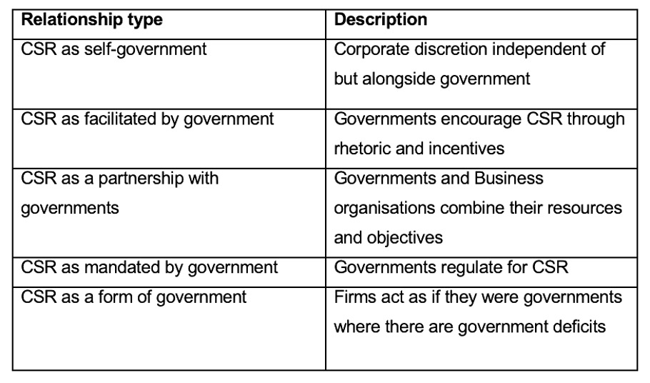
Table 2. Gond et al.’s (2011) CSR-Government Configurations

Expanding Fairtrade is another approach that could transform the free market system. Fairtrade seeks to ensure that products are ethically produced and provides labour rights for agriculture workers (Fairtrade Foundation, 2021). A Fairtrade premium aims to include the social and environmental cost of production in a product’s price (Schmelzer, 2006). Expanding Fairtrade could reduce exploitation in the food system by providing fairer working conditions. However, Fairtrade does have limitations. Viewing Fairtrade from a Kantian perspective highlights that only a small group of workers benefit, as not all products can be Fairtrade labelled. Moreover, supermarkets often retain a share of the Fairtrade premium; Fairtrade thus contributes to maintaining power imbalances. Fairtrade may also be used by companies to greenwash and portray a deceptive image of ethicality.

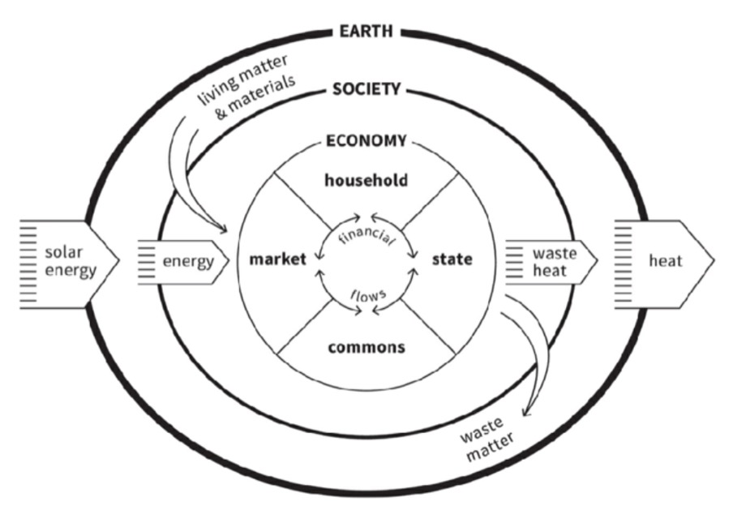
Both Fairtrade and CSR improvements reflect attempts to use the market to fix the problems it creates, which Raworth (2018) argues is inadequate. Raworth (2018) challenges the idea of net positive business, arguing that it would require improbable, high-scale technological advancement. Rather than reform the current system, a new paradigm is required to address the crisis. Raworth’s (2018) paradigm envisions the economy as an organism, embedded within society and nature (see Figure 5). Instead of seeking short-term profits and growth, the embedded economy emphasises collaboration and long-term prosperity of all stakeholders, including non-social stakeholders such as future generations.

Figure 5. The Embedded Economy (Raworth, 2018: 65)

Another alternative embedded paradigm is Rifkin’s (2014) concept of a Collaborative Commons. Rifkin (2014: 214-215) claims that cooperatives are "the only business model that will work in a near zero marginal cost society". The Collaborative Commons is a model of governance established on social capital, where community collaborations create a zero marginal cost society by sharing energy, information, and physical goods using the Internet of Things (Rifkin, 2015). Features of Rifkin’s network-based paradigm are reflected in Haier’s business model (see Table 3). The two cooperative models illustrate how stakeholders can be integrated into governance, creating more equality and social cohesion.

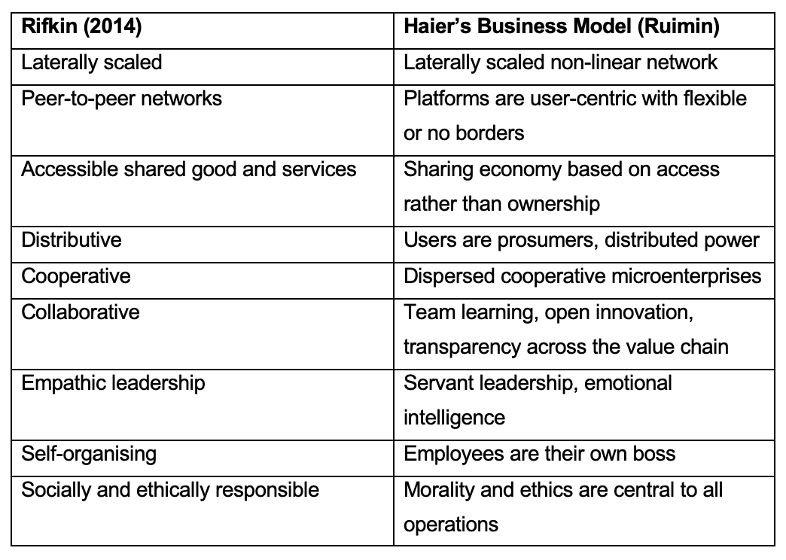
Table 3: Rifkin’s (2014) Collaborate Commons and Haier’s business model (Marschner, 2022; Yong and Yazhou, 2017).

A further radical alternative to the current food system is precision fermentation, which involves brewing microbes to create products. Monbiot (2022) argues that the process could create foods in local microbial breweries, replacing traditional farming methods. Precision fermentation uses significantly less resources than current farming methods and can be fuelled by renewable energy (Marschner, 2022). The process can also screen out undesirable components in food – such as allergens – thus producing healthier foodstuffs. Precision fermentation could be used to create cheap, healthy, and abundant food with low environmental damage. There are, however, drawbacks to the method; precision fermentation would eliminate millions of agribusiness jobs and would likely face strong public objections. Moreover, precision fermentation technologies could become patented, which would lead to a power concentration like that of the current food system. Monbiot (2020) highlights that governments could counter the drawbacks of precision fermentation by providing welfare programmes for redundant workers and introducing regulations that prevent the technology from becoming patented.

Part B
The aforementioned approaches to addressing the food crisis are encompassed within two broader categories: market-based, and non-market based approaches. Two organisations that exemplify these contrasting approaches are Olam International and iPES-Food.
Olam takes a market-based approach to transforming the food system. The organisation centres its business strategy around sustainability and creating long-term shared value for all stakeholders (Olam, 2021). This includes working towards the SDGs and restoring the environment. Olam’s detailed annual reports depict its business strategies and performance, which display ‘Mode 1’ behaviour and features of a net positive organisation (Kay, 1997: 426; Polman and Winston, 2021). The organisation undertakes responsible accounting and multi-stakeholder management; it engages in multi-capital accounting, highlighting six non-financial capitals that are fundamental to its business performance. This is illustrated through integrated annual reporting; Olam recognises the interconnected nature of the capitals and considers them all in its business strategy. Its reporting provides shareholders with detailed information about organisational conduct, allowing investors to engage in sustainable investment practices.
Olam provides an example of an embedded agri-business model based on self-regulation and creating shared value. The organisation encompasses an ethical organisational culture and stresses the importance of non-market values alongside market values. According to Olam’s (2021, 2022a, 2022b) reports, its market-based approach has been successful in allowing the organisation to help to sustainably feed the population, create positive impact for farmers, and achieve robust financial growth.
To contrast, iPES-Food (2021) illustrate a non-market alternative to the current food system. IPES emphasise that the industrialised food system must be replaced with a collaborative, agroecological-based system. Agroecology encompasses a broad set of practices that contrast industrial agriculture (IPES-Food, n.d.). The approach draws on ecology, using farming as part of a process that maintains ecosystems and enhances biodiversity. This is achieved through small-scale farming that is self-sufficient, provides more equal access to food, and enhances local communities. The approach is centred around minimising waste, recycling, and optimizing biodiversity (IPES-Food, 2018). Agroecology address many of the problems of the current food system, such as environmental depletion, power imbalances, and geopolitical vulnerability. Unlike Olam’s market-based approach, iPES propose a system that is not based on neoliberal values such as profit-seeking, and instead prioritises social and environmental richness.
IPES-Food’s (2021) vision of the future encompasses a move towards flexitarian and vegetarian diets and an expansion of fairly traded produce. A “civil-society led food system” would be built on collaboration between all stakeholders, including small-scale producers, non-governmental organisations, and consumers (IPES-Food, (2021: 13). The system would aim to function within planetary boundaries and work towards social prosperity, mirroring Raworth’s (2018) embedded economy model.
Both iPES and Olam’s approaches to reforming the food system face challenges for widespread integration. While Olam claim their approach has procured successful shared value results, market-based approaches have been criticised for inadequately addressing – and even exacerbating – social and environmental problems (Raworth, 2018; Dasgupta, 2021). Scheyvens et al. (2016: 376) warn that market-based solutions fail to “challenge the neoliberal mechanisms” that perpetuate inequalities and focus on voluntary soft measures rather than implementing regulated systematic changes. They highlight that CSR goals are often side-lined by the dominant, profit-driven business model, meaning that, ultimately, corporate decisions are based on economic priorities. Success in the market is defined by economic wealth, which sustains power imbalances and destructive environmental and social practices.
While Olam claims to create sustainable shared value, the organisation has been accused of greenwashing and creating a false image of ethicality (World Rainforest Movement, 2017). Olam has also faced allegations of involvement in deforestation practices (Eco-Business, 2020). Such accusations imply that the organisation may not be performing as well as their annual reports suggest. The allegations against Olam reflect the difficulty of creating shared value and centring sustainability endeavours around business practices. Partnering business with sustainability and ethical values arguably attempts to reconcile two opposing ideologies; the former is based on self-interest while the latter favours collaboration and collective interests (Scheyvens et al., 2016).
Because businesses operate in a system that predominantly values profit, when organisations genuinely seek to solve social and environmental problems, they often face significant challenges. This is exemplified through non-governmental organisation (NGO) Greenpeace, and its struggles in convincing corporations to convert their harmful refrigerants to eco-friendly alternatives. In the late twentieth century, chemical refrigerants were found to contribute to ozone depletion (Hartman and Stafford, 2006; Stafford et al., 2000). When an environmentally friendly refrigerant was produced, Greenpeace partnered with business Foron to produce refrigerators with the new technology, Greenfreeze. The refrigerant technology could not be patented, meaning chemical manufacturers were not interested in commercially developing it, as there were no financial benefits. Moreover, switching to Greenfreeze would require upheaval of current industry infrastructure, costing time and money. Thus, in response to the Greenpeace-Foron alliance, chemical producers and refrigerator companies engaged in misinformation campaigns suggesting that Greenfreeze technology was dangerous. To counter resistance, Greenpeace had to engage in multi-sector activism, orchestrate protests, and negotiate commercialisation deals. This exemplifies Gond et al.’s (2011) self-governance framework, with Greenpeace engaging in civil regulation and undertaking a government role to influence CRS and industry regulations.
The case reflects the difficulties of using the market to implement change, demonstrating how profit-driven market values can counter social and environmental reforms. Greenpeace’s continued activities eventually led to the misinformation allegations being dropped, and businesses slowly switched to the new, environmentally friendly technology. However, Greenpeace’s results were arguably limited, as they did not implement any fundamental corporate or systematic changes. Companies switched to the new technology, but aside from that, business as usual continued. This illustrates how the market cannot be used to fix problems that it creates. The underlying system need to be transformed, rather than addressing the subsequent problems that arise.
Non market-based approaches, such as iPES-Food’s agroecology approach, also face challenges and obstacles. Transitioning to agroecological models from the current food system would require preliminary financing. Agroecology methods require more time, knowledge, training, and labour than industrial farming and profitable sales outlets for agroecological produce are currently lacking in many areas (IPES-Food, 2020). For a widespread agroecological system to prosper, the movement must become less fragmented and requires supporting comprehensive food policies. This would entail collaboration between many stakeholders, including policymakers, consumers, NGOs, and supply chain actors.
As aforementioned, lobbying from actors who benefit from the current system hold power to counter the formation of such policies. Switching to agroecological systems would also require higher food prices and flexitarian diets, which would likely cause consumer resistance. To combat opposition to changes, a new value ideology will be required, emphasising collective values that prize the relationship between human activity, the economy, and the environment. This ideology change requires “alternative measures of success ... reflected not in the metric of money but in metrics that reflect human prosperity in a flourishing web of life” (Raworth, 2018:279). Such a huge paradigm shift would not be easily attained. All stakeholder groups would need to display resilience and support to pressure those in power to implement change. IPES (2021: 20) are optimistic about civil society’s ability to adapt to a new system, asserting that an alternative, future-oriented and sustainable system is “urgently needed” to counter the global food crisis.
Conclusion
This paper has evaluated the policy, market, and institutional failures that have contributed current global food crisis and has explored various market and non-market approaches to addressing the related problems. It has emphasised that our global food system is contributing to a sustainability disaster.

Corporations certainly can – and must – improve their ethical conduct and implement responsible business strategies. However, attempts to use CSR and market-based approaches to solve the food crisis are, ultimately, enormously inadequate. The current neoliberal system perpetuates power imbalances and exploitation. A fundamental problem with the system is the relentless pursuit of profit and the excessive commodification of capital. To address the issues of the food crisis, the very foundations of the system must be overturned and replaced by a new paradigm. This new system must be based on collaboration and an understanding on the interconnected relationship between human activity and the planet, as is emphasised in Raworth’s (2018) embedded economy and Rifkin’s (2014) Collaborative Commons. In food production, this could manifest as alternative farming methods, such as agroecology or precision fermentation. It is vital for the future of humankind and the health of our planet that the current neoliberal organisation of society and the economy is overturned. Business as usual cannot continue if we want to maintain the health of our population and planet.

Bibliography

Action Against Hunger (2022), World Hunger Facts & Statistics | Action Against Hunger. [online] Action Against Hunger. Available at: https://www.actionagainsthunger.org/the-hunger-crisis/world-hunger-facts/ [Accessed 14 Jan. 2023].
Akram-Lodhi (2022), Understanding the contemporary food crisis: structural causes, structural solutions. [online] www.youtube.com. Available at: https://www.youtube.com/watch?v=toHSc6X9n-E [Accessed 8 Nov. 2022].
Dasgupta, P. (2021), The Economics of Diversity: The Dasgupta Review. (London: HM Treasury).
Eccles, R. & Serafeim, G. (2014), Corporate & Integrated Reporting, Harvard Business School, Working Paper 14-094.
Eco-Business (2020), Investigation begins into alleged deforestation by Olam, ‘world’s largest farmer’. [online] Eco-Business. Available at: https://www.eco-business.com/news/investigation-begins-into-alleged-deforestation-by-olam-worlds-largest-farmer/ [Accessed 16 Jan. 2023].
Fairtrade Foundation (2021), What is Fairtrade? [online] Fairtrade Foundation. Available at: https://www.fairtrade.org.uk/what-is-fairtrade/ [Accessed 15 Jan. 2023].
Filimonau, V. & Ermolaev, V.A. (2022), Exploring the potential of industrial symbiosis to recover food waste from the foodservice sector in Russia. Sustainable Production and Consumption, 29(3): 467–478.
Geyer, R. and Jackson, T. (2004), Supply Loops and Their Constraints: The Industrial Ecology of Recycling and Reuse. California Management Review, 46(2): 55–73.
Gond, J-P, Kang, N. & Moon, J. (2011), The Government of Self-regulation & the Dynamics of CSR, Economy & Society, 40(4): 640-671.
Hartman, C. L., & Stafford, E. R. (2006), Chilling With Greenpeace, From the Inside Out. Stanford Social Innovation Review, [online] 4(2): 54–59. Available at: https://doi.org/10.48558/HVEW-0Z12 [Accessed 15 Jan. 2023].
Holt-Giménez, E., Shattuck, A., Altieri, M., Herren, H. & Gliessman, S. (2012), We Already Grow Enough Food for 10 Billion People … and Still Can’t End Hunger. Journal of Sustainable Agriculture, 36(6): 595–598.
IPCC (2019), Chapter 5 — Special Report on Climate Change and Land. [online] Available at: https://www.ipcc.ch/srccl/chapter/chapter-5/ [Accessed 15 Jan. 2023].
IPES-Food (2018), BREAKING AWAY FROM INDUSTRIAL FOOD AND FARMING SYSTEMS Seven case studies of agroecological transition. [online] Available at: https://ipes-food.org/_img/upload/files/CS2_web.pdf. [Accessed 14 Jan. 2023].
IPES-Food (2020), THE ADDED VALUE(S) OF AGROECOLOGY: UNLOCKING THE POTENTIAL FOR TRANSITION IN WEST AFRICA EXECUTIVE SUMMARY. [online] Available at: https://www.ipes-food.org/_img/upload/files/IPES-Food_ExecSummary_WA_EN.pdf [Accessed 13 Jan. 2023].
IPES-Food (2021), A Long Food Movement: Transforming Food Systems by 2045. [online] Available at: https://www.ipes-food.org/_img/upload/files/LongFoodMovementEN.pdf [Accessed 14 Jan. 2023].
IPES-Food (2022a), Food systems at the heart of climate action: the Glasgow Food & Climate Declaration at COP. [online] www.youtube.com. Available at: https://www.youtube.com/watch?v=9WS3mp5fzoA&list=PL0pDKBoKM0cJSanDBo3OITx91r0AVBLkM&t=100s [Accessed 12 Jan. 2023].
IPES-Food (2022b), IPES-Food (International Panel of Experts on Sustainable Food Systems) COP27 PRESS REACTION COP27 REACTION - AGRICULTURE IS IN THE CLIMATE TENT BUT SMALL-SCALE FARMERS LEFT OUT. [online] Available at: https://www.ipes-food.org/_img/upload/files/2022.11.18_COP27_press_reaction.pdf [Accessed 13 Jan. 2023].
IPES Food (2022c), IPES food | NEWS | IPCC: Transform agriculture or climate change will inflict unprecedented hunger. [online] www.ipes-food.org. Available at: http://www.ipes-food.org/pages/news-IPCC-transform-agriculture-2802022 [Accessed 15 Jan. 2023].
IPES-Food (n.d.), IPES food | Topics Agroecology. [online] ipes-food.org. Available at: https://ipes-food.org/topics/Agroecology [Accessed 13 Jan. 2023].
Kay, J. (1997), A Stakeholding Society: What Does It Mean For Business? Scottish J. of Political Economy, 44(4): 425-437.
Kumi, E., Arhin, A.A. & Yeboah, T. (2014), Can post-2015 sustainable development goals survive neoliberalism? A critical examination of the sustainable development–neoliberalism nexus in developing countries. Environment, Development and Sustainability, 16(3): 539–554.
Marschner, P. (2022), Our current methods of food production are unsustainable – in his latest book, George Monbiot considers the alternatives. [online] The Conversation. Available at: https://theconversation.com/our-current-methods-of-food-production-are-unsustainable-in-his-latest-book-george-monbiot-considers-the-alternatives-184048 [Accessed 13 Jan. 2023].
Minnaar (2018), Picking The Brain Of The World’s Most Radical CEO: Zhang Ruimin. [online] Corporate Rebels. Available at: https://corporate-rebels.com/interview-zhang-ruimin/ [Accessed 15 Jan. 2023].
Monbiot (2020), Saving Our Bacon. [online] George Monbiot. Available at: https://www.monbiot.com/2020/01/10/saving-our-bacon/ [Accessed 13 Jan. 2023].
Monbiot (2022), Embrace what may be the most important green technology ever. It could save us all | George Monbiot. [online] the Guardian. Available at: https://www.theguardian.com/commentisfree/2022/nov/24/green-technology-precision-fermentation-farming [Accessed 13 Jan. 2023].
Olam (2021), Transforming to serve a changing world. [online] Available at: https://www.olamgroup.com/content/dam/olamgroup/investor-relations/ir-library/annual-reports/annual-reports-pdfs/2021/olam_annual_report_2021.pdf [Accessed 16 Jan. 2023].
Olam (2022a), Half-Year 2022 Results Briefing. [online] Available at: https://www.olamgroup.com/content/dam/olamgroup/investor-relations/ir-library/financial-results/financial-results-pdfs/2022/h1-2022-results/12august2022_h1-fy2022_results_briefing.pdf [Accessed 16 Jan. 2023].
Olam (2022b), News Release. [online] Available at: https://www.olamgroup.com/content/dam/olamgroup/investor-relations/ir-library/financial-results/financial-results-pdfs/2022/h1-2022-results/12aug2022_h1-fy2022-results_news-release.pdf [Accessed 16 Jan. 2023].
Polanyi, K. (1957), The Great Transformation: the Political & Economic Origins of Our Time, Boston MA: Beacon.
Polman, P. & Winston, A. (2021), Net Positive, Boston (MA): Harvard Business Review Press.
Raworth, K. (2018), Doughnut Economics: Seven Ways to Think Like a 21st Century Economist, London: Penguin.
Rifkin, J. (2014), The Zero Marginal Cost Society, New York: Palgrave Macmillan
Scheyvens, R., Banks, G., Hughes, E. (2016), The Private Sector & the SDGs: The Need to Move Beyond Business as Usual, Sustainable Development, 24: 371-382.
Schmelzer, M. (2006), In or Against the Market: Is Fair Trade a Neoliberal Solution to Market Failures or a Practical Challenge to Neoliberal Trade and the Free Market Regime in General? Research Paper for Sociology 190, UC Berkeley, Spring.
Stafford, E.R., Polonsky, M.J & Hartman, C. L. (2000), Environmental NGO-Business Collaboration and Strategic Bridging: A Case Analysis of the Greenpeace-Foron Alliance. Business, Strategy, and the Environment, 9: 122–135.
Rifkin (2015), The Zero Marginal Cost Society - Jeremy Rifkin. [online] www.youtube.com. Available at: https://www.youtube.com/watch?v=MBlWEOHqdOU [Accessed 12 Jan. 2023].
United Nations (2015), Sustainable Development Goals launch in 2016. [online] United Nations Sustainable Development. Available at: https://www.un.org/sustainabledevelopment/blog/2015/12/sustainable-development-goals-kick-off-with-start-of-new-year/ [Accessed 14 Jan. 2023].
United Nations (2022), Global Impact of war in Ukraine on food, energy and finance systems. [online] Available at: https://unsdg.un.org/sites/default/files/2022-04/UN%20GCRG%20Ukraine%20Brief%20No.%201_FINAL%20%281%29.pdf [Accessed 10 Nov. 2022].
Wellesley, L. and Benton, T.G. (2022), Welcome to a new age of food insecurity. [online] Prospect. Available at: https://www.prospectmagazine.co.uk/essays/welcome-to-a-new-age-of-food-insecurity-russia-ukraine [Accessed 8 Nov. 2022].
World Rainforest Movement (2017), ‘Green’ oil palm plantations are a scam: the case of OLAM. [online] Grain. Available at: https://grain.org/fr/entries/5714-green-oil-palm-plantations-are-a-scam-the-case-of-olam [Accessed 16 Jan. 2023].
Yong, H. and Yazhou, H. (2017). Haier purpose: The Real Story of China’s First Global Super Company. Infinite Ideas.

Appendix One

SUMMATIVE ASSIGNMENT
Module title: Corporate Responsibility and Sustainability

Part A: Critically evaluate the policy, market, and institutional failures that have led to the current food crisis, and its interconnection with other global crises and systemic disorders; then consider the key arguments for and against different approaches to tackling the food crisis, and what various stakeholders could do to reverse the decline in global food security and the adverse social and environmental impacts of the global food system, drawing on relevant literature, reports, and other sources.

Part B: Critically compare iPES-Food’s non-market approach to transforming the food system with that of Olam International’s market-based approach, in the light of iPES & ETC Group’s contention that an agri-business solution will only exacerbate social and environmental problems; then discuss the business management and governance implications and transformational opportunities and challenges involved in solving those problems, drawing on relevant sources and theories.

Answer both parts of the question. Each part carries equal marks.
Overall word limit: 3000

