prme uk and ireland chapter
Seed Funding competition for Developing Innovative Pedagogic Approaches and teaching practices in PRME
APPLICATION DEADLINE: 15th December 2023 AT 5pm
APPLICATION GUIDANCE NOTES 2023
SECTION 1
In Section 1 of the form, please enter the following:
  - The name(s) and institution(s) of the applicant(s).
  - The address of the project lead(s).
  - The telephone number(s) of the project lead(s).
  - The email address(es) of the project lead(s).
  - The proposed project title.
  - The amount of funding requested to a maximum of £1,500.
Applications are welcome from individuals and teams. Teams may be comprised of faculty from one or more institutions.
Please confirm whether the lead applicant(s) is a member of the faculty at (a) a PRME member institution and (b) that the institution is a paid-up member of the UK and Ireland Chapter of PRME. (If you are unsure of your institution’s status, you can email PRME@bcu.ac.uk to confirm before submitting your application).
SECTION 2
2.1 Please briefly describe the proposed project specifically addressing its relevance to the objectives of PRME (200 words maximum).
PRME was developed as a platform to raise the profile of social responsibility and sustainability in business and management schools around the world, and to equip today’s business students with the understanding and ability to deliver change tomorrow. Working through Six Principles, PRME engages schools to ensure they provide future leaders with the skills needed to balance economic and sustainability targets, while drawing attention to the Sustainable Development Goals (SDGs) and aligning academic institutions with the work of the UN Global Compact.
Within the context of PRME, the concept of sustainability is broadly defined. For example, your project may relate to one or more of the UN SDGs. Alternatively, it may focus on business ethics or responsible management education in its wider sense. Your project should be explicit in explaining what PRME relevant issue it tackles and how this helps to further the PRME mission.
In developing your application, you may find the Blueprint for SDG Integration into Curriculum, Research and Partnerships helpful. In addition to explaining key aspects of PRME and the SDGs, it also includes sections on rethinking content and pedagogy.
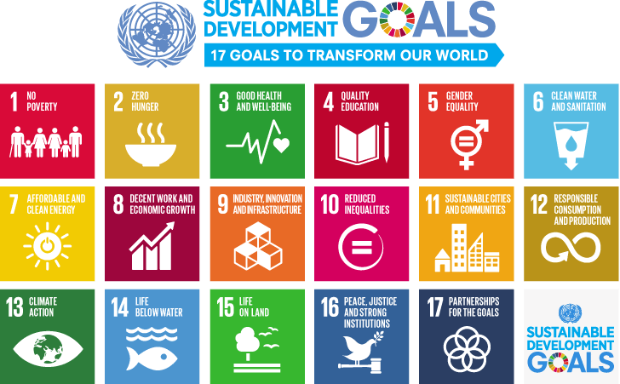

Within your application, there should be a strong focus on the UK and/or Ireland. While the proposed project may bring in partners from other parts of the world, the benefit and relevance to the region should be clear.
In addition, the project must address pedagogic approaches and/or teaching practices. More general research projects, even if they address social responsibility or sustainability related issues, are not eligible for funding. There is a separate seed funding competition for research-related projects within the Chapter.
2.2 Please describe any novel or innovative aspects to the pedagogic approach/teaching practice (200 words maximum).
A key objective of the Seed Funding Competition is to support novel and/or innovative projects. Under question 2.2, please describe what sets your proposal apart. For example, is it the mode of delivery, content covered, assessment undertaken, and/or cohort engaged? Please note, novel and/or innovative does not mean unique. For example, you may wish to trial a technique that has been used successfully in one context but not another.
2.3 Please describe why the funding is needed and what it will specifically be used for (200 words maximum).
Under question 2.3, please explain why the funding is vital to enable your project to progress. For example, why are other internal or external sources of funding not available/appropriate?
Also, please provide as much detail as possible as to how this money would be utilised (ideally a table or bullet points outlining the key expenditure). Please note that grants cannot be used to purchase equipment, unless specialist equipment essential to the project.
2.4 Please describe the potential for the generation of transferable learning and/or resources (200 words maximum).
The UK and Ireland Chapter aim to fund projects that will result in learning and/or resources of benefit to the wider UK&I PRME community. This may include, for example, a report detailing what was done (and how it could be replicated at other institutions) or physical resources such as slides, worksheets, videos, audio recordings, etc. Projects must provide transferable learning and outputs that could be used by other institutions. Please outline the potential for the generation of transferable learning/resources under question 2.4.
2.5 Is the proposed project interdisciplinary in nature? If yes, please describe (100 words maximum).
Interdisciplinary projects are encouraged but not required. By interdisciplinary, we mean combining two or more academic disciplines or areas of knowledge. This could include those that fall within the broad category of business and management (e.g., accounting, finance, marketing, operations, etc.) or between business and management and, for example, an area within the humanities, social sciences, or natural sciences. (For example, a pedagogy project that brings together students from marketing and engineering). Interdisciplinary projects can introduce a wider audience to the aims and objectives of PRME, as well as facilitate the development of fresh perspectives on responsible management and/or sustainability challenges.
2.6 Does the proposed project relate to an under-explored area, for example, in your institution or more broadly? If yes, please describe (100 words maximum).
Addressing an under-explored area is encouraged but not required. By ‘under-explored’, we mean an area that has to date been neglected or overlooked, either within your institution or more broadly. Alternatively, it could relate to an under-represented group within society in relation to sustainability. Again, this is an opportunity to explain what makes your project unique and worthy of funding.
2.7 Does the project align to the PRME ‘Impactful Five’ (i5): Learning in Leadership Education Characteristics? If yes, please describe (100 words maximum).
Projects that intentionally feature the PRME ‘Impactful Five’ (i5) are also encouraged but not required. The PRME ‘Impactful Five’ (i5), generously supported by the LEGO Foundation, is a three-year program that brings novelty to SDG leadership education by focusing on pedagogical approaches that make sustainable development the norm for responsible management education and leadership in business education. The PRME (i5) program draws on prior knowledge and experiences with ‘playful learning’ to integrate collaborative, social, meaningful, joyful, iterative, and actively engaging methods to generate the future leaders that the world urgently needs. The purpose of this program is to develop pedagogical adoption of playful learning for holistic development among the PRME network of global leadership educators. Further information about the PRME i5 project is available here.

SUMMARY OF JUDGING CRITERIA
Funding will be allocated based on the following criteria:
- Relevance to the objectives of PRME;
- Novel/innovative practice;
- Evidence of need for funding and clear outline of what it will be used for;
- The generation of transferable learning/resources; and
- Collaborative practice.
While not a necessity, applications are particularly welcome in relation to initiatives that are interdisciplinary in nature, addressing topics that are currently under-explored, and/or aligned to the PRME ‘Impactful Five’ (i5).

FINAL TIPS
- Remember that the focus is on ‘innovative pedagogic approaches and teaching practices in PRME’. Therefore, you should stress what makes your project novel and why it is of relevance to PRME.
- Endeavour to provide a clear explanation of why funding is required and what it will specifically be used for. A detailed list of proposed expenditure is particularly important.
- Similarly, try to be explicit about the project outcomes and/or impact, particularly within Section 2.4 (potential for the generation of transferable learning and/or resources). What do you hope to achieve and how might this be ultimately be of benefit to the wider PRME community?

Successful applicants can draw down funding on a vouched basis between 1 February 2024 and 31 January 2025.
Applications should be submitted to PRME@bcu.ac.uk on or before the deadline of 15th December at 5pm. Receipt of submissions will be acknowledged. Successful applicants will be notified by 15th January 2024.
If you have any questions about the competition, please feel free to contact Dr Claire May (cmay@lincoln.ac.uk) at Lincoln International Business School on behalf of the organising team.

